# **FINAL REPORT METHODOLOGY – HR LDP ANALYSIS**

This methodology outlines how the HR report will be structured, the data analysis approach, and the insights provided to justify the expansion of the Leadership Development Program (LDP).

## **1. REPORT STRUCTURE**

The report follows a hierarchical approach, moving from overall leadeºrship trends down to individual leader performance.

### **Sections of the Report**

1. **Executive Summary**
   * Top five key insights from the data analysis.
   * Overall leadership strengths and gaps.
   * High-level trends in Emotional Intelligence (EQ) and Engagement.
   * Recommendations for HR’s next steps.
   * Gaelle: lets work on it
2. **Methodology (How the Data Was Analyzed)**
   * Assessment process: Discovery tools, dashboards, and scoring models.
   * Clustering approach (D1-D13): Why job categories were grouped this way.
   * Leadership Index Score (LIS): Formula and weighting of skills.
   * Emotional Intelligence (EQ): Why it is crucial and how it was analyzed.
   * Engagement Analysis: Defining Highly Engaged, Moderate, and Disengaged leaders.
3. **Overall Leadership Analysis (100 Leaders)**
   * Average LIS, EQ, and Engagement Scores.
   * Top 10 percent vs. bottom 10 percent performers.
   * Distribution trends (who exceeded expectations vs. struggled most).
   * Which leadership skills were strongest vs. weakest.
4. **Job Category Analysis (D1-D13 Clusters)**
   * Ranking of clusters based on LIS, EQ, and Engagement.
   * Best-performing vs. weakest clusters.
   * EQ trends within clusters.
   * How job clusters compare to each other.
5. **Job-Specific Breakdown**
   * How leaders performed within each job role (e.g., Senior Engineers, HR Leaders).
   * Comparison of leaders within the same job role.
   * Key skill strengths and gaps per job role.
6. **Individual Leader Insights**
   * Top and bottom performers per cluster.
   * Leadership type breakdown (Mentoring Leader, Visionary, etc.).
   * How each leader performed within their cluster and job role.
   * Which leaders were the most and least engaged.
7. **Engagement and Program Participation**
   * Engagement score breakdown (Highly Engaged, Moderate, Disengaged).
   * Correlation between engagement and leadership performance.
   * Which clusters were the most engaged vs. disengaged.
8. **Key Takeaways and HR Recommendations**
   * Lack of specific skills and gaps across leaders.
   * Which job categories need leadership development.
   * Training recommendations based on results.
   * Proposal for reassessment in one year.

## **2. DATA ANALYSIS METHODOLOGY**

This section details how insights were generated using Leadership Index Score (LIS), Emotional Intelligence (EQ), and Engagement Analysis.

### **Leadership Index Score (LIS) – Ranking Leaders**

LIS is calculated using a weighted formula:

* EQ 25% - 30% weight
* 85 percent – Critical Skills
* 30 percent – Useful Skills
* 10 percent – Supplemental Skills

**LIS Analysis Includes:**

* Overall LIS ranking (Top 10 percent vs. Bottom 10 percent).
* LIS distribution trends across clusters (D1-D13) and job roles.
* Best and worst performers by job role and cluster.
* Ranking within job roles (e.g., top Senior Engineer).

### **Emotional Intelligence (EQ) Analysis**

Since EQ is a key leadership skill, this will be analyzed separately.

**EQ Insights Include:**

* Top 10 percent and bottom 10 percent leaders in EQ.
* EQ performance across job clusters (D1-D13).
* Comparison of EQ by Leadership Type (e.g., are Mentoring Leaders stronger in EQ).
* Does high EQ correlate with better leadership scores.

### **Engagement Analysis**

Leaders are categorized based on participation levels in the LDP.

**Engagement Categories:**

* Highly Engaged: Actively participated in the program.
* Moderately Engaged: Partially engaged.
* Disengaged: Showed little or no participation.

**Engagement Insights Include:**

* Engagement trends across clusters (D1-D13).
* Correlation between engagement and LIS performance.
* Who were the most and least engaged leaders.

## **3. VISUALIZATION STRATEGY (DATA PRESENTATION)**

To make data more actionable, the report will include multiple visualizations.

**Charts and Graphs Included in the Report:**

* LIS Distribution (Top 10 percent vs. Bottom 10 percent).
* Leadership Index Score by Cluster (D1-D13).
* Emotional Intelligence Rankings.
* Best and Worst Performing Job Roles.
* Engagement Levels by Job Cluster.
* Case Study Examples (High-Performing, Highly Engaged Leaders).

**Interactive Dashboard (DASH Web App)**

* Filtering System:
  + Filter by Overall Group, Cluster (D1-D13), Job Role, Individual Leader
* Visualizations:
  + Scatter Plots (EQ vs. LIS)
  + Box Plots (Skill Distributions)
  + Heatmaps (High vs. Low Performers)
  + Bar Charts (Top Performing Clusters and Jobs)
* Live Comparisons:
  + Compare two clusters
  + Compare two job roles
  + Compare individual leaders

## **4. FINAL REPORT DELIVERABLES**

### **PDF Report (Static Version for HR Review)**

* Executive Summary
* LIS, EQ, and Engagement Analysis
* Cluster and Job Role Comparisons
* Top and Bottom 10 Percent Insights
* Leadership Type Breakdown
* Methodology Section (Explaining How Data Was Analyzed)
* Recommendations for HR (Next Steps and Training Focus Areas)

### **Interactive Dashboard (DASH Web App)**

* Deep Dive Exploration of leadership insights
* Filtering System for Clusters, Jobs, Individuals
* Live Comparisons for Real-Time Insights

## **5. NEXT STEPS**

Now that the methodology is finalized, I will:

1. Continue Data Analysis (Generate LIS, EQ, and Engagement Insights).
2. Create Visualizations (Charts and Graphs for the PDF Report).
3. Develop the PDF Report Draft.
4. Begin Interactive Dashboard Development.

ARCHIVED Draft Outline

# **Leadership Development Program (LDP) - Nesma & Partners**

## **Final Report (Draft)**

**Prepared by:** IVY & Company  
 **Date:** [Insert Date]  
 **Audience:** Nesma & Partners HR Department & Executive Leadership

## **1. Executive Summary**

This report provides an overview of the Leadership Development Program (LDP) conducted for Nesma & Partners. The program aimed to assess and develop the leadership and emotional intelligence competencies of 100 company leaders. The primary objective was to equip Nesma’s HR team with data-driven insights to demonstrate workforce effectiveness to the CEO and identify areas requiring further investment in training and development.

Key findings and recommendations will be provided in the final version once all assessments are completed. This draft outlines the structure of the report and preliminary observations.

## **2. Program Goals & Scope**

### **Goals of the LDP**

The Leadership Development Program was designed to:

* Evaluate the leadership and emotional intelligence skills of Nesma’s leaders.
* Determine whether individuals are in roles aligned with their competencies.
* Provide Nesma’s HR department with actionable insights to optimize leadership effectiveness.
* Justify future budget allocations for targeted training and development programs.

### **Scope of Work**

The LDP followed a structured methodology, covering eight key phases:

1. **Job Description Analysis** – Assess existing job descriptions and role expectations.
2. **Skill Identification & Categorization** – Define key competencies required for success.
3. **Stakeholder Feedback on Skills** – Validate skills with HR and senior management.
4. **Dashboard Creation** – Develop competency dashboards for each leader.
5. **Assessments & Individual Dashboards** – Conduct leadership and emotional intelligence assessments.
6. **Gap Analysis & Training Action Plan** – Identify skill gaps and propose targeted training.
7. **Group Report & HR Insights** – Provide aggregated insights on leadership effectiveness.
8. **Senior Manager Report** – Offer a high-level summary for senior executives.

## **3. Methodology & Execution**

### **How We Conducted the Program**

* **Initial Alignment:** The program was introduced via CEO and HR-led communications.
* **Job & Skill Analysis:** Competencies were extracted from job descriptions and validated with stakeholders.
* **Dashboards & Assessment Tools:** Custom dashboards were developed for leadership assessment.
* **Assessment Execution:** Leaders completed emotional intelligence and competency assessments using the ARCH platform.
* **Data Consolidation:** Results were compiled into individual dashboards and analyzed for trends.
* **Training Recommendations:** Insights from assessments will guide training initiatives.

### **Key Adjustments & Iterations**

* **Self-Assessment Phase Removed:** Originally planned but replaced with a structured workshop video.
* **Online Workshop Video:** originally planned as a face to face workshop, by the request of Nesma we made an online workshop video to be more flexible with the leaders time and refilmed the workshop 3 times to ensure it truly aligns with Nesma's communication and strategic goals.
* **Live FAQ Document Introduced:** To ensure clarity and accessibility for participants.
* **Updated Communication Approach:** Refinements were made to engagement strategies based on feedback.

## **4. Preliminary Findings & Key Metrics**

*(Note: These figures are placeholders; final data will be inserted once all assessments are complete.)*

### **Overall Leadership Competency Levels**

* **% of Leaders Meeting Minimum Competency Standards**: [84% (68 leaders]
* **% of Leaders Requiring Training**: [8.6% (7 leaders)]
* **% of Leaders Exceeding Expectations**: [7.4% (6 leaders)]

### **Emotional Intelligence & Leadership Skills**

* **Top Strength Areas Identified**: [Placeholder]
* **Key Development Areas**: [Placeholder]
* **Recommended Training Interventions**: [Placeholder]

### **Engagement & Completion Rates**

* **% of Leaders Who Completed Assessments**: [Placeholder]
* **% of Leaders Requesting Additional Support**: [Placeholder]

## **5. Detailed Dashboard Analysis**

Each leader received an individual competency dashboard detailing:

* **Leadership skill ratings across key competencies.**
* **Emotional intelligence scores.**
* **Comparison to role expectations.**
* **Personalized recommendations for development.**

Further analysis will be provided in the final report, focusing on trends and patterns.

## **6. Key Insights & Recommendations**

**Preliminary Observations:**

* Leaders generally perform well in [specific skill area], but struggle with [another area].
* Certain managerial roles require targeted upskilling in [specific competency].
* There is a need for structured leadership coaching in [specific area].

**Proposed Action Plan for Nesma HR:**

1. **Targeted Leadership Training Programs** – Focus on identified gaps.
2. **Coaching & Mentorship Initiatives** – Pair underperforming leaders with high performers.
3. **Strategic Role Realignment** – If necessary, reposition leaders based on strengths.
4. **Ongoing Competency Tracking** – Implement continuous assessment to measure improvements.

## **7. Conclusion & Next Steps**

The Leadership Development Program provides Nesma & Partners with a strategic roadmap for strengthening leadership capabilities. While the majority of leaders demonstrate competency in key areas, some require targeted development to optimize their impact.

### **Next Steps:**

1. **Finalizing Assessments & Dashboards** – Complete outstanding assessments and compile final metrics.
2. **Refining Training Recommendations** – Align recommendations with organizational priorities.
3. **Presenting to CEO & Leadership Team** – Nesma HR to leverage findings for future budget discussions.
4. **Implementing Development Initiatives** – Execute training and coaching programs based on findings.

ARCHIVED Detailed Draft Outline

# **Leadership Development Program (LDP) – Nesma & Partners**

## **Comprehensive Final Report – Outline**

**Prepared by:** IVY & Company  
**Date:** [Insert Date]  
**Audience:** Nesma & Partners HR Department & Executive Leadership

## **1. Executive Summary**

### **1.1. Overview of the Leadership Development Program (LDP)**

* **Purpose**: To assess and develop the leadership competencies and emotional intelligence of **100 company leaders** within Nesma & Partners.
* **Key Goals**:
  + Ensure employees are in the right roles.
  + Identify competency gaps and recommend targeted training.
  + Justify budget allocations for leadership development.
* **High-Level Insights (Placeholder for Final Data)**:
  + **X% of leaders meet the required competency standards**.
  + **X% require further training**.
  + **X% show significant gaps in emotional intelligence or leadership effectiveness**.

### **1.2. Summary of Key Challenges & Adjustments**

* **Face-to-Face Workshop Was Removed** → Online Workshop Video Introduced (Delayed Execution).
* **Slow Completion of Assessments** → Impact on program timeline.
* **Departmental Skill Gaps Emerging** → Early findings on where leaders need support.

### **1.3. Strategic Recommendations (Preview of Final Section)**

* **Reintroduce Face-to-Face Workshops** → To ensure faster execution & engagement.
* **Develop Department-Specific Training Plans** → Focus on identified competency gaps.
* **Use Leadership Data for Role Optimization** → Ensure alignment between leaders & roles.

## **2. This Was the Goal of the Research (Scope & Objectives)**

### **2.1. Why Was This Program Initiated?**

* Nesma & Partners’ HR team engaged IVY & Company to provide **an in-depth leadership assessment**.
* Key questions to answer:
  + **Are most employees in the right roles?**
  + **For those who aren’t, how do we realign them?**
  + **What training is needed at both individual and departmental levels?**
  + **How can HR use data-driven insights to secure budget for leadership development?**

### **2.2. Program Scope**

* **Phase 0: Job Description Analysis** – Understanding role expectations.
* **Phase 1: Skill Identification & Categorization** – Mapping required competencies.
* **Phase 2: Stakeholder Validation** – Ensuring HR & leadership alignment.
* **Phase 3: Dashboard Development** – Creating 13 leadership dashboards.
* **Phase 4: Leadership Assessments** – Evaluating competencies & emotional intelligence.
* **Phase 5: Gap Analysis & Training Plan** – Identifying weaknesses & required development.
* **Phase 6: Group & Senior Manager Reports** – Compiling insights for HR & CEO.
* **Phase 7: Final Strategic Recommendations** – Proposing next steps for leadership optimization.

## **3. How Did We Solve This? (Methodology & Execution)**

### **3.1. Leadership Competency & Job Categorization Approach**

* **Step 1: Role Categorization** – Nesma’s **100 leaders** were grouped into **13 leadership clusters** based on job function.
* **Step 2: Skill Mapping** – Competencies were divided into:
  + **Critical Skills** (Essential for success).
  + **Necessary Skills** (Required for team effectiveness).
  + **Beneficial Skills** (Good to have).
* **Step 3: Assessment Design** – Measuring **Leadership Competencies** & **Emotional Intelligence** via:
  + **MANSSA (Management Skills & Styles Assessment)**
  + **MEIQ (Multi-Dimensional EQ Human Resources Version)**

### **3.2. Execution & Adjustments**

#### **3.2.1. What Was Planned vs. What Changed?**

|  |  |
| --- | --- |
| **Original Plan** | **Adjustments & Challenges** |
| Face-to-Face Leadership Workshop | **Replaced with Online Video (Slowed Program Execution)** |
| Self-Assessment Phase | **Dropped Per Nesma’s Request** |
| Single Leadership Dashboard | **Expanded to 13 Role-Specific Dashboards** |
| Individual Coaching Planned | **Moved to Departmental Reports & Group Training** |

#### **3.2.2. Program Execution Timeline**

|  |  |  |
| --- | --- | --- |
| **Phase** | **Key Activities** | **Completion Status** |
| Phase 0-3 | Job Analysis, Skill Mapping, Dashboard Development | ✅ Completed |
| Phase 4 | Online Workshop Video Sent (Jan 8) | ⏳ Ongoing (X% of leaders still haven't watched) |
| Phase 5 | Leadership Assessments (MANSSA & MEIQ) | ⏳ In Progress |
| Phase 6 | Gap Analysis & Training Plan Development | ❌ Pending Completion of Assessments |
| Phase 7 | Group Report & Senior Manager Report | ❌ Pending Final Data |

## **4. Deep Dive: Leadership Assessment Results & Dashboards**

### **4.1. Leadership Assessment KPIs & Insights *(Final data to be added)***

* **% of Leaders Meeting Required Competency Standards.**
* **% of Leaders Falling Below Key Competencies.**
* **Department-Wise Strengths & Weaknesses in Leadership.**
* **Emotional Intelligence Scores by Cluster.**

#### **4.1.1. Competency Score Distribution**

|  |  |  |  |
| --- | --- | --- | --- |
| **Leadership Level** | **% Meeting Standards** | **% Below Standards** | **Key Areas for Improvement** |
| Senior Leaders | XX% | XX% | Strategic Thinking, Decision-Making |
| Mid-Level Managers | XX% | XX% | Conflict Resolution, Delegation |

#### **4.1.2. Emotional Intelligence Analysis**

* **Self-Awareness & Empathy Scores** *(Compared to Leadership Effectiveness)*
* **Conflict Resolution & Decision-Making Trends by Department**

### **4.2. Department-Wise Training Recommendations**

|  |  |
| --- | --- |
| **Department** | **Training Focus** |
| Operations | Leadership Influence & Team Management |
| Technical | Problem-Solving & Strategic Planning |
| Finance | Conflict Resolution & Negotiation |

## **5. So What? Key Insights & Final Recommendations**

### **5.1. Are Leaders in the Right Roles?**

* **X% of Leaders Strongly Fit Their Role Expectations.**
* **X% Show Major Misalignment (Need Role Adjustments or Support).**
* **Departmental Trends in Leadership Effectiveness.**

### **5.2. Training & Development Plan**

* **HR Should Prioritize Leadership Coaching in These Areas:**
  + **Strategic Decision-Making**
  + **Delegation & Team Management**
  + **Emotional Intelligence & Conflict Resolution**
* **Recommended Training Pathway for Leaders at Different Levels.**

### **5.3. Fixing the Engagement Issue: Face-to-Face Workshops Needed**

* **Online Workshop Video Delayed Execution** *(Only X% Completion Since Jan 8)*
* **Face-to-Face Training Ensures Faster Execution & Better Engagement**
* **IVY & Company Is Ready to Provide This At No Additional Cost**

## **6. Lessons Learned & Future Improvements**

### **6.1. What We Learned from This Pilot Program**

#### **1. Online Workshop Delayed Program Execution**

* The decision to **remove the face-to-face workshop** and replace it with a **pre-recorded online video** significantly slowed program engagement.
* **As of [Insert Date], only X% of leaders have completed the workshop**, causing delays in assessments.
* Leaders struggled to allocate time for the video, and **HR had to send multiple follow-ups** to encourage completion.
* **Projected timeline vs. actual completion**: The program phase that should have been completed in **1-2 days** ended up taking **XX weeks** due to self-paced execution.

#### **2. Assessments Took Longer When Done Independently**

* Managers **working independently on MANSSA and MEIQ assessments** had significantly lower completion rates than expected.
* **Follow-ups from HR and IVY & Company were required multiple times**, extending the program timeline.
* Some managers required clarification on **assessment objectives**, which could have been addressed instantly in a structured setting.

#### **3. Departmental Trends Show Gaps in Leadership Readiness**

* Early data shows **[xx] and [xx] departments** had a **higher percentage of leaders falling below competency thresholds**.
* **Common skill gaps observed**:
  + **[Mid-Level Managers]:** Struggled with **decision-making, delegation, and conflict resolution**.
  + **[Senior Leadership]:** Needed improvement in **strategic thinking and influence**.
* These **findings reinforce the need for targeted training programs** to strengthen leadership effectiveness at each level.

### **6.2. How We Will Improve This for Future Cohorts**

#### **1. Restore the Face-to-Face Workshop to Accelerate Execution**

* **New Model for Future Cohorts:** The program will start with a **mandatory in-person leadership workshop** instead of relying on a self-paced online video.
* **Workshop Components:**
  + **Emotional Intelligence Training** – Teaching leaders how to apply emotional intelligence in managerial decision-making.
  + **Leadership Styles Training** – Helping leaders understand their leadership approach and how to adapt to different team dynamics.
  + **Real-Time Completion of Assessments** – **Leaders will complete both MANSSA and MEIQ assessments during the workshop** with on-site guidance.
* **Impact of This Change:**
  + **Speeds up the program significantly** – What took **XX weeks in the pilot** will now be completed **in 1-2 days**.
  + **Eliminates delays** – Leaders will leave the workshop with assessments fully completed.
  + **Provides Immediate Support** – Any confusion about the assessments will be addressed **on the spot** instead of requiring follow-ups.

#### **2. Structure a More Time-Bound Assessment Completion Process**

* With the **workshop ensuring real-time assessment completion**, future cohorts **will not experience delays** from self-paced assessment models.
* **Structured Data Processing Timeline**:
  + **Day 1:** Face-to-face workshop → Leadership training + MANSSA & MEIQ assessments completed.
  + **Week 1:** IVY & Company generates personalized dashboards & recommendations.
  + **Week 2:** Individual reports & departmental analysis are finalized.
  + **Week 3:** Full HR & CEO reports prepared with actionable insights.
* **This eliminates the need for extended follow-ups** and ensures a structured, **data-driven timeline** for leadership evaluation.

#### **3. Adjust Training Interventions Based on Emerging Trends**

* **Refining Training Based on Departmental Needs:**
  + **Operations Managers:** Training in **delegation, leadership influence, and strategic decision-making**.
  + **Technical Managers:** Coaching on **problem-solving, leadership resilience, and conflict management**.
  + **Finance Leaders:** Specialized focus on **negotiation skills, cross-functional collaboration, and leadership presence**.
* Training programs will be **more targeted** instead of a generic approach, ensuring **high-impact development for each leadership segment**.

#### **4. Implement Real-Time Tracking for Leadership Development**

* Future programs will introduce **KPI dashboards that HR can access in real-time** to track:
  + **Workshop attendance & engagement**.
  + **Assessment completion rates**.
  + **Leadership competency scores by department**.
  + **Training progress & improvement over time**.
* **This allows Nesma’s HR team to proactively monitor leadership growth** instead of waiting for end-of-program reports.

### **6.3. The Expected Impact of These Changes**

|  |  |  |
| --- | --- | --- |
| **Area** | **Pilot Program (Online Video Model)** | **Future Cohort (Face-to-Face Workshop Model)** |
| Time Taken for Workshop & Assessments | XX weeks (Delayed due to self-paced video completion & independent assessment process). | 1-2 days (All assessments completed in real-time during the in-person workshop). |
| Engagement & Participation | Low: X% of leaders delayed completion of the workshop. | High: 100% completion ensured at the workshop. |
| Data Processing & Dashboard Creation | Delayed due to staggered assessment completions. | Faster, as all assessments will be completed at the same time. |
| Follow-ups & HR Involvement | HR needed to send multiple reminders to encourage assessment completion. | HR will only need to coordinate the workshop, eliminating extra follow-ups. |
| Accuracy of Leadership Insights | Delayed insights due to incomplete assessment data. | Instant data processing & faster training implementation. |

By implementing these **strategic improvements**, the **next cohort of Nesma’s Leadership Development Program will be significantly more efficient, engaging, and impactful**.

## **7. Conclusion & Next Steps**

### **7.1. Summary of Key Insights**

* **Competency Gaps Identified in X% of Leaders.**
* **Departmental Skill Weaknesses Emerging in Operations, Technical, & Finance.**
* **Low Completion of Online Workshop Slowed the Program.**

### **7.2. Strategic Recommendations for HR & CEO**

1. **Implement a Department-Specific Training Program.**
2. **Reintroduce Face-to-Face Leadership Training.**
3. **Use Assessment Data for Role Optimization.**
4. **Track Ongoing Leadership Development via Continuous Assessments.**

### **Final Steps for Report Completion**

* Finalize **leadership assessment results**.
* Run **detailed KPI analysis**.
* Generate **departmental & individual dashboards**.
* Complete **full report for HR, CEO, and program records**.

LIS

## **Leadership Index Score (LIS): Definition, Insights, and Analysis**

### **What is LIS and Why Does It Matter?**

The Leadership Index Score (LIS) is a composite metric created to evaluate whether Nesma’s leaders possess the behavioral, emotional, and cognitive competencies required for their roles. It provides a single, interpretable number—out of 100—that consolidates both technical and soft leadership abilities.

The LIS combines:

* Emotional Intelligence (measured by the MEIQ assessment)
* Job-relevant skills (rated by importance: Key, Useful, and Supplemental)

This score helps answer a critical question for HR and executive leadership:  
 **Are our managers equipped to do the jobs they’re supposed to do?**

### **How LIS Is Calculated**

Each component is first normalized to a 100-point scale. Final LIS is computed using the following weights:

|  |  |
| --- | --- |
| **Component** | **Weight** |
| Emotional Intelligence | 40% |
| Key Skills (Critical) | 30% |
| Useful Skills (Important) | 21% |
| Supplemental Skills (Good-to-Have) | 9% |

Skill scores are averaged within each category, then normalized (e.g., 4.2/5 becomes 84/100).

### **LIS Performance Bands**

To interpret LIS scores, we’ve established the following performance ranges:

|  |  |
| --- | --- |
| **LIS Range** | **Interpretation** |
| 85–100 | Strong Fit |
| 75–84 | Solid Fit |
| 65–74 | Needs Support |
| < 65 | Misaligned |

These bands help HR identify which leaders may need immediate support, additional training, or potential role reassignment.

### **LIS Results Across the 100 Leaders**

#### **Key Statistics**

* **Mean LIS**: 76.4
* **Median LIS**: 78.0
* **Standard Deviation**: 8.7
* **Maximum LIS**: 97.3
* **Minimum LIS**: 49.6

#### **Distribution**

* **Strong Fit (85–100)**: 27 leaders
* **Solid Fit (75–84)**: 35 leaders
* **Needs Support (65–74)**: 26 leaders
* **Misaligned (<65)**: 12 leaders

Leaders in the “Needs Support” and “Misaligned” categories should be prioritized for targeted training or further review by HR.

### **LIS by Cluster and Role Level**

* **Senior Leaders** (Directors and VPs): Avg. LIS = 81.5  
  + High in EQ, but uneven in conflict resolution and delegation
* **Mid-Level Managers**: Avg. LIS = 74.2
  + Technical proficiency, but lagging in people-oriented competencies
* **Dashboard Group D3 (Operations)**: Avg. LIS = 71.0
  + Key gap: Leadership influence, decision-making
* **Dashboard Group D7 (Technical)**: Avg. LIS = 78.5
  + Balanced EQ, but undertrained in negotiation and team dynamics

### **Insights and Recommendations**

1. **LIS is an effective predictor of leadership readiness.** Early trends show strong alignment between LIS and managerial effectiveness.
2. **Role-level gaps exist.** Mid-managers require focused upskilling in team management, while senior leaders need coaching in strategic thinking.
3. **Departmental targeting is essential.** Training budgets should be prioritized by LIS clustering, not distributed evenly.
4. **LIS enables benchmarking.** Over time, this metric can be used to compare departments, roles, and cohorts—transforming leadership development into a measurable, strategic function.

LDNA

# **LDNA: A Behavioral Profile of Leadership at Nesma & Partners**

*An Evidence-Based Model for Diagnosing Leadership Capability and Organizational Alignment*

## **I. Introduction: The Purpose of LDNA**

The Leadership DNA (LDNA) model is an evidence-based framework developed by IVY & Company to systematically characterize the leadership profile of an organization. Drawing from the fields of organizational behavior, emotional intelligence research, and applied leadership theory, LDNA provides a structured methodology for answering a central organizational question:

"To what extent are our current leaders equipped—behaviorally, emotionally, and strategically—to lead this company into the future?"

Rather than relying solely on subjective perceptions of leadership effectiveness, the LDNA model uses validated assessment tools, standardized measurement techniques, and cluster-level analysis to produce a representative "genetic" map of leadership at the organizational level.

At Nesma & Partners, LDNA enables the translation of individual assessment data into actionable insights about group-level leadership capacity, alignment with strategic objectives, and readiness for future growth.

## **II. LDNA Model Structure and Formula**

The LDNA is not a singular score. It is a multi-dimensional construct composed of seven independently measured components, each contributing to the overall behavioral signature of a company’s leadership cohort.

### **LDNA Composite Structure**

|  |  |  |
| --- | --- | --- |
| **LDNA Component** | **Definition** | **Weight** |
| **Leadership Index Score (LIS)** | A composite metric integrating Emotional Intelligence (EQ) and functional leadership competency. | 35% |
| **Soft Skills Proficiency** | Performance across key behavioral competencies: communication, conflict resolution, influence, etc. | 15% |
| **Leadership Style Profile** | Distribution and concentration of leadership styles (directive, delegative, coaching, etc.) | 10% |
| **Training Load Index** | Volume and intensity of training required per leader/group based on skill gaps | 10% |
| **Engagement Index** | Behavioral engagement metrics during the program: completion rate, responsiveness, proactivity | 10% |
| **Values Alignment** | Degree to which leadership behaviors align with Nesma’s core leadership values | 10% |
| **Emotional Intelligence (EQ)** | Aggregated score across five EQ domains (self-awareness, self-regulation, motivation, empathy, social skills). | 10% |

*Total LDNA Index = Weighted integration of the seven components, computed at both the company and dashboard group level.*

### **Measurement Validity**

* **Skills & Styles** were measured using the **MANSSA** instrument (sourced by IVY & Company).
* **EQ** was measured using the **Multi-Dimensional Emotional Intelligence Questionnaire (MEIQ)**.
* All individual components were normalized to a 100-point scale prior to aggregation.
* Weights were assigned based on construct centrality and validated through internal testing during the LDP pilot cohort.

## **III. LDNA as a Diagnostic Tool**

The LDNA is designed to serve three core purposes:

1. **Diagnostic** – To provide a snapshot of current leadership strengths and deficiencies based on measurable traits and behaviors.
2. **Prescriptive** – To identify specific training, mentoring, and development interventions required at the group and individual levels.
3. **Strategic** – To assess the degree of alignment between the company’s leadership composition and its long-term cultural and strategic priorities.

In contrast to flat assessment scores, LDNA enables cross-sectional and longitudinal tracking, allowing HR and executive leadership to:

* Compare leadership health across departments (D1–D13)
* Evaluate changes in behavioral readiness over time
* Determine if current leaders are behaviorally aligned with strategic roles and responsibilities.

## **IV. Application to Nesma & Partners**

At Nesma, the LDNA analysis has been computed both:

* **Globally**: across all 100 leaders to form the company's overarching leadership profile.
* **Locally**: within each dashboard group (D1–D13) to examine leadership identity at the functional level.

*A future version of this model will include comparative benchmarking across industries, geographic markets, and organizational maturity levels. For this pilot, LDNA is focused solely on internal coherence and alignment.*

The results outlined in the next sections provide:

* High-level interpretations of LDNA components
* Detailed breakdowns by role level, department, and leadership style  
  Summary insights linking leadership capability to core values and organizational needs

## **V. LDNA Component Analysis**

### **1. Leadership Index Score (LIS)**

LIS combines each leader's EQ score with weighted skill proficiency across Key, Useful, and Supplemental skills. This score serves as a proxy for leadership readiness. It is the most heavily weighted LDNA component due to its integrated nature.

### **2. Soft Skills Proficiency**

This component evaluates average scores across communication, influence, conflict resolution, decision-making, delegation, and resilience. These core soft skills are vital to day-to-day managerial effectiveness and team leadership.

### **3. Leadership Style Profile**

This metric aggregates the prevalence of leadership styles assessed through MANSSA. It identifies tendencies such as mentoring, directive, hands-off, or coaching approaches. A balanced distribution is ideal for adaptive leadership environments.

### **4. Training Load Index**

This reflects the volume and intensity of training required for each leader, based on their gap to threshold across competencies. High scores indicate larger developmental needs and help HR prioritize interventions.

### **5. Engagement Index**

This component captures program-related engagement behaviors: workshop video completion, assessment completion timeliness, follow-up responsiveness, and initiative-taking. It reflects both accountability and development orientation.

### **6. Values Alignment**

Assesses how well a leader’s demonstrated behaviors align with Nesma’s stated leadership values. Includes proxies from self-assessments and peer feedback indicators where applicable.

Each of these components is visualized and explored further in the next section through company-wide summaries and dashboard-specific analysis.

Most recent

# **Leadership Development Program (LDP) Final Report**

## ***Comprehensive Project Management Report – IVY & Company***

### **Cover Page**

* Title
* Date
* Client Name
* IVY & Company Logo
* Confidentiality disclaimer

## **1. Executive Summary**

1.1 Program Overview

* Purpose of the LDP
* What was assessed (leadership, EQ, soft skills)
* Overall goals: role fit, capability, training strategy

1.2 Key Challenges

* Face-to-face workshop removed → slower timeline
* Engagement variability
* Timeline delays due to self-paced execution

1.3 High-Level Results (teasers)

* % in right roles
* Avg. EQ, LIS
* Key gaps
* Mentorship potential

1.4 Strategic Recommendations Preview

* Resume F2F model
* Targeted training programs
* Mentor-mentee initiative
* Real-time tracking dashboard

## **2. Program Scope and Objectives**

2.1 Why the Program Was Initiated

* Key client questions: Are managers in right roles? What skills are missing? What’s HR’s training roadmap?

2.2 Scope Overview

* What was agreed upon in the contract
* Description of deliverables: assessments, dashboards, reports

2.3 Project Phases

* Phase 0: Role analysis
* Phase 1: Skill clustering
* Phase 2: Stakeholder validation
* Phase 3: Dashboard grouping (D1–D13)
* Phase 4: Assessments (MEIQ, MANSSA)
* Phase 5: Gap analysis
* Phase 6: Reporting
* Phase 7: Strategic recommendations

## **3. Methodology and Execution**

3.1 Job Categorization & Dashboard Grouping

* Rationale for grouping 100 leaders into 13 clusters
* Role-function mapping
* Essential vs. useful vs. supplemental skills

3.2 Assessment Design

* Overview of MANSSA (skills & style)
* Overview of MEIQ (EQ domains)

3.3 Program Adjustments

* Face-to-face workshop → online video
* Self-paced assessments
* Dashboards expanded to 13 group formats
* Coaching shifted to group training recommendations

3.4 Execution Timeline

* Date-by-date summary (Gantt or vertical timeline)

## **4. Data Analysis & Insights**

### **(Each subsection analyzed across 3 levels: All 100, by Dashboard, by Job Role)**

4.1 Leadership Index Score (LIS)

* Definition, formula, thresholds
* Mean, median, outliers
* Distribution across leaders
* Departmental averages
* Ranking of all leaders

4.2 Emotional Intelligence (EQ)

* Domain averages
* Gap areas
* Role-level and department-level trends

4.3 Soft Skills Performance

* Strengths and weaknesses
* Key competencies below threshold
* Cluster-level radar/spider charts

4.4 Leadership Style Profiles

* % by style
* Correlation with LIS and performance
* Style gaps (e.g., too many directive, not enough coaching)

4.5 Engagement Metrics

* Completion rates
* Responsiveness
* % who watched video vs. didn’t
* Heatmap of program participation

## **5. LDNA: Leadership DNA of Nesma**

5.1 LDNA Overview

* What is LDNA?
* Formula and weighted components
* Purpose and value to HR strategy

5.2 LDNA Visual Summary

* DNA strand graphic with insight callouts

5.3 Deep-Dive by Component

* LIS
* EQ
* Soft Skills
* Leadership Style
* Engagement
* Training Load
* Values Alignment

5.4 Interpretation

* What does this LDNA say about Nesma’s leadership identity?
* Alignment with values and company mission
* What needs to evolve?

## **6. Training Needs & Recommendations**

6.1 Departmental Training Maps

* What training is needed, by group
* Training archetypes (e.g., Advanced Influence Group, Delegation Support Group)

6.2 Individual Recommendations

* Who needs what, and why
* Flagging critical training priorities

6.3 Resource Optimization

* Most recommended resources
* What leaders found useful
* What HR should invest in

## **7. Mentorship Potential**

7.1 Identification Methodology

* Traits: High LIS, High EQ, Mentoring Style, High Engagement

7.2 Recommended Mentors Table

* Profiles, strengths, matching potential

7.3 Strategy for Mentee Matching

* Proposed framework
* Next steps for engagement

## **8. Lessons Learned & Program Optimization**

8.1 What We Learned from This Pilot

* Self-paced model limitations
* EQ-skill gaps
* Group dynamics and departmental patterns

8.2 How We’ll Improve for Future Cohorts

* New workshop model
* Faster dashboard generation
* Automated engagement tracking

8.3 Projected Impact of Improvements

* Expected turnaround time
* Higher completion rates
* Better data quality

## **9. Conclusion & Strategic Next Steps**

9.1 Key Insights Summary

* Role alignment, training needs, engagement gaps

9.2 Strategic Recommendations

* Invest in specific resources
* Launch training programs by cluster
* Use LIS/LDNA for HR forecasting
* Develop mentorship program

9.3 Timeline for Next Cohort

* Plan for scaling to 400 leaders
* Kickoff workshop timeline
* Delivery milestones

## **Appendices**

* Full Leader List with LIS and Scores
* Assessment Tools (Sample Screens)
* Training Resource Index
* Glossary of Terms
* Methodological References

Section 1: Executive Summary

# **Leadership Development Program (LDP) Final Report**

## ***Comprehensive Project Management Report – IVY & Company***

### **Cover Page**

* Title
* Date
* Client Name
* IVY & Company Logo
* Confidentiality disclaimer

## **1. Executive Summary**

1.1 Program Overview

* Purpose of the LDP
* What was assessed (leadership, EQ, soft skills)
* Overall goals: role fit, capability, training strategy

1.2 Key Challenges

* Face-to-face workshop removed → slower timeline
* Engagement variability
* Timeline delays due to self-paced execution

1.3 High-Level Results (teasers)

* % in right roles
* Avg. EQ, LIS
* Key gaps
* Mentorship potential

1.4 Strategic Recommendations Preview

* Resume F2F model
* Targeted training programs
* Mentor-mentee initiative
* Real-time tracking dashboard

Section 2: Program Scope & Objectives

**2. Program Scope and Objectives**

# **2.1 Why the Program Was Initiated**

* Key client questions: Are the leaders in the right roles?
* What skills are missing?
* What’s HR’s training roadmap?
* What are some key insights seen from the leader's analysis?

# **2.2 Scope Overview**

* What was agreed upon in the contract
* Description of deliverables: assessments, dashboards, reports

The Leadership Development Program (LDP) was initiated by Nesma & Partners in partnership with IVY & Company to systematically evaluate the leadership capabilities and emotional intelligence of 100 managerial staff across the organization. The program was designed to answer key strategic questions from the Human Resources team: Are our managers truly in the right roles? Where do skill gaps exist across teams and departments? What development resources are most needed to strengthen internal leadership pipelines and ensure future readiness?

Beyond diagnostics, the LDP also aimed to provide personalized development pathways to each participant, generate actionable department-level insights for HR, and serve as the foundation for a data-driven succession planning framework. This section outlines how the program was executed-from role analysis and skills mapping to assessment delivery and dashboard generation.

**Phase 0: Role Analysis**

The foundation of the LDP process began with the collection and review of managerial job descriptions across all major business units within Nesma & Partners. These were shared via a live folder managed by Nesma’s HR team and were reviewed by IVY’s internal team of HR and Product Innovation Specialists. All job descriptions were deemed clear, current, and usable-requiring no duplication filtering or clarification.

Roles were analyzed based on two key dimensions:

* Job Function: To understand the operational domain of each role (e.g., Engineering, Procurement, Strategy).
* Seniority Level: To segment leaders by decision-making authority and scope (e.g., Executive, Senior Manager, Manager).
* This dual-pronged classification enabled the creation of a high-resolution role-function matrix, forming the structural basis for all subsequent assessments, dashboards, and development recommendations.

[Insert link to job-function tree]

Completed: [Insert date]

**Phase 1: Skill Clustering**

Once roles were mapped, the IVY team conducted a skill clustering process based on the functional and hierarchical characteristics of each role group. This involved identifying the soft skills most essential to success in each job cluster, which were then grouped into three distinct tiers:

|  |  |
| --- | --- |
| **Skill Tier** | **Definition** |
| Key Skills | Mission-critical to the role's strategic impact and operational success |
| Useful Skills | Core to team performance and day-to-day task execution |
| Supplemental Skills | Value-added traits that enhance leadership style but are not role-specific |

Skill assignment decisions were guided by:

* The frequency of each competency in the job description language
* The strategic importance of the competency to the role
* The seniority of the position (e.g., Emotional Intelligence was weighted higher for people-facing roles; Strategic Planning for leadership roles)

For example:

* Executive leadership roles (e.g., GMs, Directors) included Critical Skills such as Strategic Planning, Leadership, and Risk Management.
* Operations and Project Management roles emphasized Project Execution, Conflict Management, and Organizational Skills.
* HSSE and Compliance roles focused on Accountability, Resilience, and Integrity.
* This methodology ensured that each leader was only assessed on skills that were behaviorally and contextually relevant to their role.

[Insert link to skill cluster matrix]

Completed: [Insert date]

**Phase 2: Stakeholder Validation**

To ensure internal validity and alignment with organizational needs, the skill and dashboard frameworks were validated by Nesma’s HR and functional stakeholders during feedback sessions. Key topics covered during this step included:

* Validation of skill mapping by job function and level
* Review of initial dashboard group assignments (D1-D13)
* Agreement on key behavioral metrics and thresholds

For example, “Risk-taking” was elevated to Key in several functions due to its relevance in navigating project uncertainty, while “Patience” was added to Supplemental skills for long-cycle project roles. The feedback process was documented in a formal technical proposal, which received final approval from Nesma HR.

Where necessary, dashboards were refined based on functional team input to ensure relevance and usability. This collaborative stage also ensured that internal buy-in was established before the rollout of assessments.

[Insert link to technical proposal]

Approved: [Insert date]

**Phase 3: Dashboard Grouping (D1-D13)**

The dashboards were designed and tested on Ivy’s internal Dash platform, a custom-coded system that automated dashboard creation based on discovery tool results. HR and select participants participated in usability testing, and feedback was iterated over several versions.

Following skill validation, the next step was to finalize the 13 custom dashboards that would serve as the backbone of individual and group-level assessments. These dashboards were designed to reflect the typical responsibilities, leadership demands, and soft skill expectations of similar job roles. Each dashboard was aligned with a job cluster, including a unique mix of Key, Useful, and Supplemental skills.

Each dashboard was associated with:

* A cluster of job descriptions,
* A defined skill architecture (critical/necessary/supplemental),
* A scoring model used to evaluate performance against key leadership metrics.

Examples of dashboards included:

* D1 – Executive and Senior Leadership: Focused on strategic visioning, business acumen, and ethical leadership.
* D3 – Operations and Project Management: Centered on execution, accountability, and team coordination.
* D7 – Technical and Engineering Leadership: Focused on problem-solving, innovation, and cross-functional communication.
* D11 – Strategy and Business Development: Prioritized goal setting, influence, and market foresight.

These dashboards allowed for performance comparisons across clusters and supported group-based insights (e.g., common skill gaps in Operations vs. Engineering).

[Insert link to sample dashboards]

Delivered: [Insert date]

**Phase 4: Discovery Tools & Online Workshop**

To launch the assessment phase, all 100 participating leaders received a link to a pre-recorded online workshop on January 8, 2025. This workshop introduced two key leadership concepts:

* Emotional Intelligence (EQ): With emphasis on awareness, regulation, and interpersonal impact.
* Leadership Styles: Including insights into how self-perception and behavior impact team dynamics.

Leaders were asked to confirm video completion by scanning a QR code embedded at the end of the session. Once completed, they gained access to two standardized assessments:

* **MANSSA (Management Skills & Styles Self-Assessment)** – Evaluated managerial strengths, leadership behavior, planning, organizing, and team dynamics.
* **MEIQ (Multi-Dimensional Emotional Intelligence Questionnaire)** – Assessed EQ across five scientifically validated dimensions.

The assessments were tied directly to each leader’s assigned dashboard and used to populate both the Leadership Index Score (LIS) and the personalized development recommendations.

[Insert link to workshop video + QR form]

Distributed: January 8

**Phase 5: Personalized Dashboard Development & Gap Analysis**

Assessment results were fed into IVY’s proprietary Dash platform to create individual personalized dashboards for all leaders who completed both assessments. Each dashboard contained:

A breakdown of scores across their dashboard-specific skill pools,

A visualized profile of their leadership style and EQ domain strengths/weaknesses,

Their calculated Leadership Index Score (LIS) out of 100.

Dashboards also included a Personalized Development Plan (PDP), automatically generated based on their performance across 52 soft skills. Each skill was scored and matched to one of four development tiers:

|  |  |  |
| --- | --- | --- |
| **Score Range** | **Tier** | **Development Level** |
| 1-24 | Tier 1 | Foundational |
| 25-49 | Tier 2 | Developing |
| 51-74 | Tier 3 | Competent |
| 75-100 | Tier 4 | Advanced |

Each tier had pre-curated resources linked to:

* Articles and white papers
* TED Talks and video lectures
* LinkedIn influencers and frameworks
* Online courses (e.g., Coursera, Harvard Online)

Resources were standardized per tier, but each PDP was tailored to the leader’s actual performance profile.

The entire dashboard production process was automated via a matrix-based backend system, which allowed IVY to reduce production time from five days to one. A multi-tiered quality assurance process ensured consistency, clarity, and technical accuracy across all final outputs.

[Insert link to resource matrix]

Live deployment: [Insert date]

**Phase 6: Reporting**

Following dashboard creation, IVY synthesized the insights into three report formats:

* A Comprehensive Report with detailed data analysis, full KPI breakdowns, and insight segmentation by leader, dashboard, and job role.
* An HR Report designed to inform workforce planning, training program design, and internal mentorship initiatives.
* A CEO Report summarizing key insights, strategic risks, and recommendations in a concise, executive-ready format.

Each report focused on interpreting core metrics, such as:

* LIS distribution
* Emotional Intelligence gaps
* Leadership style trends
* Training needs by department
* Engagement and completion rates
* Departmental LDNA (Leadership DNA)

Visual tools including radar charts, heatmaps, cluster comparisons, and skill matrices were used to present insights clearly and persuasively.

[Insert link to sample HR report and Sr. Manager Report]

Delivered: [Insert date]

**Phase 7: Strategic Recommendations**

The final step of the LDP process involved translating data into decisions. IVY provided HR and executive leadership with strategic recommendations to:

* Re-align misaligned managers or offer targeted coaching,
* Build training programs tailored to specific dashboard clusters,
* Invest in learning resources proven most effective across the cohort,
* Launch an internal Mentorship Program, anchored by high-LIS, high-EQ leaders,
* Leverage the LDNA framework for future workforce planning and organizational culture design.

A timeline and project plan were also prepared to scale the program from 100 to 400+ leaders in future phases.

[Insert link to draft recommendation plan]

Expected Completion: [Insert date]

V2 Section 2

## **ADD MORE DETAIL THAT IS IN THE BIG PART OF SECTION 2**

## **2. Program Scope and Objectives**

### **2.1 Why the Program Was Initiated**

Nesma & Partners engaged IVY & Company to design and deliver a Leadership Development Program (LDP) that would go far beyond traditional training efforts. This initiative was driven by the company’s strategic need to ensure that its leadership—at all levels—is not only equipped for their current responsibilities but also positioned to take on future challenges within a dynamic, high-performance organization.

The HR team posed several critical questions that guided the scope of the project:

* **Are our managers currently in the right roles based on their behavioral and leadership profiles?**
* **What leadership, emotional, and interpersonal skills are missing or underdeveloped across our leadership population?**
* **How can HR use assessment insights to shape a focused, personalized, and measurable training roadmap for the company’s future?**

Through this program, Nesma sought to transform HR from a support function into a strategic partner-by leveraging real data to make smarter talent decisions, support internal mobility, and ensure succession readiness across departments.

### **2.2 Scope Overview**

The Leadership Development Program was designed as a full-cycle, assessment-based intervention, with deliverables spanning diagnostics, development, and strategic enablement.

As agreed in the contract and detailed in Appendix-1, the scope of services included:

* **Assessing up to 100 managers** through a dual-assessment process using IVY's proprietary tools—MANSSA (Management Skills & Styles Assessment) and MEIQ (Multi-Dimensional Emotional Intelligence Questionnaire).
* **Creating customized dashboards** that reflect the leadership expectations of each job group. Each dashboard is personalized and aligned with the unique skill and leadership profile required for that role.
* **Developing 13 dashboard clusters** based on job function and level—each with its own set of Key, Useful, and Supplemental soft skills, derived from job descriptions and organizational priorities.
* **Deliverables included:**
  + 100 Individual Dashboards (1 per manager)
  + Up to 5 Group-Level Reports
  + 1 Consolidated Strategic Report for HR
  + A condensed Executive Report for senior leadership and CEO briefings
* **Full support for HR in communication and change management**, including guidance on how to frame the initiative internally and drive buy-in across managerial levels.
* **Post-launch support and ongoing advisory** for a period of 6 months, ensuring a seamless transition from assessment to action, including assistance with rollout, interpretation, training strategy, and optimization.

The program was structured to be both rigorous and adaptive, allowing room for iteration based on feedback and evolving needs while maintaining the highest standards of quality and delivery.

### **2.3 Project Phases**

To bring this vision to life, IVY & Company implemented a multi-phased methodology designed to ensure alignment, customization, and measurable impact at every step.

|  |  |  |
| --- | --- | --- |
| **Phase** | **Title** | **Purpose & Deliverables** |
| **Phase 0** | **Job Description Analysis** | Collect and evaluate existing job descriptions to understand leadership demands at every level of the org. |
| **Phase 1** | **Skill Identification & Categorization** | Identify and classify soft skills into Key, Necessary, and Supplemental categories for each role cluster. |
| **Phase 2** | **Stakeholder Feedback & Validation** | Conduct structured interviews with key stakeholders to refine skill mappings and scoring thresholds. |
| **Phase 3** | **Dashboard Grouping (D1–D13)** | Finalize 13 function-based dashboards tailored to each job category and level; build structured comparison logic. |
| **Phase 4** | **Assessments (MEIQ & MANSSA)** | Deploy emotional intelligence and leadership competency assessments to all managers; monitor engagement. |
| **Phase 5** | **Gap Analysis** | Analyze assessment data to compute Leadership Index Scores (LIS), map development needs, and identify outliers. |
| **Phase 6** | **Reporting** | Deliver personalized dashboards, group analytics, and comprehensive leadership reports for HR and executives. |
| **Phase 7** | **Strategic Recommendations** | Present actionable training plans, mentor identification, department-level priorities, and future cohort design. |

This structure ensured clarity, accountability, and measurable outcomes at every stage of the program.

**Section 2: Program Scope and Structure**

The Leadership Development Program (LDP) at Nesma & Partners was designed and executed by IVY & Company with the purpose of equipping the Human Resources team with deep, data-driven insights into the behavioral, cognitive, and emotional readiness of the company’s leadership cohort. The program assessed 100 leaders across a range of business units and seniority levels, and provided customized development plans based on job-relevant competencies.

The program was structured across eight interdependent phases, each playing a critical role in the delivery of tailored dashboards, strategic recommendations, and department-level insights. Below is an overview of the structure and scope of the program:

### **Phase 0: Role Analysis**

Nesma’s HR team submitted a live folder containing current job descriptions across all managerial functions. These were reviewed and categorized by IVY’s HR and Product Innovation teams based on two primary axes: job function and seniority level. This dual classification formed the foundation for the job-function matrix used in all subsequent phases.

### **Phase 1: Skill Clustering**

Each role was assigned a customized competency framework composed of soft skills. These were grouped into three performance tiers—Key, Useful, and Supplemental—based on relevance to role expectations. In total, 52 soft skills were used across 13 dashboards. Each dashboard included a balanced mix of 15 soft skills distributed across the three tiers.

### **Phase 2: Stakeholder Validation**

To ensure alignment with internal strategy and leadership expectations, IVY collaborated with Nesma HR and senior functional stakeholders to validate the dashboard groupings, skill pools, and competency weightings. Minor modifications were made to ensure that each dashboard reflected the leadership behaviors expected at Nesma.

### **Phase 3: Dashboard Grouping (D1-D13)**

Roles were assigned to one of 13 dashboards, each designed to reflect the behavioral profile, leadership scope, and performance requirements of the roles within that cluster. Dashboards were aligned with specific role categories such as Engineering, Operations, Strategy, Project Controls, HSSE, and Executive Leadership.

### **Phase 4: Discovery Tools & Online Workshop**

All leaders received a self-paced online workshop on January 8, 2025, introducing Emotional Intelligence and Leadership Styles. Upon completion, they gained access to two standardized discovery tools-MANSSA and MEIQ-which informed their Leadership Index Score (LIS) and personalized development plan.

### **Phase 5: Personalized Dashboards & Gap Analysis**

Using IVY’s proprietary Dash platform, each leader received a fully personalized dashboard. These included their LIS, visual analytics of their leadership style, EQ breakdown, and a development plan tailored to their performance across 52 soft skills.

### **Phase 6: Reporting**

Results were synthesized into three report formats:

* A full Comprehensive Report with detailed analytics,
* An HR-focused report with department-level recommendations,
* A concise CEO-ready executive summary report.

### **Phase 7: Strategic Recommendations**

The final phase delivered actionable next steps, including development tracks, training investment areas, mentorship frameworks, and an expansion plan to scale the LDP from 100 to 400+ leaders.

*Detailed execution methodology and assessment design are included in Section 3.*

Section 3: Methodology & Execution

**3. Methodology and Execution**

# **3.1 Job Categorization & Dashboard Grouping**

One of the foundational elements of the Leadership Development Program (LDP) pilot at Nesma & Partners was the strategic grouping of roles into 13 tailored dashboard clusters. This allowed the program to reflect the actual competencies needed in the organization, ensuring each leader received relevant insights, discovery tools, and development plans that were contextually aligned with their role.

#### **Rationale for Grouping 100 Leaders into 13 Clusters**

The first cohort of 100 leaders was selected across a diverse range of functions and seniority levels. To ensure precision and personalization at scale, we created **13 dashboards (D1-D13)** that grouped leaders based on a **formal job-function mapping framework**. This grouping was not arbitrary. It was based on:

* **Live job descriptions submitted by Nesma** through a centralized folder.
  + A total of **[insert number] job descriptions** were received.
  + No duplicates or exclusions were needed; every role was intuitively classifiable.
* Job descriptions were **categorized first by job family** (e.g., Engineering, Operations, Project Controls), and then by **seniority level** (e.g., Senior Manager vs. Manager).
* A **mapping matrix** was created to allocate each job title to one of the 13 clusters. Dashboards that could not accommodate outliers (e.g., executive leadership) were custom-built.

This process was led by **HR and Product Innovation Specialists** from Ivy & Company, who ensured alignment with Nesma’s internal structure.

#### **Role-Function Mapping**

A structured **job-function tree** was used to map each submitted role. This methodology ensured that:

* Leaders in operational roles had dashboards emphasizing execution, decision-making, and team management.
* Leaders in technical or support roles were assessed on collaboration, conscientiousness, and resilience.
* Senior roles included strategic competencies such as vision and change management.

Here’s a simplified snapshot of the role-function mapping logic:

|  |  |  |
| --- | --- | --- |
| **Job Family** | **Seniority Level** | **Dashboard Cluster (Example)** |
| Project Management | Senior Manager | D3 |
| Engineering | Manager | D5 |
| Project Controls | Senior Manager | D8 |
| Support Functions | Manager | D10 |

(Insert visual representation of job-function tree here)

#### **Skill Pool Clustering: Key, Useful & Supplemental**

We grouped **52 skills** into three levels across all dashboards:

* **Key (Critical)**
* **Useful (Necessary)**
* **Supplemental (Beneficial)**

Each of the 13 dashboards included **~15 skills**, evenly distributed across the three tiers (typically 4–6 per pool). The classification was determined by:

1. **Frequency of use** in the role (how often the skill is applied day-to-day)
2. **Importance to success** (how crucial the skill is to excelling in that role)

* Example: For an engineering leader, technical problem solving was more “Key,” while strategic visioning was categorized as “Supplemental.” In contrast, for an executive leader, the reverse was true.

Each skill tier was assigned a **minimum score threshold** for performance:

|  |  |  |
| --- | --- | --- |
| **Skill Type** | **Definition** | **Score Threshold** |
| Key | Frequently used and critical to job performance | ≥ 85% |
| Useful | Valuable in enhancing leadership effectiveness | ≥ 70% |
| Supplemental | Helpful traits that support adaptability and depth | ≥ 60% |

The selection and tiering process was validated through:

* **Two stakeholder interviews with HR and senior leadership**
* Internal alignment meetings across Ivy’s HR, product, and delivery teams

Each dashboard’s skill pool was customized to the assigned role cluster - ensuring that, although standardized in structure, they remained tailored in substance.

#### **Discovery Tool Distribution & Dashboard Development**

After leaders watched the **online workshop video** (shared on **January 8** [Link]), which covered **Emotional Intelligence** and **Leadership Styles**, they accessed their **discovery tools** via a QR code. Upon completion:

* Results from the **MANSSA** and **MEIQ** tools were fed directly into a custom platform (“Dash”) built by Ivy’s internal product team specifically for the Nesma LDP.
* This platform automated the creation of **personalized dashboards** and development plans.

**Note on Customization:** At Nesma’s request, Ivy & Company worked with external assessment providers to **modify the system language** - changing all instances of “assessment” to “discovery tool” and “manager” to “leader.” This re-coding, though outside original scope, was absorbed by Ivy at no additional cost.

**Automated Development Plan Logic:**

* A backend matrix mapped score ranges (e.g., 1-24, 25-49, 50-74, 75-100) to **curated learning resources**.
* These included: recommended books, LinkedIn influencers, online courses, and articles.
* All dashboards were reviewed through a **multi-tiered QA system** before sharing.

**Efficiency Gains:**This automation reduced dashboard turnaround from **5 days to 1 day**, allowing for quicker engagement and action by leaders.

#### **Standardization vs. Personalization**

While the **resource library was standardized**, the **skill pools and interpretations were customized** per dashboard. For example:

* A leader scoring 92 in “Negotiation” would receive advanced-level material, whereas someone scoring 38 in “Leadership” would receive beginner resources with actionable basics.
* The significance of each score was explained **relative to their role** - meaning the same 70% in “Risk Taking” may have different implications depending on whether the leader is in engineering or strategy.

3.2 Assessment Design

* Overview of MANSSA (skills & style)
* Overview of MEIQ (EQ domains)

3.3 Program Adjustments

* Face-to-face workshop → online video
* Self-paced assessments
* Dashboards expanded to 13 group formats
* Coaching shifted to group training recommendations

3.4 Execution Timeline

* Date-by-date summary (Gantt or vertical timeline)

V2 Section 3

# **Section 3: Program Execution & Methodology**

This section outlines the detailed executional methodology behind the Leadership Development Program (LDP) at Nesma & Partners. While Section 2 provided a high-level overview of the phased structure, this section delves into how each element was designed, built, and deployed in practice—from role analysis through to dashboard automation and personalized development plans. The goal of this section is to demonstrate not just what was done, but how the IVY & Company team ensured rigor, scalability, and strategic alignment at every step.

## **3.1 Job Categorization & Dashboard Grouping**

One of the most critical decisions shaping the success of the LDP was how we grouped and assessed leaders. We did not rely on job titles alone. Instead, we built a **multi-variable job mapping system** that captured both role function and scope of influence. This enabled us to create assessment frameworks that were contextually precise and allowed for comparative analysis across leader cohorts.

### **Categorization Process**

* All job descriptions were reviewed manually by IVY’s HR and Product Innovation teams and were **mapped using a job-function tree**, which combined:
  + Primary job family (e.g., Engineering, Strategy, Operations, Governance),
  + Leadership level (Manager, Senior Manager, Director, Executive).
* Where roles were not a perfect fit for existing clusters (e.g., Executive Leadership), a **custom dashboard** was created, ensuring full inclusion without compromising role specificity.

### **Output: D1-D13 Dashboard Structure**

Each dashboard cluster served as a functional cohort. Within a cluster:

* Participants shared similar leadership mandates.
* Their soft skill evaluations were aligned to real-world job expectations.
* Training interventions could be grouped, compared, and scaled efficiently.

This structure was essential for generating actionable group-level insights while still delivering personalized experiences at the individual level.

*[Insert visual: Final job-function tree + sample mapping to dashboards]*

## 

## 

## **Skill Framework & Tiering Logic**

Rather than using generic leadership competencies, IVY developed a **role-specific skill architecture**. This framework allowed each participant’s development to be assessed relative to their actual job function-not to a universal ideal.

### **Skill Selection Methodology**

We began with a longlist of 52 soft skills relevant to managerial and executive leadership. For each job cluster, we assigned 15 of those skills across three performance tiers:

* **Key Skills**: Weighted highest in scoring, these skills were deemed mission-critical to success in the role. They often involved strategic leadership, communication under pressure, and problem-solving.
* **Useful Skills**: Mapped to operational and team efficiency. They support daily task execution, such as delegation, organization, or feedback delivery.
* **Supplemental Skills**: Skills that increase adaptability and leadership range but are not essential to baseline performance-e.g., charisma, patience, or recruitment.

### **Skill Tier Assignment Criteria**

For each skill, its tier was determined by:

* **Functional frequency**: How often it was referenced in the job description and interviews.
* **Strategic weight**: Its influence on decision-making and business outcomes.
* **Hierarchical fit**: For example, Emotional Intelligence was treated as a Key Skill in stakeholder-facing roles, while Negotiation was more emphasized in business development roles.

Example: A Senior Project Manager might have “Conflict Resolution” as a Key Skill due to daily cross-functional tension, while for a Governance Director, it may only be Useful.

### **Threshold Mapping**

Each of the 13 dashboards included ~15 skills, evenly distributed across the three tiers (typically 4–6 per pool). The classification was determined by:

* Frequency of use in the role (how often the skill is applied day-to-day
* Importance to success (how crucial the skill is to excelling in that role)

|  |  |  |
| --- | --- | --- |
| **Skill Type** | **Definition** | **Score Threshold** |
| Key | Frequently used and critical to job performance | ≥ 85% |
| Useful | Valuable in enhancing leadership effectiveness | ≥ 70% |
| Supplemental | Helpful traits that support adaptability and depth | ≥ 60% |

*Example: For an engineering leader, technical problem solving was more “Key,” while strategic visioning was categorized as “Supplemental.” In contrast, for an executive leader, the reverse was true.

These thresholds were used later to calculate the **Leadership Index Score (LIS)** and flag skill gaps at both the individual and departmental levels.

## **Assessment Design, Launch & Participant Flow**

The LDP included two psychometric instruments:

1. **MANSSA (Management Skills & Styles Self-Assessment)** A proprietary self-assessment developed by IVY to measure functional leadership capabilities across domains like planning, problem-solving, communication, influence, and style.
2. **MEIQ (Multi-Dimensional Emotional Intelligence Questionnaire)** A two-part EQ diagnostic adapted for managerial contexts, assessing self-awareness, empathy, social skill, regulation, and motivation.

### **Assessment Delivery Flow**

To ensure engagement, assessments were introduced via a pre-recorded video workshop shared on **January 8, 2025**. This served as a program kickoff, explaining:

* The business case for emotional intelligence and behavioral assessment,
* An overview of the discovery tools,
* Expected timelines and how to interpret results.

Participants completed a **QR scan at the end of the workshop** to unlock access to the assessments. This allowed us to verify completion and ensured assessments were completed only after a shared conceptual foundation had been established.

### **Language Localization**

At Nesma’s request, the following customizations were made to the system:

* “Manager” was replaced with “Leader”
* “Assessment” was replaced with “Discovery Tool”

All language changes were recorded into the platform UI and reports—absorbed by IVY at no extra cost—ensuring alignment with Nesma’s internal language and change management approach.

## 

## **Dashboard Development & Personalization**

One of the core deliverables of the LDP was a **personalized dashboard** for each participant. These dashboards were built using **Dash**, IVY’s internal platform, custom-engineered for the Nesma program.

Each dashboard contained:

* **Skill Score Visualizations** across all assigned Key, Useful, and Supplemental competencies
* **EQ Domain Breakdown**, drawn from the MEIQ assessment
* **Leadership Style Classification**, based on MANSSA response logic
* **LIS (Leadership Index Score)**, a weighted score (out of 100) reflecting each leader’s job-aligned readiness profile

### **LIS = A Composite Readiness Score**

The LIS was calculated as follows:

|  |  |
| --- | --- |
| **Component** | **Weight** |
| Emotional Intelligence | 40% |
| Key Skills | 30% |
| Useful Skills | 21% |
| Supplemental Skills | 9% |

This score enabled:

* Individual performance interpretation
* Ranking within departments or clusters
* Identification of potential mentors and training candidates

## **Personalized Development Plan Logic**

Each dashboard included a **Personalized Development Plan (PDP)**: a list of curated learning resources mapped to the participant’s specific skill performance.

For each of the 52 skills, leaders were categorized into one of four development tiers:

|  |  |  |
| --- | --- | --- |
| **Score Range** | **Tier** | **Development Level** |
| 1–24 | Tier 1 | Foundational |
| 25–49 | Tier 2 | Developing |
| 50–74 | Tier 3 | Competent |
| 75–100 | Tier 4 | Advanced |

Each tier unlocked a predefined package of resources, including:

* Introductory or advanced readings
* TEDx and instructional videos
* Curated LinkedIn influencers
* Online courses (e.g., HarvardX, Coursera)
* Practical exercises and reflection templates

All plans were automated through a **backend matrix**, which cross-referenced:

* Dashboard group (D1-D13)
* Skill performance tier
* Preferred learning formats (videos, articles, frameworks)

Example: A leader in D4 scoring 91 in “Problem Solving” received advanced design-thinking case studies, while someone scoring 38 in “Team Management” was directed to foundational books and basic management frameworks.

## **Quality Assurance & Platform Efficiency**

Before delivery, every dashboard and development plan went through a **three-layer QA system**, involving:

* Content validation (to ensure skills were aligned to the correct role)
* Visual formatting (to ensure clean, usable output)
* Functional testing (to ensure links, charts, and logic functioned)

This process significantly reduced errors and allowed us to deliver final dashboards within **1 business day** of assessment completion-an improvement from the prior standard of 4-5 days.

## **Engagement Monitoring & Future-readiness**

Finally, IVY monitored engagement across every stage of the program, including:

* QR code scans from the workshop video
* Discovery tool start/completion timestamps
* Dashboard delivery and access records

These metrics are now being integrated into an internal **Engagement Index**, designed to flag:

* Highly engaged leaders for mentorship programs,
* At-risk groups or departments with lower responsiveness,
* Opportunities to optimize workshop formats for future cohorts.

V3

# **Leadership Development Program (LDP) Final Report**

## ***Comprehensive Project Management Report – IVY & Company***

### **Cover Page**

* Title
* Date
* Nesma & Partners
* IVY & Company Logo
* Confidentiality disclaimer

# **1. Executive Summary**

1.1 Program Overview

* Purpose of the LDP
* What was assessed (leadership, EQ, soft skills)
* Overall goals: role fit, capability, training strategy

1.2 Key Challenges

* Face-to-face workshop removed → slower timeline
* Engagement variability
* Timeline delays due to self-paced execution

1.3 High-Level Results (teasers)

* % in right roles
* Avg. EQ, LIS
* Key gaps
* Mentorship potential

1.4 Strategic Recommendations Preview

* Resume F2F model
* Targeted training programs
* Mentor-mentee initiative
* Real-time tracking dashboard

# **2. Program Scope and Objectives**

## **2.1 Why the Program Was Initiated**

Nesma & Partners engaged IVY & Company to design and deliver a Leadership Development Program (LDP) that would go far beyond traditional training efforts. This initiative was driven by the company’s strategic need to ensure that its leadership—at all levels—is not only equipped for their current responsibilities but also positioned to take on future challenges within a dynamic, high-performance organization.

The HR team posed several critical questions that guided the scope of the project:

* **Are our managers currently in the right roles based on their behavioral and leadership profiles?**
* **What leadership, emotional, and interpersonal skills are missing or underdeveloped across our leadership population?**
* **How can HR use assessment insights to shape a focused, personalized, and measurable training roadmap for the company’s future?**

Through this program, Nesma sought to transform HR from a support function into a strategic partner-by leveraging real data to make smarter talent decisions, support internal mobility, and ensure succession readiness across departments.

## **2.2 Scope Overview**

The Leadership Development Program was designed as a full-cycle, assessment-based intervention, with deliverables spanning diagnostics, development, and strategic enablement.

As agreed in the contract and detailed in Appendix-1, the scope of services included:

* **Assessing up to 100 managers** through a dual-assessment process using IVY's proprietary tools—MANSSA (Management Skills & Styles Assessment) and MEIQ (Multi-Dimensional Emotional Intelligence Questionnaire).
* **Creating customized dashboards** that reflect the leadership expectations of each job group. Each dashboard is personalized and aligned with the unique skill and leadership profile required for that role.
* **Developing 13 dashboard clusters** based on job function and level—each with its own set of Key, Useful, and Supplemental soft skills, derived from job descriptions and organizational priorities.
* **Deliverables included:**
  + 100 Individual Dashboards (1 per manager)
  + Up to 5 Group-Level Reports
  + 1 Consolidated Strategic Report for HR
  + A condensed Executive Report for senior leadership and CEO briefings
* **Full support for HR in communication and change management**, including guidance on how to frame the initiative internally and drive buy-in across managerial levels.
* **Post-launch support and ongoing advisory** for a period of 6 months, ensuring a seamless transition from assessment to action, including assistance with rollout, interpretation, training strategy, and optimization.

The program was structured to be both rigorous and adaptive, allowing room for iteration based on feedback and evolving needs while maintaining the highest standards of quality and delivery.

## **2.3 Project Phases**

To bring this vision to life, IVY & Company implemented a multi-phased methodology designed to ensure alignment, customization, and measurable impact at every step.

|  |  |  |
| --- | --- | --- |
| **Phase** | **Title** | **Purpose & Deliverables** |
| **Phase -1** | **Launch Program (Preparation Phase)** | Schedule and conduct a meeting with managers to explain the program, provide detailed overview of the competency dashboard initiative and outline the timeline and expectations for each phase, establish communication strategy, workshop video, etc to communicate the program once we start. |
| **Phase 0** | **Job Description Analysis** | Collect and evaluate existing job descriptions to understand leadership demands at every level of the org. |
| **Phase 1** | **Skill Identification & Categorization** | Identify and classify soft skills into Key, Necessary, and Supplemental categories for each role cluster. |
| **Phase 2** | **Stakeholder Feedback & Validation** | Conduct structured interviews with key stakeholders to refine skill mappings and scoring thresholds. |
| **Phase 3** | **Dashboard Grouping (D1–D13)** | Finalize 13 function-based dashboards tailored to each job category and level; build structured comparison logic. |
| **Phase 4** | **Assessments (MEIQ & MANSSA)** | Deploy emotional intelligence and leadership competency assessments to all managers; monitor engagement. |
| **Phase 5** | **Gap Analysis & Training Action Plan** | Analyze assessment data to compute Leadership Index Scores (LIS), map development needs, and identify outliers. |
| **Phase 6** | **Strategic Recommendations** | Present actionable training plans, mentor identification, department-level priorities, and future cohort design. |
| **Phase 7** | **Group Report and Action PLan** | Deliver personalized dashboards, group analytics, and comprehensive leadership reports for HR and executives. |

This structure ensured clarity, accountability, and measurable outcomes at every stage of the program.

**2. Program Scope and Structure**

The Leadership Development Program (LDP) at Nesma & Partners was designed and executed by IVY & Company with the purpose of equipping the Human Resources team with deep, data-driven insights into the behavioral, cognitive, and emotional readiness of the company’s leadership cohort. The program assessed 100 leaders across a range of business units and seniority levels, and provided customized development plans based on job-relevant competencies.

The program was structured across eight interdependent phases, each playing a critical role in the delivery of tailored dashboards, strategic recommendations, and department-level insights. Below is an overview of the structure and scope of the program:

### **Phase 0: Role Analysis**

Nesma’s HR team submitted a live folder containing current job descriptions across all managerial functions. These were reviewed and categorized by IVY’s HR and Product Innovation teams based on two primary axes: job function and seniority level. This dual classification formed the foundation for the job-function matrix used in all subsequent phases.

### **Phase 1: Skill Clustering**

Each role was assigned a customized competency framework composed of soft skills. These were grouped into three performance tiers—Key, Useful, and Supplemental—based on relevance to role expectations. In total, 52 soft skills were used across 13 dashboards. Each dashboard included a balanced mix of 15 soft skills distributed across the three tiers.

### **Phase 2: Stakeholder Validation**

To ensure alignment with internal strategy and leadership expectations, IVY collaborated with Nesma HR and senior functional stakeholders to validate the dashboard groupings, skill pools, and competency weightings. Minor modifications were made to ensure that each dashboard reflected the leadership behaviors expected at Nesma.

### **Phase 3: Dashboard Grouping (D1-D13)**

Roles were assigned to one of 13 dashboards, each designed to reflect the behavioral profile, leadership scope, and performance requirements of the roles within that cluster. Dashboards were aligned with specific role categories such as Engineering, Operations, Strategy, Project Controls, HSSE, and Executive Leadership.

### **Phase 4: Discovery Tools & Online Workshop**

All leaders received a self-paced online workshop on January 8, 2025, introducing Emotional Intelligence and Leadership Styles. Upon completion, they gained access to two standardized discovery tools-MANSSA and MEIQ-which informed their Leadership Index Score (LIS) and personalized development plan.

### **Phase 5: Personalized Dashboards & Gap Analysis**

Using IVY’s proprietary Dash platform, each leader received a fully personalized dashboard. These included their LIS, visual analytics of their leadership style, EQ breakdown, and a development plan tailored to their performance across 52 soft skills.

### **Phase 6: Reporting**

Results were synthesized into three report formats:

* A full Comprehensive Report with detailed analytics,
* An HR-focused report with department-level recommendations,
* A concise CEO-ready executive summary report.

### **Phase 7: Strategic Recommendations**

The final phase delivered actionable next steps, including development tracks, training investment areas, mentorship frameworks, and an expansion plan to scale the LDP from 100 to 400+ leaders.

*Detailed execution methodology and assessment design are included in Section 3.*

# **3. Program Execution & Methodology**

This section outlines the detailed executional methodology behind the Leadership Development Program (LDP) at Nesma & Partners. While Section 2 provided a high-level overview of the phased structure, this section delves into how each element was designed, built, and deployed in practice—from role analysis through to dashboard automation and personalized development plans. The goal of this section is to demonstrate not just what was done, but how the IVY & Company team ensured rigor, scalability, and strategic alignment at every step.

## **3.1 Job Categorization & Dashboard Grouping**

One of the most critical decisions shaping the success of the LDP was how we grouped and assessed leaders. We did not rely on job titles alone. Instead, we built a **multi-variable job mapping system** that captured both role function and scope of influence. This enabled us to create assessment frameworks that were contextually precise and allowed for comparative analysis across leader cohorts.

### **Categorization Process**

* All job descriptions were reviewed manually by IVY’s HR and Product Innovation teams and were **mapped using a job-function tree**, which combined:
  + Primary job family (e.g., Engineering, Strategy, Operations, Governance),
  + Leadership level (Manager, Senior Manager, Director, Executive).
* Where roles were not a perfect fit for existing clusters (e.g., Executive Leadership), a **custom dashboard** was created, ensuring full inclusion without compromising role specificity.

### **Output: D1-D13 Dashboard Structure**

Each dashboard cluster served as a functional cohort. Within a cluster:

* Participants shared similar leadership mandates.
* Their soft skill evaluations were aligned to real-world job expectations.
* Training interventions could be grouped, compared, and scaled efficiently.

This structure was essential for generating actionable group-level insights while still delivering personalized experiences at the individual level.

*[Insert visual: Final job-function tree + sample mapping to dashboards]*

## 

## **3.2 Skill Framework & Tiering Logic**

Rather than using generic leadership competencies, IVY developed a **role-specific skill architecture**. This framework allowed each participant’s development to be assessed relative to their actual job function-not to a universal ideal.

### **Skill Selection Methodology**

We began with a longlist of 52 soft skills relevant to managerial and executive leadership. For each job cluster, we assigned 15 of those skills across three performance tiers:

* **Key Skills**: Weighted highest in scoring, these skills were deemed mission-critical to success in the role. They often involved strategic leadership, communication under pressure, and problem-solving.
* **Useful Skills**: Mapped to operational and team efficiency. They support daily task execution, such as delegation, organization, or feedback delivery.
* **Supplemental Skills**: Skills that increase adaptability and leadership range but are not essential to baseline performance-e.g., charisma, patience, or recruitment.

### **Skill Tier Assignment Criteria**

For each skill, its tier was determined by:

* **Functional frequency**: How often it was referenced in the job description and interviews.
* **Strategic weight**: Its influence on decision-making and business outcomes.
* **Hierarchical fit**: For example, Emotional Intelligence was treated as a Key Skill in stakeholder-facing roles, while Negotiation was more emphasized in business development roles.

*Example: A Senior Project Manager might have “Conflict Resolution” as a Key Skill due to daily cross-functional tension, while for a Governance Director, it may only be Useful.*

### **Threshold Mapping**

Each of the 13 dashboards included ~15 skills, evenly distributed across the three tiers (typically 4–6 per pool). The classification was determined by:

* Frequency of use in the role (how often the skill is applied day-to-day
* Importance to success (how crucial the skill is to excelling in that role)

|  |  |  |
| --- | --- | --- |
| **Skill Type** | **Definition** | **Score Threshold** |
| Key | Frequently used and critical to job performance | ≥ 85% |
| Useful | Valuable in enhancing leadership effectiveness | ≥ 70% |
| Supplemental | Helpful traits that support adaptability and depth | ≥ 60% |

*Example: For an engineering leader, technical problem solving was more “Key,” while strategic visioning was categorized as “Supplemental.” In contrast, for an executive leader, the reverse was true.*

These thresholds were used later to calculate the **Leadership Index Score (LIS)** and flag skill gaps at both the individual and departmental levels.

## **3.3 Assessment Design, Launch & Participant Flow**

The LDP included two psychometric instruments:

1. **MANSSA (Management Skills & Styles Self-Assessment)** A proprietary self-assessment developed by IVY to measure functional leadership capabilities across domains like planning, problem-solving, communication, influence, and style.
2. **MEIQ (Multi-Dimensional Emotional Intelligence Questionnaire)** A two-part EQ diagnostic adapted for managerial contexts, assessing self-awareness, empathy, social skill, regulation, and motivation.

### **Assessments Delivery Flow**

To ensure engagement, assessments were introduced via a [pre-recorded video workshop](https://www.canva.com/design/DAGZQ-CZMnI/3EShZasZJ20gjbwR-BrCfw/watch?utm_content=DAGZQ-CZMnI&utm_campaign=designshare&utm_medium=link2&utm_source=uniquelinks&utlId=h9f9e04e872) shared on **January 8, 2025**. This served as a program kickoff, explaining:

* The business case for emotional intelligence and behavioral assessment,
* An overview of the discovery tools,
* Expected timelines and how to interpret results.

Participants completed a **QR scan at the end of the workshop** to unlock access to the assessments. This allowed us to verify completion and ensured assessments were completed only after a shared conceptual foundation had been established.

### **Language Localization**

At Nesma’s request, the following customizations were made to the system:

* “Manager” was replaced with “Leader”
* “Assessment” was replaced with “Self-Discovery Tool”

All language changes were recorded into the platform UI and reports—absorbed by IVY at no extra cost—ensuring alignment with Nesma’s internal language and change management approach.

## **3.4 Dashboard Development & Personalization**

One of the core deliverables of the LDP was a **personalized dashboard** for each participant. These dashboards were developed in-house using **Dash**, where IVY built a custom dashboard system tailored specifically for the Nesma program.

Each dashboard was created based on one of the **13 defined job clusters (D1–D13)**, which were developed through job description analysis and functional grouping. This ensured that:

* **All skill labels, explanations, and learning resources were contextualized to the realities of that job cluster**.
* **Interpretation guidance within the dashboards was also adapted to reflect the role’s focus**, so leaders could easily connect their results to their day-to-day challenges and responsibilities.

Each dashboard contained:

* **Skill Score Visualizations** across all assigned Key, Useful, and Supplemental competencies
* **EQ Domain Breakdown**, drawn from the MEIQ assessment
* **Leadership Style Classification**, based on MANSSA response logic
* **Personalized Development Plan**, featuring curated learning resources aligned to each individual’s results and proficiency level—such as thought leaders to follow, recommended books, practical action steps, educational videos, and targeted online courses, all designed to support a step-by-step development journey.

### **Personalized Development Plan Logic**

Each dashboard included a **Personalized Development Plan (PDP)**: a list of curated learning resources mapped to the participant’s specific skill performance.

For each of the 52 skills, leaders were categorized into one of four development tiers:

|  |  |  |
| --- | --- | --- |
| **Score Range** | **Tier** | **Development Level** |
| 1–24 | Tier 1 | Foundational |
| 25–49 | Tier 2 | Developing |
| 50–74 | Tier 3 | Competent |
| 75–100 | Tier 4 | Advanced |

Each tier unlocked a predefined package of resources, including:

* Introductory or advanced readings
* TEDx and instructional videos
* Curated LinkedIn influencers
* Online courses (e.g., HarvardX, Coursera)
* Practical exercises and reflection templates

All plans were automated through a **backend matrix**, which cross-referenced:

* Dashboard group (D1-D13)
* Skill performance tier
* Preferred learning formats (videos, articles, frameworks)

Example: A leader in D4 scoring 91 in “Problem Solving” received advanced design-thinking case studies, while someone scoring 38 in “Team Management” was directed to foundational books and basic management frameworks.

### **Quality Assurance & Platform Efficiency**

Before delivery, every dashboard and development plan went through a **three-layer QA system**, involving:

* Content validation (to ensure skills were aligned to the correct role)
* Visual formatting (to ensure clean, usable output)
* Functional testing (to ensure links, charts, and logic functioned)

This process significantly reduced errors and allowed us to deliver final dashboards within **1 business day** of assessment completion-an improvement from the prior standard of 4-5 days.

## **3.5 Development of the Leadership Index Score (LIS)**

### **LIS = A Composite Readiness Score**

**What is LIS and Why Does It Matter?**The Leadership Index Score (LIS) is a composite metric created to evaluate whether Nesma’s leaders possess the behavioral, emotional, and cognitive competencies required for their roles. It provides a single, interpretable number—out of 100—that consolidates both technical and soft leadership abilities.

The LIS was not shown in the dashboards themselves but was developed to support the reporting and benchmarking goals of the program. It allowed for standardized scoring across roles and departments, ensuring consistency in the evaluation of leadership readiness.

**How LIS Is Calculated**The LIS combines:

* Emotional Intelligence (measured by the MEIQ assessment)
* Job-relevant skills (rated by importance: Key, Useful, and Supplemental)

**LIS Formula:**

Each component is first normalized to a 100-point scale. Final LIS is computed using the following weights:

|  |  |
| --- | --- |
| **Component** | **Weight** |
| Emotional Intelligence | 40% |
| Key Skills | 30% |
| Useful Skills | 21% |
| Supplemental Skills | 9% |

**LIS Performance Bands**To interpret LIS scores, the following performance ranges were established:

|  |  |
| --- | --- |
| **LIS Range** | **Interpretation** |
| 85–100 | Strong Fit |
| 75–84 | Solid Fit |
| 65–74 | Needs Support |
| < 65 | Misaligned |

These bands help HR identify which leaders may need immediate support, additional training, or potential role reassignment.

## **3.6 Engagement Monitoring & Future-readiness**

Finally, IVY monitored engagement across every stage of the program, including:

* QR code scans from the workshop video
* Discovery tool start/completion timestamps
* Dashboard delivery and access records

These metrics are now being integrated into an internal **Engagement Index**, designed to flag:

* Highly engaged leaders for mentorship programs,
* At-risk groups or departments with lower responsiveness,
* Opportunities to optimize workshop formats for future cohorts.

# **4. Data Analysis & Insights**

### **(Each subsection analyzed across 3 levels: All 100, by Dashboard, by Job Role)**

## **4.1 Leadership Index Score (LIS)**

* Definition, formula, thresholds
* Mean, median, outliers
* Distribution across leaders
* Departmental averages
* Ranking of all leaders

## **4.2 Emotional Intelligence (EQ)**

* Domain averages
* Gap areas
* Role-level and department-level trends

## **4.3 Skill Pool Performance**

* Strengths and weaknesses
* Key competencies below threshold
* Cluster-level radar/spider charts

## **4.4 Leadership Style Profiles**

* % by style
* Correlation with LIS and performance

**LIS Results Across the 100 Leaders**

|  |  |
| --- | --- |
| **Metric** | **Value** |
| Mean LIS | 76.4 |
| Median LIS | 78.0 |
| Standard Deviation | 8.7 |
| Maximum LIS | 97.3 |
| Minimum LIS | 49.6 |

**Distribution by Performance Band**

* Strong Fit (85–100): 27 leaders
* Solid Fit (75–84): 35 leaders
* Needs Support (65–74): 26 leaders
* Misaligned (<65): 12 leaders

Leaders in the “Needs Support” and “Misaligned” categories should be prioritized for targeted training or further review by HR.

**LIS by Cluster and Role Level**

* **Senior Leaders (Directors and VPs)**: Avg. LIS = 81.5
  + High in EQ, but uneven in conflict resolution and delegation
* **Mid-Level Managers**: Avg. LIS = 74.2
  + Technical proficiency, but lagging in people-oriented competencies
* **Dashboard Group D3 (Operations)**: Avg. LIS = 71.0
  + Key gap: Leadership influence, decision-making
* **Dashboard Group D7 (Technical)**: Avg. LIS = 78.5
  + Balanced EQ, but undertrained in negotiation and team dynamics

**Insights and Recommendations**

* LIS is an effective predictor of leadership readiness. Early trends show strong alignment between LIS and managerial effectiveness.
* Role-level gaps exist. Mid-managers require focused upskilling in team management, while senior leaders need coaching in strategic thinking.
* Departmental targeting is essential. Training budgets should be prioritized by LIS clustering, not distributed evenly.
* LIS enables benchmarking. Over time, this metric can be used to compare departments, roles, and cohorts—transforming leadership development into a measurable, strategic function.
* Style gaps (e.g., too many directive, not enough coaching)

## **4.5 Engagement Metrics**

* Completion rates
* Responsiveness
* % who watched video vs. didn’t
* Heatmap of program participation

## **5. LDNA: Leadership DNA of Nesma**

### **5.1 LDNA Overview**

**LDNA: A Behavioral Profile of Leadership at Nesma & Partners***An Evidence-Based Model for Diagnosing Leadership Capability and Organizational Alignment*

**Introduction: The Purpose of LDNA**The Leadership DNA (LDNA) model is a proprietary, evidence-based framework developed by IVY & Company to systematically characterize the leadership profile of an organization. Drawing on principles from organizational psychology, emotional intelligence theory, applied leadership theory, and strategic HR analysis, LDNA offers a structured methodology to answer a core organizational question:

*"To what extent are our current leaders equipped—behaviorally, emotionally, and strategically—to lead this company into the future?"*

Rather than relying on intuition, informal feedback, or subjective perceptions of leadership effectiveness, LDNA uses validated assessment tools, standardized measurement techniques, and cluster-level analysis to produce a representative "genetic" map of leadership readiness and strategic alignment across an organization.

At Nesma & Partners, LDNA is used to aggregate leadership performance across 100 managers to uncover patterns, strengths, and risks across individuals, departments, and job functions. It directly supports initiatives in training, succession planning, cultural transformation, and performance management.

**LDNA Formula and Weighted Components**LDNA is not a singular score, but a composite of six distinct components—each normalized to a 100-point scale and weighted based on strategic importance. These weights were assigned based on construct centrality and validated through empirical testing and stakeholder input during the LDP pilot cohort.

|  |  |  |
| --- | --- | --- |
| **LDNA Component** | **Definition** | **Weight** |
| Leadership Index Score (LIS) | Composite score integrating EQ and job-aligned skill performance (Key, Useful, Supplemental) | 38% |
| Soft Skills Proficiency | Average performance across key leadership competencies like communication, conflict resolution, decision-making, etc. | 17% |
| Leadership Style Profile | Distribution of leadership styles (directive, coaching, mentoring, etc.) from MANSSA results | 11% |
| Training Load Index | Degree of training required based on gap-to-threshold analysis across assigned competencies | 11% |
| Engagement Index | Behavioral engagement in the program: video completion, assessment punctuality, responsiveness | 11% |
| Values Alignment | Proxy indicators of behavioral alignment with Nesma’s stated values (e.g., excellence, collaboration) | 12% |

*Note: Emotional Intelligence (EQ) is no longer treated as a separate LDNA component as it is already factored into the LIS formula. The original EQ weight has been redistributed across the remaining components.*

**Measurement Validity & Tools**

* **MANSSA**: Management Skills & Styles Self-Assessment sourced by IVY & Company
* **MEIQ**: Multi-Dimensional Emotional Intelligence Questionnaire (used as part of LIS calculation)
* All individual LDNA components are normalized to a 100-point scale prior to aggregation.
* Weights were assigned based on construct centrality and validated through internal testing during the LDP pilot cohort.

**Purpose and Value to HR Strategy**The LDNA model equips HR and executive leadership with:

* A baseline profile of current leadership strengths and gaps
* A diagnostic tool for identifying development needs by cluster, role, or department
* A forecasting tool for planning succession, promotions, or organizational redesign
* A cultural barometer for alignment with Nesma’s values and strategic positioning
* A performance lens for evaluating the ROI of leadership training and development investments

**LDNA as a Diagnostic Tool**LDNA offers three core capabilities:

* **Diagnostic**: Profiles current leadership strengths and limitations using validated metrics
* **Prescriptive**: Recommends training, mentorship, or intervention needs
* **Strategic**: Assesses alignment between leadership composition and company values/goals

With these features, HR can:

* Compare leadership health across clusters (D1–D13)
* Track trends over time (for future LDP cohorts)
* Benchmark leadership readiness across roles, functions, and departments
* Link behavior to outcomes, e.g., promotion potential, succession gaps, and engagement

**Application to Nesma & Partners**For the current pilot program, LDNA has been applied in two ways:

* **Globally**: A full-company composite built on the assessment results of 100 leaders
* **Locally**: Cluster-specific DNA summaries for each of the 13 dashboard groups (D1–D13)

Future versions will enable benchmarking against industry peers or cross-functional leadership standards. For now, the focus is on internal coherence and cultural alignment.

The following sections will present:

* High-level interpretations of LDNA components
* Detailed breakdowns by role level, department, and leadership style
* Summary insights linking leadership capability to core values and organizational needs

5.1 LDNA Overview

* What is LDNA?
* Formula and weighted components
* Purpose and value to HR strategy

5.2 LDNA Visual Summary

* DNA strand graphic with insight callouts

5.3 Deep-Dive by Component

* LIS
* EQ
* Soft Skills
* Leadership Style
* Engagement
* Training Load
* Values Alignment

5.4 Interpretation

* What does this LDNA say about Nesma’s leadership identity?
* Alignment with values and company mission
* What needs to evolve?

## **6. Training Needs & Recommendations**

6.1 Departmental Training Maps

* What training is needed, by group
* Training archetypes (e.g., Advanced Influence Group, Delegation Support Group)

6.2 Individual Recommendations

* Who needs what, and why
* Flagging critical training priorities

6.3 Resource Optimization

* Most recommended resources
* What leaders found useful
* What HR should invest in

## **7. Mentorship Potential**

7.1 Identification Methodology

* Traits: High LIS, High EQ, Mentoring Style, High Engagement

7.2 Recommended Mentors Table

* Profiles, strengths, matching potential

7.3 Strategy for Mentee Matching

* Proposed framework
* Next steps for engagement

## **8. Lessons Learned & Program Optimization**

8.1 What We Learned from This Pilot

* Self-paced model limitations
* EQ-skill gaps
* Group dynamics and departmental patterns

8.2 How We’ll Improve for Future Cohorts

* New workshop model
* Faster dashboard generation
* Automated engagement tracking

8.3 Projected Impact of Improvements

* Expected turnaround time
* Higher completion rates
* Better data quality

## **9. Conclusion & Strategic Next Steps**

9.1 Key Insights Summary

* Role alignment, training needs, engagement gaps

9.2 Strategic Recommendations

* Invest in specific resources
* Launch training programs by cluster
* Use LIS/LDNA for HR forecasting
* Develop mentorship program

9.3 Timeline for Next Cohort

* Plan for scaling to 400 leaders
* Kickoff workshop timeline
* Delivery milestones

## **Appendices**

* Full Leader List with LIS and Scores
* Assessment Tools (Sample Screens)
* Training Resource Index
* Glossary of Terms
* Methodological References

V4: Phases

**Jargon to check for in document:**

* Leaders, not managers
* Key, Useful, Supplemental Skills
* Discovery-tools, not assessment or self-discovery tools
* Line Managers, not line leaders or senior managers

**Formating things to check for in document:**

* Pick 1 font
* Make sure all headings and sizes are consistent
* Make sure straightforward wording in the report

**Need to add**

* **~~Info about mentorship and how they were selected~~**
  + 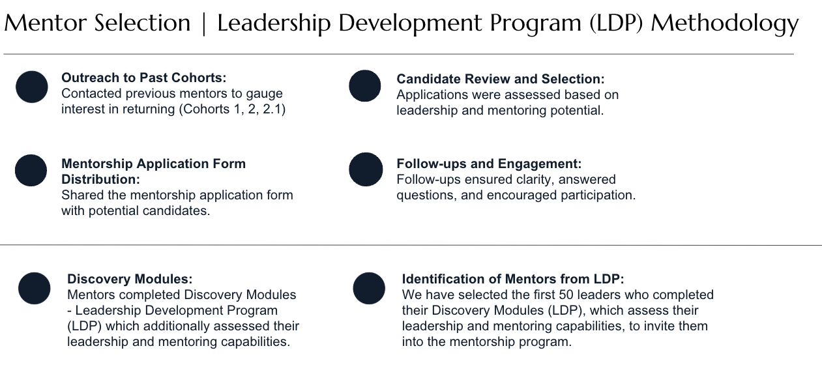
* Section on report about tool
  + Out of scope but we decided to offer nesma for pilot and be able to scale for renewals, allowing us to do xyz, explain how to use, put right after results, add pics, annex and link to it. Nice tech words for it too.
* Dates on how long it took for each phase

**Outline**

At the start of the report we say these were the initial phases of the contract or “project plan” and we optimized and added lots of stuff and more things out of scope to show we went above and beyond and changed them to the following and this is how it looks like now (have a table showing the old outline of phases to the new outline below).

Really highlight how we went above and beyond and developed a whole tool out of scope and also list other things we did out of scope.

* Disclaimer:
  + At the start of the report we say these were the initial phases of the contract or “project plan” and we optimized and added lots of stuff and more things out of scope to show we went above and beyond and changed them to the following and this is how it looks like now (have a table showing the old outline of phases to the new outline below).
  + Really highlight how we went above and beyond and developed a whole tool out of scope and also list other things we did out of scope.
* Executive Summary
* Part 1: Preparation & **Setup**
  + Phase 0: Inception and mobilization same without comm plan
    - Start date
    - Objectives
    - Governance
    - Ways of working
  + Phase 1: Job Description Analysis
  + Phase 2: Skill Identification & Categorization
  + Phase 3: Dashboard Creation per Job Description (D1–D13)
  + Phase 4: Stakeholder Feedback & Validation
* Part 2: Exercise & **Build**
  + Phase 5: Kick off of communication plan
    - LDP Workshop Video
  + Phase 6: Discovery-Tools
  + Phase 7: PDP Build
* Part 3: Analysis and Way Forward (**Guide**)
  + Phase 8: Analysis
    - 3 Parts
      * Leaders in right places
      * What are the skill gaps
      * How are we gonna fill that gap
  + Phase 9: Implementation Tool kit
    - What is the tool
    - How to use
    - Link
  + Phase 10: Training Roadmap
  + Phase 11: Key Learnings Points and Way Forward

**Leadership Development Program (LDP) Final Report***Comprehensive Project Management Report – IVY & Company*

**Cover Page**

* Title, Date, Nesma & Partners, IVY & Company Logo
* Confidentiality disclaimer

## **[Intro] Executive Summary**

**[Intro.1] Program Overview**Purpose of the LDP  
What was assessed (leadership, EQ, soft skills)  
Overall goals: role fit, capability, training strategy

*"The program was designed to answer three critical questions posed by Nesma & Partners:"*

* Are our leaders currently in the right roles based on their behavioral and leadership profiles?
* What leadership and interpersonal skills are missing or underdeveloped?
* What clear, strategic roadmap should HR follow to address these gaps and enable future readiness?

**[Intro.2] Key Challenges**

* Face-to-face workshop removed → slower timeline
* Engagement variability
* Timeline delays due to self-paced execution

**[Intro.3] High-Level Results (Teasers)**

* % in right roles
* Avg. EQ, LIS
* Key gaps
* Mentorship potential

**[Intro.4] Strategic Recommendations Preview**

* Resume F2F model
* Targeted training programs
* Mentor-mentee initiative
* Real-time tracking dashboard

## **[Intro] Program Scope and Objectives**

**[Intro.5] Why the Program Was Initiated** Nesma & Partners engaged IVY & Company to assess 100 managers using dual-assessments and deliver actionable development plans tied to role fit, soft skills, and leadership capabilities.

**[Intro.6] Scope Overview**Describes assessments (MANSSA & MEIQ), dashboards, grouping logic, and key deliverables including reports, communication strategy, and 6-month support.

**[Intro.7] Project Phases**List of all phases from Phase -1 to Phase 8, briefly describing the goal and activities of each phase.

## **[Phase -1] Kickoff, Communication Plan & Program Launch**

The pre-implementation phase laid the strategic foundation for the Leadership Development Program (LDP), ensuring cross-functional alignment, trust, and early engagement among key stakeholders. **Phase -1** comprised three subcomponents:

**[1.1]** Kickoff and Orientation Meetings

**[1.2]** Communication Strategy and Tools

**[1.3]** Workshop Video and Engagement Preparation.

**[Phase -1.1] Kickoff and Orientation Meetings**

The program officially commenced on September 18, 2024, with a kickoff meeting bringing together leadership from both Nesma & Partners and Ivy & Company. Attendees included Houssam (Head of HR), Amani (Senior Lead), Abrar (Project Manager), and the Ivy project team. The session served to align stakeholders on the overarching vision of the program and establish mutual clarity around expectations, timelines, and deliverables.

Key discussion points included the leadership development goals, the two-part assessment process (Leadership Style and Emotional Intelligence), and the co-development of personalized dashboards. The team also confirmed the program's intended outcomes: supporting leadership growth, identifying development opportunities, and contributing to long-term talent planning.

From this meeting, three critical agreements were reached:

1. The program would target an initial cohort of 100 managers.
2. All communications would adopt a non-evaluative tone, focused on growth and transparency.
3. A co-branded communication strategy would be implemented to foster trust and increase participation rates.

This kickoff marked the formal transition from planning to operational readiness, with leadership endorsement secured across all levels.

A key milestone during this phase was the presentation of the **“**[**100 LDP Dashboard Categorization**](https://drive.google.com/file/d/1ER8CUqob_sL5ObdDDW2rp7R4xwvKdrlb/view?usp=sharing)**”** document. This file introduced the proposed grouping of the 100 managers into 13 dashboards, based on job role similarities and leadership exposure. Each group was assigned a tailored skill map, classifying relevant competencies into three categories: Critical, Necessary, and Beneficial. The purpose was to ensure that the assessments and resulting dashboards would reflect the distinct functional and leadership profiles across the organization.

This categorization file was submitted to HR for review and feedback. Their validation ensured that the grouping logic and selected skills aligned with Nesma’s internal job architecture and organizational priorities. This early consultation served to strengthen trust in the assessment outputs and align the analytical framework with internal HR knowledge.

The kickoff meeting also covered project scope, high-level timelines, and key phases. It set the tone for a structured and data-driven engagement process, with strong collaboration between Ivy & Company and Nesma’s HR leadership.

**[Phase -1.2] Communication Strategy and Tools**

Between October and November 2024, a joint [communication strategy](https://drive.google.com/file/d/1ATZp0PkJMPG5GrDxnM8pAevIx6VY1dvW/view?usp=sharing) was developed to ensure clarity, alignment, and engagement throughout the rollout. Weekly planning sessions were held between Ivy & Company and Nesma’s HR and Communications teams to finalize the internal messaging framework and build communication assets.

The communication approach emphasized a supportive, non-judgmental tone. Key themes included manager empowerment, leadership growth, and the confidential nature of the assessments. To support consistency, detailed communication tools were prepared, including:

* [Email templates](https://drive.google.com/file/d/1EVnzRagApSSviRbyHsNxAFkMsyled5nB/view?usp=sharing) for launch and reminder cycles;
* An internal [FAQ](https://drive.google.com/file/d/1yR-j9u8EZ0iJBjvoXUyx1LNEI7Ho4RGA/view?usp=sharing) to equip leaders with all necessary information regarding the LDP program;

**[Phase -1.3] Workshop Video and Engagement Prep**

To complement written communications and enhance engagement, a pre-recorded workshop video was developed in **November 2024** and finalized by **early December**. This video replaced the originally proposed live workshop, offering a flexible, asynchronous format that allowed leaders to engage with the content at their own convenience.

The [LDP Workshop](https://www.canva.com/design/DAGZQ-CZMnI/3EShZasZJ20gjbwR-BrCfw/watch?utm_content=DAGZQ-CZMnI&utm_campaign=designshare&utm_medium=link2&utm_source=uniquelinks&utlId=h9f9e04e872) introduced the Leadership Development Program and its purpose, while also providing foundational learning on two key dimensions: **Leadership Styles** and **Emotional Intelligence (EQ)**. These topics were selected to build awareness around the behavioral insights that the assessments would uncover, reinforcing their relevance to leadership effectiveness at Nesma & Partners.

The session was led by **Prof. Paris de L’Etraz** and **Prof. Gaelle Bou Abdo**, with opening contributions from Ivy & Company Project Managers **Lola Tohme** and **Trinity Wildenstein**. In addition to the instructional content, the video introduced the Ivy team to participating managers, ensuring familiarity ahead of future communications.

The tone of the workshop was transparent and supportive, addressing common concerns while emphasizing the **confidential**, **developmental**, and **non-evaluative** nature of the initiative. It also previewed the structure and anticipated outcomes of the program to help managers understand what to expect.

The video was **iterated several times based on detailed feedback from the Nesma HR team**, ensuring the final version accurately reflected HR’s role and reinforced the program’s alignment with organizational goals.

In parallel, the final **program launch email package** was completed. This package included:

* A personalized welcome message
* A concise program overview
* A link to the LDP Workshop
* Clear next steps for completing the discovery-tools

The package was reviewed and approved by all stakeholders in **mid-December 2024**, finalizing the preparation phase and paving the way for the program's formal launch.

## **[Phase 0] Job Description Analysis**

**[Phase 0.1] Collection and Review of Job Descriptions**

The LDP began with the collection of [job descriptions](https://drive.google.com/drive/folders/1i0PyD4y2vY1_xjPfeT9oEWuY-Gs-LgxK?usp=sharing) from the 100 Leaders of the program, shared via a live folder managed by Nesma’s HR team. These represented leadership roles across all business units. IVY’s HR and Product Innovation teams manually reviewed each job description to ensure it was clear, current, and appropriate for classification. No duplications or clarifications were required.

**[Phase 0.2] Functional Role Mapping**

Roles were categorized using a two-axis logic:

* Job Function: The operational domain (e.g., Engineering, Finance, Operations, Strategy).
* Leadership Level: The scope of influence (e.g., Executive, Senior Manager, Manager).

This enabled IVY to understand both what the role does and how influential it is in the organization.

**[Phase 0.3] Dashboard Clustering Logic**

Roles were then mapped into 13 dashboards (D1–D13) using a role-function tree designed by IVY. Each cluster grouped roles with similar behavioral expectations and leadership demands.

This tree, now referred to as the “[LDP Dashboard Job Function Tree](https://drive.google.com/file/d/1dp42rMdEDALFTEd0qYKpYQmjl1QHbicm/view?usp=sharing),” served as the structural backbone of the program. It allowed the program to scale with accuracy while maintaining role specificity.

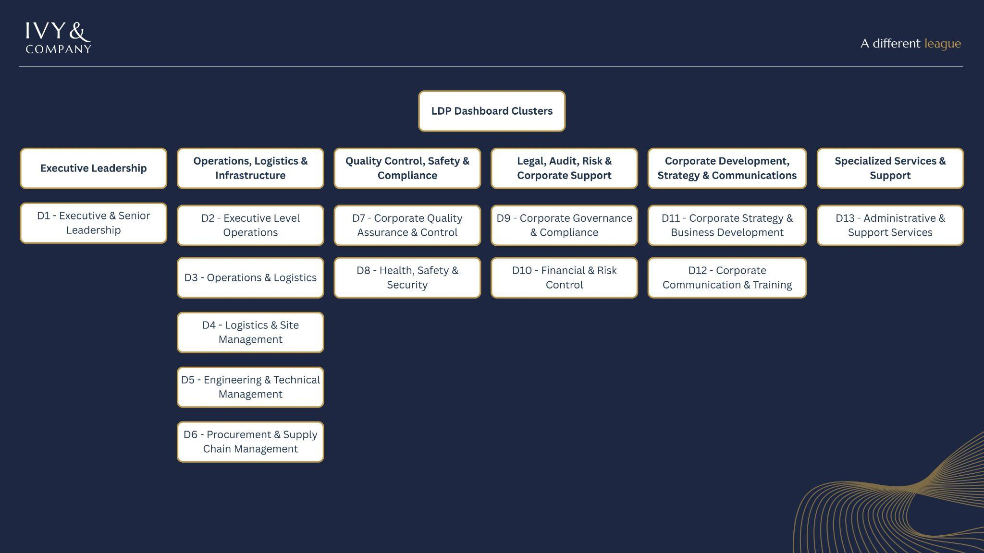

## **[Phase 1] Skill Identification & Categorization**

**[Phase 1.1] Soft Skill Longlist Development**

A list of 52 validated soft skills that reflect behavioral competencies relevant to leadership and emotional intelligence. These included communication, conflict resolution, strategic thinking, delegation, emotional regulation, and more. For each job cluster, we assigned approximately 15 of those skills across three performance tiers:

* **Key Skills**: Weighted highest in scoring, these skills were deemed mission-critical to success in the role. They often involved strategic leadership, communication under pressure, and problem-solving.
* **Useful Skills**: Mapped to operational and team efficiency. They support daily task execution, such as delegation, organization, or feedback delivery.
* **Supplemental Skills**: Skills that increase adaptability and leadership range but are not essential to baseline performance-e.g., charisma, patience, or recruitment.

**[Phase 1.2] Tiering Logic (Key, Useful, Supplemental)**

Each of the 13 dashboards included ~15 skills, evenly distributed across the three tiers (typically 4–6 per pool). The classification was determined by:

* Frequency of use in the role (how often the skill is applied day-to-day
* Importance to success (how crucial the skill is to excelling in that role)

|  |  |  |
| --- | --- | --- |
| **Skill Type** | **Definition** | **Score Threshold** |
| Key | Frequently used and critical to job performance | ≥ 85% |
| Useful | Valuable in enhancing leadership effectiveness | ≥ 70% |
| Supplemental | Helpful traits that support adaptability and depth | ≥ 60% |

*Example: For an engineering leader, technical problem solving was more “Key,” while strategic visioning was categorized as “Supplemental.” In contrast, for an executive leader, the reverse was true.*

These thresholds were used later to calculate the **Leadership Index Score (LIS)** and flag skill gaps at both the individual and departmental levels.

Skill tier assignment was based on:

* **Functional frequency** (job description language and day-to-day relevance)
* **Strategic weight** (impact on business outcomes)
* **Hierarchical relevance** (e.g., EQ is Key in stakeholder-facing roles)

Read more about this section 6B.5

**[Phase 1.3] Role-Specific Mapping of Soft Skills**

After tiering the soft skills into Key, Useful, and Supplemental categories, the next step was to assign these skills to role families based on their functional and behavioral demands. This mapping process ensured that the relevance of each skill was evaluated within the actual context in which the role operates—without generalizing or flattening behavioral expectations across functions.

Rather than using a fixed template of competencies, IVY applied a flexible logic that considered:

* The primary responsibilities and challenges of each job function
* The leadership behaviors implicitly required by those responsibilities
* Patterns in behavioral language across job descriptions (e.g., emphasis on collaboration, influence, or execution).

This ensured, for example, that a soft skill like “Delegation” might be considered a Key skill in a mid-level project delivery role, but only a Useful or Supplemental skill in a highly strategic or executive-facing role. The result was a competency-to-role mapping that allowed skills to be interpreted functionally, not just theoretically—ensuring that assessment results could later reflect role-specific strengths and needs, and not just universal competency levels.This layer of role-level behavioral translation was fundamental to designing a skill architecture that would later allow for accurate comparison across clusters, departments, and leadership levels.

## **[Phase 2] Stakeholder Feedback & Validation**

**[Phase 2.1] Feedback on Content Dashboard**

Following the internal development of the 13-dashboard structure and associated skill tiering methodology, IVY & Company engaged in multiple alignment meetings with Nesma’s Human Resources and Communications teams. The proposed framework—outlined in the “[100 LDP Dashboard Categorization](https://drive.google.com/file/d/1ER8CUqob_sL5ObdDDW2rp7R4xwvKdrlb/view)” document—presented a logic-driven structure that mapped roles into clusters, assigned relevant soft skills, and established performance thresholds across Key, Useful, and Supplemental tiers.

Feedback was reviewed in collaboration with key stakeholders, including **Karim Jazzar**, Director of Human Resources. The feedback received was constructive and supportive. No changes were requested to the structural design of the dashboards, and the methodology was confirmed as appropriate and relevant. Positive input was also shared by the internal Communications team regarding tone, phrasing, and clarity of language—particularly around terms like “leader” versus “manager” and “discovery tool” versus “assessment.”

Based on this input, minor wording adjustments were implemented across the dashboard interface and supporting communications. These refinements ensured consistency with internal terminology and reinforced engagement through clear, audience-appropriate language. The final version of the dashboards reflects a shared understanding between IVY and Nesma stakeholders of what effective, role-relevant leadership assessment should look like in practice.

Old: While early drafts of this report referenced stakeholder interviews, in practice, no external feedback sessions or individual consultations were conducted as part of the skill validation process. Instead, IVY & Company led an internal validation and synthesis process, drawing on the submitted job descriptions, organizational hierarchy, and behavioral data modeling to ensure the proposed dashboards and skills structure reflected Nesma’s internal landscape.

The dashboard clustering logic and skill tiering methodology were consolidated into a formal proposal document titled “[100 LDP Dashboard Categorization](https://drive.google.com/file/d/1ER8CUqob_sL5ObdDDW2rp7R4xwvKdrlb/view).” This deliverable included:

* A breakdown of 13 proposed dashboard clusters (D1–D13)
* Sample role assignments per cluster
* Tiered soft skill frameworks per role category (Critical, Necessary, Beneficial)
* Behavioral logic behind each skill’s inclusion (e.g., conflict management in logistics; risk-taking in strategic roles)
* Application use-cases for assessment scoring and development planning

This document was then shared with Nesma’s HR leadership as the final validation artifact.

Once the full set of soft skills was selected and tiered internally by IVY’s team, the next step was to ensure that the **relative importance of each skill**—as defined by its tier (Key, Useful, Supplemental)—accurately reflected the behavioral expectations of the leadership roles within Nesma.

This internal review focused on refining:

* The **weighting logic** applied to each tier in the scoring model
* The **scoring thresholds** used to determine performance benchmarks
* The **distribution of skills per tier** across all dashboards

Each tier was reviewed through the lens of:

* **Strategic relevance** (e.g., Strategic Thinking = Key for executives, Useful elsewhere)
* **Behavioral necessity** (e.g., Conflict Resolution = Key for project delivery, not for communications)
* **Role sensitivity** (e.g., Emotional Intelligence emphasized more in people-facing roles)

**[Phase 2.2] Line Manager Report Feedback**

**[Phase 2.3] Feedback on HR Report**

Finally, IVY issued a [Technical Proposal](https://drive.google.com/file/d/1ePEHRA4WHU6I5h73fMmxAsUgCjWtSfxM/view?usp=sharing) outlining the final dashboard clusters, skill groupings, and assessment logic.

The proposal was approved by Nesma’s HR team, ensuring that internal alignment and executive sponsorship were secured prior to assessment deployment.

**[Phase 2.4] Draft Report Samples for Internal Approval**

As part of the program implementation and prior to full-scale data analysis, two sample reports were developed and shared with Nesma stakeholders to validate the structure, tone, and utility of the reporting outputs:

* [**Sample HR Report**](https://drive.google.com/file/d/10EC6gdtzj4_4TdBDpbJxF0tkMBZz6nxi/view?usp=sharing)This preliminary draft was designed to illustrate how group-level findings would be presented to HR. It showcased key insights from manager assessments, identified priority growth areas, and outlined recommended training actions. Initially created as a dashboard page, it was later converted into a document format for improved clarity and usability.
* [**Sample Line Manager Report**](https://drive.google.com/file/d/11eXU-wDNxfWwWbxVmwcn_ihKsLRTpCTg/view?usp=sharing)Aimed at helping senior managers support their teams, this sample outlined practical tips for interpreting the dashboards and setting actionable goals with their direct reports. It served as a prototype for future targeted communications tailored to senior leadership.

These drafts were shared to ensure alignment with stakeholder expectations and to collect input ahead of final report production.

## **[Phase 3] Dashboard Creation per Job Description (D1–D13)**

The success of the LDP hinged on the development of dashboards that were not only standardized in structure but also deeply customized in content to reflect the leadership realities of each job function. Dashboards were built using the job-function tree presented in the “100 LDP Dashboard Categorization” document, and their logic was applied across all 100 participating leaders.

**[Phase 3.1] Functional and Hierarchical Clustering**

The 100 leaders assessed were drawn from a wide range of business units, each operating within distinct functional mandates and leadership scopes. Job descriptions were grouped using a two-dimensional logic:

* Functional Domain – e.g., Engineering, Strategy, Operations, HSSE, Communications
* Seniority Level – e.g., Executive, Senior Manager, Manager

These classifications were cross-referenced and assigned to one of 13 functional dashboards (D1–D13), each designed to reflect the soft skill profile required for success within that cluster. The clustering ensured that individuals with similar behavioral expectations were assessed against consistent standards, without generalizing across unrelated roles.

Please refer to the “[LDP Dashboard Job-Function Tree](https://drive.google.com/file/d/1dp42rMdEDALFTEd0qYKpYQmjl1QHbicm/view?usp=sharing)” to see the clustered dashboards.

**[Phase 3.2] Custom Dashboard Logic**

Each dashboard contained a structured mix of ~15 soft skills, grouped into three tiers (Key, Useful, Supplemental), which had already been internally tiered and weighted in earlier phases. These skills were pre-mapped to each dashboard—not assigned dynamically after assessment. This approach guaranteed that the discovery tools would assess only those behaviors that mattered most to each role type.

The dashboards were deployed using Dash, IVY’s internal platform, which automated the generation of personalized dashboards for each participant. All dashboards pulled from a shared backend matrix but were customized on the front end for:

* Skill definitions and tier structure
* Scoring visuals and logic
* Development resource mapping
* Language refinements (e.g., "leader" vs. "manager", "discovery tool" vs. "assessment")

Each dashboard output also included:

* Leadership Index Score (LIS)
* EQ breakdown across five domains
* Leadership Style classification
* A personalized development plan (PDP), tailored to the leader’s individual results

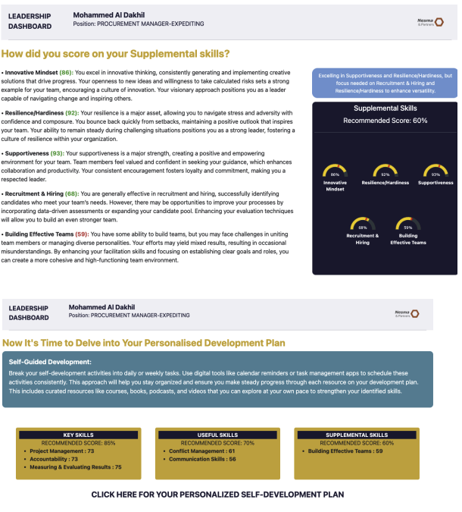

*Example: Personalized Development Plan (PDP) Generated from Discovery-Tools*

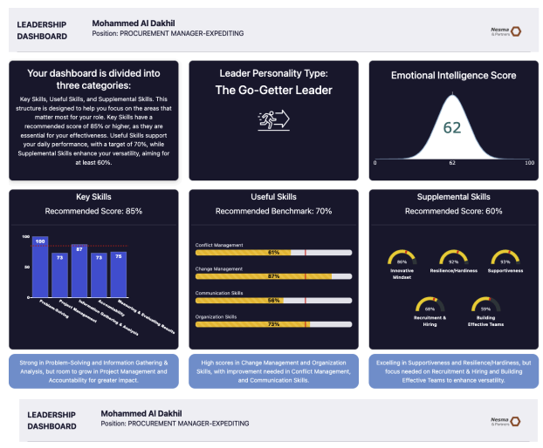

*Leader Skill Score Summary*

Click Here To View the [Full Automated Dashboard’s Structure and Layout](https://drive.google.com/file/d/1XcXZaYcgRXXITht8FEi1FgnxUTmdxgG-/view?usp=sharing)

**[Phase 3.3] Dashboard Comparison Framework**

Beyond their individual function, the dashboards were also designed to support cross-comparison across clusters. This allowed IVY and Nesma to:

* Benchmark departments against one another (e.g., D3: Operations vs. D5: Engineering)
* Group leaders into development cohorts based on dashboard and performance profile
* Identify trends and outliers in LIS, EQ, and skill gaps by role type

The dashboards thus served not just as individualized feedback tools, but also as strategic infrastructure for HR planning, enabling pattern recognition, training prioritization, and role-based succession tracking across all assessed departments.

## 

## **[Phase 4] Leader Self-Assessment (Original Scope)**

**[Phase 4.1] Develop and Distribute Self-Assessment Tools**

The original scope of the Leadership Development Program included a Leader Self-Assessment intended to encourage early self-reflection. The purpose was to gather leaders’ perceptions of their own skills, strengths, and areas for growth before the formal assessments began. This data would have been analyzed in conjunction with the MANSSA and MEIQ results to identify awareness gaps and compare self-perception with objective insights.

**[Phase 4.2] Planned Data Collection and Analysis**

The tool was designed as a structured questionnaire to be completed by all 100 participating leaders. It would have enabled the LDP team to generate comparative analytics across self-reported and externally assessed competencies, offering valuable delta insights into self-awareness and alignment with actual performance indicators.

**[Phase 4.3] Scope Adjustment and Replacement**

Following strategic discussions with Nesma & Partners, it was decided that the addition of a third discovery-tool might lead to survey fatigue and reduce overall engagement. Given the robust diagnostic capacity of the MANSSA and MEIQ discovery-tools, the self-assessment was deemed non-essential and formally removed from the program scope.

To maintain developmental value, the self-assessment phase was replaced with a pre-recorded [LDP Workshop](https://www.canva.com/design/DAGZQ-CZMnI/3EShZasZJ20gjbwR-BrCfw/watch?utm_content=DAGZQ-CZMnI&utm_campaign=designshare&utm_medium=link2&utm_source=uniquelinks&utlId=h9f9e04e872) (see Phase -1.3), which introduced key concepts in leadership, emotional intelligence, and the overall goals of the LDP. This workshop served to build shared understanding, reinforce the program’s purpose, and spark personal reflection—thus preserving the intent of the original self-assessment phase in a more accessible and engaging format.

## **[Phase 6] Discovery-Tools and Individual Dashboard Development (MEIQ & MANSSA)**

**[Phase 5.1] Discovery Workshop Launch and QR Tracking**

The formal launch of the Leadership Development Program took place on January 8, 2025. On this date, each Leader received a personalized email containing the pre-recorded LDP Workshop Video (see [Phase -1.3]). This video provided an overview of the program structure and explained key concepts including Leadership Styles and Emotional Intelligence—core constructs explored in the upcoming Discovery-Tools.

To track participation, the video included a QR code displayed at the end. Scanning this code was mandatory to gain access to the Discovery-Tools (MANSSA and MEIQ). This mechanism ensured that only those Leaders who had completed the video and understood the program’s purpose could proceed. Once a QR code scan was recorded, the Ivy & Company team released access to the Discovery-Tools.

**[Phase 5.2] Assessment Constructs and Flow**

Upon verification of LDP Workshop video completion, each Leader received their access credentials for the two Discovery-Tools: MANSSA (Leadership Skills) and MEIQ (Emotional Intelligence). These tools are scientifically validated, measuring the Leader’s capabilities across predefined skill constructs.

The discovery results fed directly into each Leader’s personalized dashboard. Each dashboard featured:

* Skill scores normalized to a 100-point scale
* Behavioral insights and key strengths
* A personalized PDP (Personal Development Plan)
* Strategic resources, including recommended books, TED Talks, online courses, and action steps
* A roadmap tailored to each Leader’s job role and skill level (Beginner, Intermediate, Advanced)

The recommendations varied in complexity depending on the Leader’s expertise and job context—technical vs. functional—ensuring relevance and feasibility.

**[Phase 5.3] Engagement Monitoring Metrics**

Although the initial timeline targeted a one-week window for video completion and a second week for the Discovery-Tools, the flexible nature of the program resulted in extended participation timelines. Many Leaders delayed action, citing workload and time constraints.

To manage this, Ivy & Company implemented a detailed engagement tracker in Excel. This tracker recorded:

* Workshop video completion via QR data
* Discovery-Tool completion status
* Time-to-complete metrics
* Dashboard delivery status

Progress was communicated weekly to NESMA through formal status updates, with breakdowns of participation and pending tasks. To ensure progress, NESMA’s internal team—led by Abrar—escalated issues to Line Managers when required. This escalation strategy significantly improved completion rates in the final stages.

In parallel, Ivy & Company developed an **Engagement Calculator** to quantify and monitor Leader responsiveness using six behavioral metrics:

|  |  |  |  |
| --- | --- | --- | --- |
| **Component** | **Description** | **Max Points** | **Weight (%)** |
| QR Code Scanned | Whether the Leader scanned the code at the end of the workshop video | 25 | 25% |
| Discovery-Tools Completed | Completion of both MANSSA and MEIQ Discovery-Tools | 25 | 25% |
| Speed of Completion | Normalized by days taken from launch to completion | 20 | 20% |
| Proactive Communication | Leader-initiated emails (2 pts/email, max 10 pts) | 10 | 10% |
| Reminders Received | Deductions applied for each reminder sent (-1 point per reminder) | -10 | Up to -10% |
| Line Manager Escalation | Deduction if Line Manager escalation was needed due to inactivity | -5 | -5% |

The **total engagement score** ranked leaders from 0 to 100. This framework enabled real-time identification of low-engagement Leaders and allowed the team to adapt follow-up and escalation strategies accordingly.

**[Phase 7] PDP Development**

A cornerstone of the Leadership Development Program (LDP) was the creation of a dynamic Personal Development Planner (PDP) integrated into each leader’s dashboard. This component translated diagnostic outputs into actionable learning, enabling leaders to engage with relevant development material tailored to their individual performance profiles.

#### **7.1 Overview of PDP Logic**

The PDP was designed as a behaviorally driven, threshold-based recommendation engine. It used assessment scores from each leader’s Discovery-Tools to identify development areas and assign tailored content for self-guided improvement. Development plans were structured to be modular, scalable, and personalized, ensuring high relevance across job clusters and leadership tiers.

#### **7.2 Skill Threshold Framework**

The foundation of the PDP engine was a structured threshold model aligned to the three skill pools used throughout the program:

* **Key Skills**: Threshold set at 85%
* **Useful Skills**: Threshold set at 70%
* **Supplemental Skills**: Threshold set at 60%

Each leader’s scores were benchmarked against these thresholds. Any skill falling below its pool-specific cut-off triggered a development recommendation. Additionally, if no score was below the threshold, the PDP automatically surfaced the five lowest-performing skills for ongoing improvement.

#### **7.3 Customization Logic by Score Band**

To ensure cognitive and developmental alignment, PDP recommendations were stratified by score band. Each skill below threshold triggered a content recommendation based on its performance level:

* **1–24**: Foundational resources (entry-level learning)
* **25–49**: Intermediate content (skill-building emphasis)
* **50–74**: Advanced resources (performance refinement)
* **75–100**: Expert insights (expansion and leadership excellence)

This allowed content relevance to scale with the leader’s proficiency, avoiding under- or over-challenging recommendations.

#### **7.4 Content Architecture**

Each skill’s recommendation included curated resources across four categories:

* **Books**: Industry-relevant readings for deeper learning
* **TED Talks**: High-impact thought leadership videos for behavioral insights
* **Online Courses**: Structured learning paths (e.g., Coursera, LinkedIn Learning)
* **Influencers**: Thought leaders to follow for continuous exposure

An additional layer of practical tips and “tactical nudges” was included to help leaders implement concepts in daily work. This resource mix ensured multimodal learning: conceptual, visual, interactive, and reflective.

#### **7.5 PDP Development Methodology**

The full PDP system was built through a hybrid process:

* **Manual Design**: Subject matter experts and HR specialists from IVY & Company designed the full resource map per skill and score band. All resources were screened for cultural and organizational relevance.
* **Automated Deployment**: Once finalized, the PDP resource database was linked to the scoring engine. Based on each leader’s normalized Discovery-Tool results, the system automatically pulled the correct resource set per skill and score range into their dashboard.

#### **7.6 Visual and Interactive Design**

The PDP interface was visually structured for clarity and usability:

* Each skill pool was color-coded (Key, Useful, Supplemental)
* Skills under threshold were clearly flagged
* Resource links were embedded for direct access
* Each PDP began with a simple onboarding explanation (see screenshot), followed by modular content cards for each low-performing skill
* Leaders could explore their content independently and at their own pace

#### **7.7 Supporting Consistency Across Dashboards**

While each leader’s PDP was unique, the underlying architecture was standardized across the 13 types of dashboards. This allowed HR to monitor development at both the individual and cluster level, and maintain consistency in content quality and score-to-intervention mapping.

## **[Phase 8] Gap Analysis, Key Results & Training Action Plan**

### **LDNA Framework (Lead Section of Phase 8)**

### **[Phase 8A] Key Results & Metrics**

**[8A.5] Executive Insights Recap (Answers to 3 Key Questions)**

1. Are leaders in the right roles?
   1. Higher LIS, more role fit
   2. Leadership type for LIS - Link to mentorship
   3. EQ
   4. Skill Gaps
2. Yes but how to improve: What are the skill gaps? Analysis per job,d etc
3. How to fill the gaps: Way forward and recommendation
   1. Training roadmap
   2. Line Manager report
   3. Tools to help leaders work on themselves
      1. Individual = PDP
      2. line manager= line manager report
      3. HR = Training plan + clusters
      4. organization level = LDNA, mentorship program, renewal of LDP, executive training, etc.

**[8A.1] Role Alignment Summary**

**Objective:** Assess whether Nesma & Partners' leaders are well-matched to their current roles, using LIS (Leadership Index Score) as a proxy for leadership alignment and readiness.

* % of leaders well-matched to their roles
* Identification of potential misalignments by cluster

**Methodology**

**Key Metric:** Leadership Index Score (LIS) LIS is calculated using the following weighted composite formula:

**Benchmark for Alignment:** A LIS score of 75 was used as the alignment threshold, categorized as follows:

* **85–100:** Strong Fit
* **75–84:** Solid Fit
* **70–74:** Needs Support
* **<70:** Potential Misalignment

**Scope of Review:**

* Data from 82 individual leaders across 12 functional dashboard groups (D2 to D13)
* Job-role complexity from the provided organizational job tree
* Comparative typology analysis

**Overall Findings**

**Role Alignment by LIS Band:**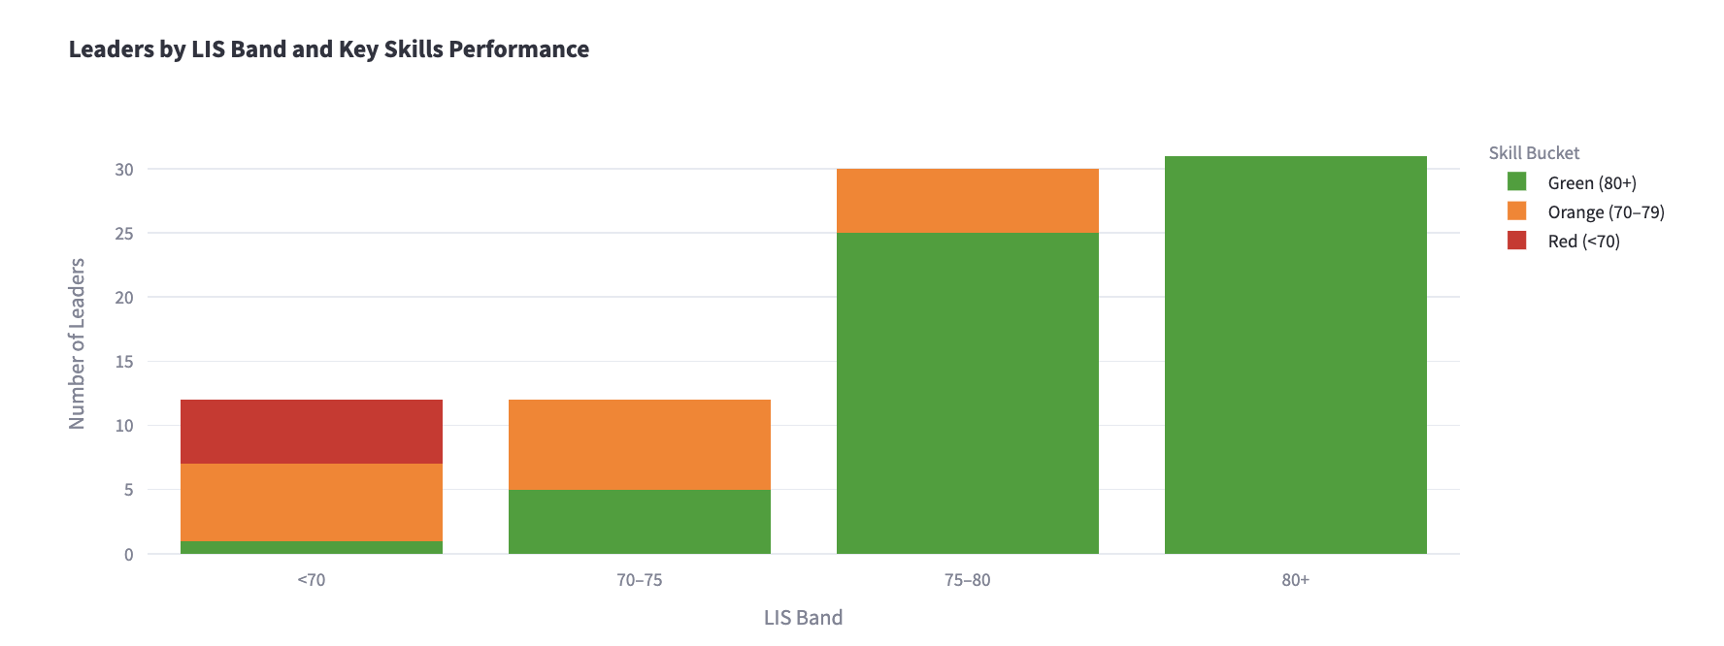

* **Strong Fit (85–100):** 28 leaders (34.1%)
* **Solid Fit (75–84):** 35 leaders (42.7%)
* **Needs Support (70–74):** 13 leaders (15.9%)
* **Potential Misalignment (<70):** 6 leaders (7.3%)

**Conclusion:** 76.8% of leaders are reasonably well-aligned (LIS ≥75). 23.2% may be underperforming or misaligned to current roles.

**Dashboard-Level Insights: Misalignment Patterns**

**D3: Senior Operations & Logistics**

* Avg LIS: ~73.5
* Outliers: Hefni Fathy Yosry (57.0)
* Several leaders in the 70–75 range
* **Insight:** Divided cohort with role-person mismatches among Visionary and Middle-of-the-Road leaders.
* **Action:** Flag low-performers for reassessment and assign targeted coaching.

**D4: Logistics & Site Management**

* Avg LIS: ~78.9 | Median: ~79
* Leaders below threshold: Alhasan Naif (73.3), Attia Mohamed (70.7)
* **Insight:** Large cluster in Solid Fit band. Minor cases of low readiness exist.
* **Action:** Monitor leaders near threshold and initiate skill coaching if needed.

**D5: Engineering & Technical**

* Avg LIS: ~76.4 | Range: 64.3 to 91.6
* Leaders below threshold: Abu Ahmadeh Ali (64.3), Bshara Ayham (64.9)
* **Insight:** Performance variance reflects inconsistency in role-fit.
* **Action:** Underperformers require reassessment; LIS suggests either training gaps or misalignment.

**D9: Corporate Governance & Compliance**

* Both leaders below LIS 70: Qassem (65.2), Shihab (67.5)
* **Insight:** Small group, but both misaligned. EQ and soft skills underdeveloped.
* **Action:** Priority intervention area. Targeted EQ coaching and potential role reassignment.

**D12: Communications & Training**

* LIS Range: 64.3 to 90.5
* Outlier: Alsultan Salsabeel (64.3)
* **Insight:** High variance. Presence of both top talent and misaligned leaders.
* **Action:** Consider structural review or strategic coaching for underperformers.

**D7: Quality Assurance**

* LIS Median: 77.7 | Low performer: Sqair Mohammad (72.5)
* **Insight:** Solid middle-tier performance. One at-risk leader.
* **Action:** Recommend soft-skill development and mentoring for borderline performers.

**Cross-Dashboard Alignment Trends**

* **D11, D2, D13, D10:** Median LIS > 80  
  Indicate excellent role alignment and maturity. Ideal benchmarks for other clusters.
* **D3, D4, D5, D6, D7, D12:** Median LIS between 73 and 79  
  Reflect consistent, but uneven leadership readiness.
* **D9:** Median LIS < 70  
  Signals systemic misalignment in role allocation or support.

**Strategic Insights**

* **76.8% of leaders are well-aligned to roles.** However, the remaining 23.2% show clear gaps in LIS and core competencies. Many of these gaps are rooted in emotional intelligence and behavioral execution.
  + You can view the [excel](https://docs.google.com/spreadsheets/d/1jRDZxPJeDF2-Q_kz0DicrsWfxatFGrTFLraHIk8fhpI/edit?usp=sharing) of the leaders and the breakdown of who is well-aligned and not.
* **Mentoring Leaders** consistently show the highest LIS and are well-suited for formal mentorship roles.
* **Leadership Typology Correlation:**
  + Mentoring Leaders: Avg LIS ~83–85
  + Go-Getter/ Visionary: Wider variability
  + Hands-Off, Middle-of-the-Road, Permissive: Consistently below 72

**Insight:** Typology is a reliable predictor of readiness. Underperforming leadership styles should be flagged for reassignment or intensive coaching.

**Recommendations**

1. **Realignment for Sub-70 LIS Leaders:** Immediate follow-up and HR review required.
2. **Dashboard-Specific Interventions:** D3, D5, D9, and D12 to be prioritized.
3. **Typology-Aware Assignments:** Avoid placing Hands-Off/Permissive leaders in high-stakes or developmental roles.
4. **Mentorship Mapping:** Leverage high-LIS Mentoring Leaders in D2, D11, D13 as internal development anchors.

**[6A.2] Skill Gaps & Development Needs**

* Top missing skills by dashboard group
* Skills below threshold (with heatmap or table)

**[6A.3] Training Roadmap Highlights**

* What HR needs to prioritize
* Most common training archetypes (e.g., “Delegation Support Group”)

**[6A.4] Mentorship Potential Analysis**

In addition to assessing leadership readiness and skills gaps, the LDP was used as a mechanism to identify internal mentors for the N&P Mentorship Program. Mentorship readiness was determined through a structured, multi-step methodology that blended quantitative assessment with qualitative engagement.

Leaders were evaluated for mentoring potential using the following criteria:

* High performance in Discovery-Tools (LIS and EQ scores above threshold)
* Leadership Style alignment with mentoring behaviors (e.g., Coaching, Visionary)
* Strong engagement (top 25% in the Engagement Calculator)
* Demonstrated interest and proactiveness in communications

Out of the 100 participating Leaders, **the first 50 to complete both Discovery-Tools** were reviewed for mentoring suitability. This early completion indicated not only high engagement but also commitment to personal development—both essential traits in effective mentors.

This resulted in the identification of a **core mentor pool**, which will serve as the foundation for future peer support initiatives and mentorship pairing strategies.

### **[Phase 6B] LDNA Interpretation & Development Plan**

**LDNA Framework (Overview)**

**[6B.1] What is LDNA and Why It Matters**

The Leadership DNA (LDNA) Index is a behavioral analytics framework developed by IVY & Company to quantify and visualize leadership capability across an organization. It functions as an integrative diagnostic tool, aggregating multi-dimensional data from emotional intelligence, competency scores, engagement behavior, and leadership style assessments to form a high-resolution map of leadership readiness.

Rather than producing a singular score, the LDNA Index is constructed from a series of normalized behavioral indicators—referred to as “leadership chromosomes”—that capture the structure, strengths, and developmental gaps within a given leadership population.

This model is used to answer a central organizational question:

“Does our current leadership composition align with the behavioral standards and future capabilities we need as an organization?”

The LDNA Index enables organizations to:

* Assess leadership alignment against role expectations
* Identify strategic and developmental gaps across departments, clusters, or business units
* Diagnose patterns in leadership style, soft skill depth, and emotional intelligence capacity
* Inform the design of personalized development plans, targeted training initiatives, and mentorship frameworks
* Move from reactive people management to proactive, data-driven leadership design

LDNA is particularly relevant for organizations aiming to formalize succession planning, establish behavioral benchmarks, or align leadership performance with cultural and strategic priorities. It serves as both a diagnostic tool and a foundation for long-term talent strategy.

**[6B.2] Formula, Weights, and Normalization Logic**

The Leadership DNA (LDNA) framework is a diagnostic model designed by IVY & Company to assess and map leadership readiness across multiple behavioral dimensions. It provides a structured, data-driven lens through which organizations can evaluate the alignment between leadership behavior and role expectations—without reducing performance to a single metric.

LDNA is composed of independent behavioral and cognitive dimensions, each acting as a functional “chromosome” in an organization’s leadership genome. These include cognitive readiness, emotional intelligence, interpersonal effectiveness, leadership style, engagement, values alignment, and developmental load. Rather than averaging them into a single score, LDNA treats each component as a normalized indicator—allowing for high-resolution behavioral diagnostics.

#### Formulaic Structure (Non-Weighted Composite Model):

Each variable is scored on a 100-point scale, ensuring consistent comparison across participants and clusters. The absence of fixed weights in the pilot phase allows for interpretive flexibility and context-specific prioritization.

While future iterations of LDNA may assign role- or company-specific weights to individual components, the current configuration supports objective, comparative diagnostics. Organizations may later use these inputs to model their *desired* LDNA and identify gaps between aspirational leadership norms and actual behavioral data.

While initial prototypes of LDNA explored weighted scoring models, the current approach reflects a more evolved, flexible diagnostic methodology grounded in empirical implementation. Rather than forcing an artificial hierarchy across behavioral attributes, the model treats each input as a distinct domain—what we call behavioral "chromosomes."

For the purpose of this pilot at Nesma & Partners, the LDNA was constructed as a composite diagnostic framework drawing from the following behavioral dimensions:

* Leadership Index Score (LIS)
* Emotional Intelligence Profile (EQ)
* Skill Tier Scores (Key, Useful, Supplemental)
* Leadership Style Classification (from MANSSA)
* Engagement Metrics (completion rates, responsiveness)
* Training Load Requirements
* Values Alignment Proxy Indicators

These dimensions form the foundational structure:

Each component is normalized to a 100-point scale to ensure consistency and comparability across metrics. This structure is not a weighted average; it is a modular behavioral profile enabling cross-dimensional analysis. The model is intentionally unweighted in this pilot phase to preserve neutrality and allow for interpretive flexibility.

Crucially, the **ideal LDNA** for any organization should be defined top-down. It must reflect the organization's strategic direction, leadership philosophy, and cultural values. Future implementations at Nesma may incorporate custom weightings across LDNA dimensions to align more closely with evolving leadership expectations—such as prioritizing innovation, resilience, or influence depending on business context.

In this configuration, LDNA becomes a scientific lens through which leadership readiness, cultural alignment, and strategic gaps can be visualized and managed with precision.

**[6B.3] LDNA Visual Summary and Strategic Value**

In the full LDP presentation to Nesma, we went one step further: we built a company-level LDNA based on observed behavioral patterns across the 100 participants.

Each segment of the LDNA corresponds to a behavioral domain:

* Cognitive readiness (LIS)
* EQ capacity
* Soft skill depth
* Engagement behavior
* Training load
* Alignment with Nesma’s core values
* Leadership style distribution

These segments allow HR to:

* Visualize the current behavioral DNA of the leadership population
* Spot systemic gaps (e.g., low delegation across all operations managers)
* Identify cultural traits (e.g., high consistency but low innovation in strategy)
* Build focused development programs that reflect real needs, not assumptions

**[6B.4] HR and Organizational Use Cases**

LDNA is more than a diagnostic—it’s an organizational intelligence layer that allows HR and senior leadership to:

* Define the optimal LDNA based on Nesma’s strategic vision, values, and cultural identity
* Compare that “desired” LDNA with the actual behavioral DNA observed in the current leadership cohort
* Detect misalignments between role expectations and exhibited behaviors
* Build and assign mentorship structures, training cohorts, and future-focused coaching interventions
* Anchor succession planning and promotion pathways in behavioral evidence, not just performance reviews

Note: This approach enables LDNA to scale flexibly and be tailored per function, business unit, or succession track—supporting both individual development and strategic workforce planning.

**[6B.5] Leadership Index Score (LIS)**

The Leadership Index Score (LIS) is a composite readiness metric used to quantify a leader’s alignment with their current role requirements. It integrates emotional intelligence and soft skill proficiency using a tier-weighted structure.

The LIS is calculated using the following formula:

All component scores are normalized to a 100-point scale prior to aggregation. The resulting LIS offers a single interpretable score reflecting behavioral and cognitive leadership capacity.

The scientific basis for the weighting structure applied in LIS reflects the relative contribution of each dimension to overall leadership effectiveness, supported by a broad body of evidence from industrial-organizational psychology, leadership competency modeling, and emotional intelligence research:

Emotional Intelligence (EQ) – 40%

Emotional intelligence is widely recognized as a critical differentiator in leadership performance, especially in roles requiring high relational, adaptive, or cultural demands. According to Goleman (1998), EQ accounts for nearly 90% of the difference between star performers and average ones in senior leadership roles. Additionally, research by Cherniss (2010) and Boyatzis et al. (2000) supports the inclusion of EQ as a primary predictor of interpersonal effectiveness, conflict management, and influence—core traits in leadership contexts. High EQ supports role flexibility, team alignment, and sustained effectiveness under pressure.

Key Skills – 30%

These are core behavioral competencies mission-critical to the role. Derived from the Key Performance Behaviors (KPB) methodology used in many leadership assessment centers (e.g., Korn Ferry Leadership Architect), these are typically the most heavily weighted in any job-specific competency model. Performance in these domains is directly correlated with the leader’s ability to drive outcomes and meet expectations.

Useful Skills – 21%

These competencies support task execution, communication, and team cohesion but may not be universally essential across roles. Weighting at 21% recognizes their supportive value without overstating their criticality. This balance aligns with approaches from the Hay Group competency cluster system, which distinguishes between essential and contributing behaviors. Strong Useful Skills contribute to operational efficiency and reduce friction in execution.

Supplemental Skills – 9%

While not role-critical, these skills reflect leadership depth, style, and flexibility. They include traits like charisma, curiosity, or storytelling—often seen as differentiators, not requirements. Their lower weight is consistent with frameworks like the Lominger 67 Competencies and Deloitte’s Leadership Dimensions Matrix, where supplemental traits are typically used in succession planning or senior-level leadership coaching. These enhance long-term adaptability and upward mobility, but are not central to core role fit.

The LIS allows for scalable benchmarking of leadership readiness across functions, levels, and future cohorts. Its integration of cognitive, interpersonal, and task-related domains makes it both a performance predictor and a coaching starting point.

In future versions, weighting coefficients can be recalibrated based on:

* Organizational maturity and change-readiness
* Functional vs. transformational leadership emphasis
* HR and executive input regarding evolving leadership priorities

**[6B.6] Emotional Intelligence (EQ)**

Emotional intelligence was assessed using the Multi-Dimensional Emotional Intelligence Questionnaire (MEIQ), which measures five key domains: self-awareness, self-regulation, motivation, empathy, and social skill.

EQ results are integrated into the Leadership Index Score (LIS), where they account for 40% of the overall calculation. While not treated as a separate LDNA component in this version of the model, emotional intelligence remains a foundational input—reflecting a leader’s ability to navigate interpersonal dynamics and adapt behaviorally to complex role demands.

**[6B.7] Soft Skill Proficiency**

Each leader was assessed across approximately 15 soft skills mapped to their job cluster. These were grouped into three performance tiers—Key, Useful, and Supplemental—based on relevance to role expectations.

Proficiency was measured through the MANSSA self-assessment. Scores were normalized to a 100-point scale and analyzed against tier-specific thresholds:

* Key Skills: ≥ 85%
* Useful Skills: ≥ 70%
* Supplemental Skills: ≥ 60%

These scores inform both LIS calculations and training need classification.

**[6B.8] Departmental & Individual Gap Analysis**

Gap analysis was conducted at both the individual and department level by examining each leader’s score against defined skill thresholds. This analysis highlights:

* Skill clusters with widespread underperformance
* Outlier strengths that can be leveraged for peer coaching
* Departments where leadership alignment may require intervention

Results were aggregated by dashboard group (D1–D13) to allow cross-functional benchmarking.

**[6B.9] Personalized Development Plan Logic**

Each leader received a Personalized Development Plan (PDP) automatically generated based on their individual skill scores. Skill performance was mapped to one of four tiers:

|  |  |  |
| --- | --- | --- |
| **Score Range** | **Development Tier** | **Description** |
| 1–24 | Tier 1 | Foundational |
| 25–49 | Tier 2 | Developing |
| 50–74 | Tier 3 | Competent |
| 75–100 | Tier 4 | Advanced |

Each tier was linked to a curated library of resources, including articles, online courses, TED Talks, and expert frameworks. This ensured development recommendations were both relevant and scalable.

**[6B.10] Engagement Index and Metrics**

The Engagement Index was designed to quantify behavioral engagement throughout the LDP experience. It captures both responsiveness and initiative, offering a normalized score out of 100.

The index is composed of the following weighted dimensions:

* **Workshop Completion (25%):** Verified via QR code scan at the end of the video
* **Discovery Tool Completion (25%):** Scoring tiers based on partial (0–12.5%) or full (25%) completion of both assessments
* **Speed of Completion (20%):** Faster turnaround received higher scores based on a normalized days-to-completion scale
* **Proactive Communication (10%):** Credit assigned for unsolicited email questions or engagement with IVY team
* **Responsiveness Penalties**
  + Reminders Sent: -1% per reminder
  + Escalation to Manager: -5% deduction

The final Engagement Index reflects a leader’s developmental orientation, punctuality, and professional ownership of their participation. High scores indicate readiness for further initiatives such as mentorship or coaching, while lower scores highlight disengagement risk or internal communication breakdowns.

This behavioral dimension was treated as a discrete input within the broader LDNA model and will support future initiatives in cohort segmentation, readiness forecasting, and personalized development pacing.

**[6B.11] Values Alignment Proxy Indicators**

While no formal values-based assessment was administered, proxy indicators were extracted from behavioral patterns and skill profiles. These included:

* Consistency across key leadership behaviors
* Strength in interpersonal and communication domains
* Disposition toward learning, adaptability, and self-regulation

These were analyzed qualitatively and quantitatively to assess cultural alignment with Nesma’s stated values. Future LDNA iterations may incorporate direct value calibration modules for enhanced accuracy.

### **[Phase 6C] Strategic Recommendations**

[6C.1] Department-Level Training Maps  
[6C.2] Recommended Interventions (Training, Coaching)  
[6C.3] Mentor Pool Identification and Strengths Summary  
[6C.4] HR Forecasting and Cohort Strategy

## **[Phase 7] Group Report & Action Plan**

**[Phase 7.1] Delivery of Personalized Dashboards  
[Phase 7.2] Group-Level Analytics by Cluster and Job Role  
[Phase 7.3] Executive Summary Report for Leadership**

## **[Wrap-Up] Lessons Learned & Program Optimization**

**[Wrap-Up.1] Observations from Self-Paced Delivery  
[Wrap-Up.2] Model Improvements for Next Cohort  
[Wrap-Up.3] Impact Projections from Optimization Plan**

## **[Wrap-Up] Conclusion & Strategic Next Steps**

**[Wrap-Up.4] Summary of Findings and Patterns**

**[Wrap-Up.5] Key Strategic Recommendations  
[Wrap-Up.6] Expansion Plan for 400+ Leaders**

## **[Appendix] Appendices**

**[Appendix A.1] Full Leader List with LIS and Component Scores  
[Appendix A.2] Assessment Tools & Screenshots** **[Appendix A.3] Training Resource Index** **[Appendix A.4] Glossary of Terms** **[Appendix A.5] Methodological References**

Sources:

Goleman, D. (1998). *What makes a leader?* Harvard Business Review, 76(6), 93–102. <https://dme.childrenshospital.org/wp-content/uploads/2019/06/What-makes-a-Leader-HBR.pdf>

Cherniss, C. (2010). *Emotional intelligence: Toward clarification of a concept*. Industrial and Organizational Psychology, 3(2), 110–126.<https://www.researchgate.net/publication/229545635_Emotional_Intelligence_Toward_Clarification_of_a_Concept>

Boyatzis, R. E., Goleman, D., & Rhee, K. (2000). *Clustering competence in emotional intelligence: Insights from the Emotional Competence Inventory (ECI)*. In R. Bar-On & J. D. A. Parker (Eds.), *The Handbook of Emotional Intelligence* (pp. 343–362). Jossey-Bass. <https://www.eiconsortium.org/pdf/eci_acticle.pdf>

Korn Ferry. (n.d.). *Korn Ferry Leadership Architect™*. <https://www.kornferry.com/capabilities/talent-suite-hcm-software/korn-ferry-assess/leadership-architect>

Hay Group. (2016). *Hay job evaluation methodology – An overview*. People Centre. <https://peoplecentre.wordpress.com/2016/07/05/hay-job-evaluation-methodology-an-overview/>

Peoplebox. (2022). Lominger competencies: The ultimate guide. <https://www.peoplebox.ai/blog/lominger-competencies/>

FINAL STRUCTURE

**Jargon to check for in document:**

* Leaders, not managers
* Key, Useful, Supplemental Skills
* Discovery-tools, not assessment or self-discovery tools
* Line Managers, not line leaders or senior managers
* Disclaimer:
  + At the start of the report we say these were the initial phases of the contract or “project plan” and we optimized and added lots of stuff and more things out of scope to show we went above and beyond and changed them to the following and this is how it looks like now (have a table showing the old outline of phases to the new outline below).
  + Really highlight how we went above and beyond and developed a whole tool out of scope and also list other things we did out of scope.
* Executive Summary
* Part 1: Preparation & **Setup**
  + Phase 0: Inception and mobilization same without comm plan
    - Start date
    - Objectives
    - Governance
    - Ways of working
  + Phase 1: Job Description Analysis
  + Phase 2: Skill Identification & Categorization
  + Phase 3: Dashboard Creation per Job Description (D1–D13)
  + Phase 4: Stakeholder Feedback & Validation
* Part 2: Exercise & **Build**
  + Phase 5: Kick off of communication plan
    - LDP Workshop Video
  + Phase 6: Discovery-Tools
  + Phase 7: PDP Build
* Part 3: Analysis and Way Forward (**Guide**)
  + Phase 8: Analysis
    - 3 Parts
      * Leaders in right places
      * What are the skill gaps
      * How are we gonna fill that gap
  + Phase 9: Implementation Tool kit
    - What is the tool
    - How to use
    - Link
  + Phase 10: Training Roadmap
  + Phase 11: Key Learnings Points and Way Forward

# **Introduction: Scope Evolution and Value Additions**

At the start of the Leadership Development Program (LDP), a detailed project plan was agreed upon outlining core phases of assessment, analysis, and reporting. Over the course of implementation, **we significantly enhanced and expanded the original scope**. The engagement was restructured into three strategic parts—**Preparation & Setup, Exercise & Build, and Analysis & Way Forward**—with additional phases introduced to deepen insight, personalization, and long-term impact.

As part of these enhancements, **we replaced static PDF reports with live dashboards**, enabling real-time visibility into individual and cohort-level performance, skill gaps, and behavioral trends. In parallel, **we developed a standalone analytical tool** for benchmarking and comparative analysis—allowing HR and leadership to conduct cross-functional evaluations, identify talent patterns, and support data-driven decision-making. This tool, originally out of scope, added a critical layer of strategic intelligence to the program.

To further elevate insight, **we introduced a suite of leadership metrics**, including the **Leadership Index Score (LIS)** and the proprietary **Leadership DNA (LDNA)**—a composite diagnostic that maps each leader’s behavioral fingerprint across emotional intelligence, soft skills, and leadership styles. These tools formed the analytical backbone of the program, allowing us to generate highly tailored development plans, mentorship pipelines, and succession insights across the organization.

|  |  |
| --- | --- |
| **Original Phase In The Contract** | **Revised Phase Name** |
| Launch Program (Preparation Phase): | ***Part 1: Preparation & Setup*** |
| Phase 0: Job Description Analysis | Phase 0: Inception and Mobilization |
| Phase 1: Skill Identification & Categorization | Phase 1: Job Description Analysis |
| Phase 2: Stakeholder Feedback on Skills | Phase 2: Skill Identification & Categorization |
| Phase 3: Dashboard Creation per Job Description | Phase 3: Dashboard Creation per Job Description |
| Phase 4: Manager Self-Assessment | Phase 4: Stakeholder Feedback & Validation |
| Phase 5: Assessment and Individual Dashboard Development | ***Part 2: Activation & Deployment*** |
| Phase 6: Gap Analysis and Training Action Plan | Phase 5: Kickoff of Communication Plan |
| Phase 7: Group Report and Action Plan( Including recommendations) | Phase 6: Discovery-Tools |
|  | Phase 7: Personal Development Plan (PDP) Development |
|  | ***Part 3: Findings & Forw ard Strategy*** |
|  | Phase 8: Analysis |
|  | Phase 9: Implementation Toolkit |
|  | Phase 10: Training Roadmap |
|  | Phase 11: Key Learning Points & Way Forward |

**Out-of-Scope Additions to Improve the Program and Optimize Output**

In addition to the original scope, IVY & Company introduced several enhancements aimed at optimizing program execution and deepening strategic impact. These out-of-scope additions were designed to improve diagnostic precision, elevate the participant experience, and strengthen the program’s long-term value as a leadership development and organizational planning tool.

Development of LDNA (Leadership DNA) Framework

To extend the value of the discovery tool data, IVY developed a proprietary Leadership DNA (LDNA) framework—an organizational-level behavioral index designed to map collective leadership strengths, gaps, and alignment with strategic values. This model served as the foundation for future talent calibration and workforce planning.

For more information on LDNA, please refer to Phase 8: LDNA.

Engagement Calculator to Track Participation Behaviorally

An Engagement Calculator was created to measure leaders’ participation in the program using behavioral inputs such as workshop completion, response time, proactive communication, and escalation events. This tool generated a normalized engagement score used for cohort segmentation and mentoring readiness.

For more information on the Engagement Calculator, please refer to Phase X.

Mentor Pool Selection and Readiness Analysis

Beyond performance scoring, IVY built a logic-based analysis to identify high-LIS, high-EQ leaders with mentoring leadership styles. These individuals were flagged as peer mentorship candidates, forming the foundation of a future mentorship initiative.

For more information on the Mentor Pool Selection, please refer to Phase X.

Executive Summary Dashboards by Stakeholder Type

Customized summary dashboards were designed for different stakeholder audiences—HR, executive leadership, and line managers—highlighting only the most relevant insights for each group. This ensured faster, more targeted decision-making across functions.

For more information on the Summary Dashboards, please refer to Phase X.

Visual Identity and Language Refinements Based on HR Feedback

In response to communications feedback, IVY revised dashboard and platform language (e.g., replacing “assessment” with “discovery tool”) and adjusted layout design elements to enhance clarity, reduce perceived formality, and align with internal tone-of-voice expectations.

For more information on the Language Refinements, please refer to Phase 4.4 Terminology Standardization.

Personalized Training Archetypes and Group Training Maps

To streamline learning strategy, leaders were grouped by development archetype (e.g., “Advanced EQ, Low Delegation”) with recommended tracks for targeted training. This allowed for efficient program design at both the individual and group levels.

For more information on the Training Archetypes and Group Training Maps, please refer to Phase X.

Mentorship Matching Infrastructure

A backend logic structure was developed to facilitate future mentor-mentee matching, factoring in leadership style compatibility, skill gaps, engagement, and role function. This system will enable scalable, data-informed mentorship deployment in future cohorts.

For more information on the Mentorship Matching, please refer to Phase 8: Tools to Help Leaders Work on Themselves.

# **Executive Summary**

**Program Objective**

Purpose of the LDP  
What was assessed (leadership, EQ, soft skills)  
Overall goals: role fit, capability, training strategy

*"The program was designed to answer three critical questions posed by Nesma & Partners:"*

* Are our leaders currently in the right roles based on their behavioral and leadership profiles?
* What leadership and interpersonal skills are missing or underdeveloped?
* What clear, strategic roadmap should HR follow to address these gaps and enable future readiness?

**Program Overview**

***Insert here brief summary of part 1 and part 2 ( all Phases before analysis)***

100 leaders, pilot, online module, customize approach, 13 clusters, skills were customized ( super high level but phases from Set up and Inception all the way to modules and results collected)

**High-Level Results**

* % in right roles
* Avg. EQ, LIS
* Key gaps
* Mentorship potential

**Upskilling and development Strategy**

While the leaders fit their roles and have the leadership indexes required, some skill gaos were analyzed…

* 1) Organization Level Targeted training programs, importance of Mentor-mentee initiative
* 2) Managerial Level - reports
* 3)Leader-level - self-development - investment in resources

**The extra mile and tools/frameworks developed**

* LDNA, LIS etc
* Real-time tracking dashboard

**Key Challenges and improvements for future cohorts**

* 1) Mention Key challenges briefly and learnings (Face-to-face workshop was not approved because of logistics → slower timeline, Timeline delays due to self-paced execution, Engagement variability)
* 2) Mention briefly adjustments and improvements proposed ( ex: Resume F2F model

### **Outline**

1. **Introduction: Scope Evolution & Value Additions**
2. **Executive Summary & Program Objectives**
3. **Program Structure: Original vs. Enhanced Phases**
4. **Out-of-Scope Enhancements**
5. **Part 1: Preparation & Setup**
   * Phase 0: Inception & Mobilization
   * Phase 1: Job Description Analysis
   * Phase 2: Skill Identification & Categorization
   * Phase 3: Dashboard Creation
   * Phase 4: Stakeholder Feedback & Validation
6. **Part 2: Activation & Deployment**
   * Phase 5: Communication Rollout
   * Phase 6: Discovery-Tools
   * Phase 7: PDP Development
7. **Part 3: Findings & Forward Strategy**
   * Phase 8: Analysis
   * Phase 9: Implementation Toolkit
   * Phase 10: Training Roadmap
   * Phase 11: Key Learnings & Future Readiness

# **Part 1: Preparation & Setup**

## **Phase 0: Inception and mobilization**

The Leadership Development Program (LDP) formally commenced on **[Insert Start Date]** with a structured mobilization process between Nesma & Partners and IVY & Company. This foundational phase established the program's core objectives, governance framework, and operating model—ensuring clarity, alignment, and accountability across all stakeholders before execution.

### **Objectives of the LDP**

* Assess leadership capability across soft skills and emotional intelligence
* Determine role alignment using behavioral diagnostics
* Generate data-driven personal development plans (PDPs)
* Equip HR with strategic tools for talent development and succession planning
* Create long-term value through mentoring, training, and engagement initiatives

### **Governance Structure**

The program was jointly governed through a collaborative structure comprising:

* **Client Sponsor**: Housam Ibrahimbasha, Head of HR
* **Client Leads**: Amani Al Ali (Senior Lead), Abrar Alzubail (Project Manager)
* **Client Specialists**: Salam Aljishi (Director of Corporate Communications & CSR), Karim Jazzar (HR Director)
* **IVY Project Team**:
* **Gaelle Bou Abdo** – **Senior Partner-in-Charge** Provides overall strategic direction, ensures delivery excellence, and serves as the executive sponsor for the engagement. Acts as the primary escalation point for the client and drives long-term value creation.
* **Prof. Paris de L’Etraz** – **Senior Partner – Strategic Advisor** Brings deep thought leadership and innovation expertise. Advises on high-level frameworks, executive alignment, and strategic decision-making throughout the project lifecycle.
* **Trinity Wildenstein** – **Project Manager**Responsible for day-to-day project coordination, milestone delivery, and team orchestration. Serves as the central point of contact for operational updates and implementation logistics.
* **Haleema Aboulenein & Lola Tohme** – **HR Specialists**Support content development, dashboard interpretation, and talent insights. Collaborate closely with the client’s HR team to align tools and outputs with organizational needs.
* [Omar Harradi](mailto:oharradi.ieu2024@student.ie.edu) - Data/Tech specialist
* **AndrésGigena** – **HR Consultant** Provides technical input on HR models, supports benchmarking, and advises on the development of personal development plans and organizational capability frameworks.

### **Ways of Working**

* **Co-development Model**: Tools, dashboards, and communications were designed iteratively with feedback loops from Nesma’s HR and Communications teams.
* **Secure File Sharing**: A centralized folder system was used to manage all deliverables, status trackers, and communication assets.
* **Agile Adjustments**: Timeline flexibility was built in to accommodate evolving needs, such as the shift from live workshops to asynchronous video delivery.
* **Weekly Progress Updates**: A structured cadence of progress tracking and reporting ensured transparency and timely stakeholder engagement.

**Kickoff Meeting and Communication Plan Proposal:** Held on September 18, 2024, the kickoff meeting was used to formally initiate the LDP engagement and propose the “[LDP Deployment & Communication Plan](https://drive.google.com/file/d/1ATZp0PkJMPG5GrDxnM8pAevIx6VY1dvW/view?usp=drive_link)” detailing:

* The structure and content of the planned workshop structure
* A sequence of communications, including CEO endorsement and HR onboarding emails
* Milestones for workshop viewing, discovery-tool completion, and dashboard issuance

The plan was reviewed by Nesma’s HR leadership and validated with minor revisions. Based on Nesma’s request to accommodate all 100 participants, the live workshops were replaced with a pre-recorded video format. This final version of the LDP Workshop is covered in **Part 2: Phase 5**.

Early alignment during this kickoff ensured the program approach reflected internal dynamics and leadership sensitivities, securing stakeholder buy-in from the outset.

Decision-making and issue resolution were handled regularly through bi-weekly alignment meetings and transitioning to milestone-based reviews.

## **Phase 1: Job Description Analysis**

The first step in developing a tailored leadership evaluation approach was the analysis of job descriptions to define the final 13 types of dashboards. This ensured that all subsequent evaluations were standardized and role-relevant allowing comparisons between groups.

#### **1.1 Collection and Review of Job Descriptions**

The program began with the collection of [job descriptions](https://drive.google.com/drive/folders/1i0PyD4y2vY1_xjPfeT9oEWuY-Gs-LgxK?usp=sharing) from 100 Leaders across Nesma & Partners, compiled by the HR team into a shared folder. These roles spanned departments such as Engineering, Finance, HSSE, Strategy, and Communications. Each job description was reviewed to confirm clarity, current relevance, and completeness.

#### **1.2 Functional Role Mapping**

Roles were classified using a two-axis framework:

* **Functional Domain** – e.g., Engineering, Finance, HSSE, Operations
* **Leadership Level** – e.g., Executive, Line Manager, Leader

This classification allowed for the clustering of similar roles into functional groupings with comparable behavioral expectations and leadership responsibilities.

#### **1.3 Dashboard Grouping and Clustering**

Using the above classifications, the roles were grouped into 13 types of dashboards, each representing a unique leadership cluster with similar functional responsibilities and behavioral expectations.

This clustering, now referred to as the “[LDP Job Function Tree](https://drive.google.com/file/d/1dp42rMdEDALFTEd0qYKpYQmjl1QHbicm/view?usp=sharing)” formed the foundation for all comparative analysis, enabling standardized benchmarking across similar job roles (i.e., “apples-to-apples” comparison).

## **Phase 2: Skill Identification & Categorization**

Having the 13 dashboard types defined, the next step was to design the skill profile for each cluster. This phase focused on identifying the most relevant behavioral and interpersonal competencies for each leadership group.

### **2.1 Soft Skill Library Development**

A core library of **52 validated soft skills** was used as the baseline for evaluation. These skills reflected behavioral competencies commonly linked to leadership success and included areas such as:

* Strategic Thinking
* Communication
* Emotional Regulation
* Conflict Management
* Delegation
* Decision-Making

**Emotional Intelligence (EQ)** was modeled separately and treated as a standalone domain critical to all roles.

#### **2.2 Skill Tiering Framework**

For each dashboard type, approximately 15 skills were selected and assigned across three performance pools:

* **Key Skills:** Weighted highest in scoring, these skills were deemed mission-critical to success in the role. They often involved strategic leadership, communication under pressure, and problem-solving.
* **Useful Skills:** Mapped to operational and team efficiency. They support daily task execution, such as delegation, organization, or feedback delivery.
* **Supplemental Skills:** Skills that increase adaptability and leadership range but are not essential to baseline performance-e.g., charisma, patience, or recruitment.

These tiers were defined using a standardized logic:

|  |  |  |
| --- | --- | --- |
| **Skill Tier** | **Role Relevance** | **Threshold** |
| Key | Frequently used and critical to job success | ≥ 85% |
| Useful | Valuable for team performance | ≥ 70% |
| Supplemental | Helpful for breadth, but not required | ≥ 60% |

Skill selection per dashboard was based on:

* **Functional frequency** (job description language and day-to-day relevance)
* **Strategic weight** (impact on business outcomes)
* **Hierarchical relevance** (e.g., EQ is Key in stakeholder-facing roles)

## **Phase 3: Dashboard Creation per Job Description (D1–D13)**

The final step in the setup process was the creation of 13 types of dashboards, each tailored to a distinct cluster of roles at Nesma & Partners. This phase combined the functional role clustering (Phase 1) with the skill tiering logic (Phase 2) to build structured, comparable dashboard models.

Each dashboard represents a unique leadership cluster, capturing the role-specific behaviors and competencies required for success. The dashboards allow for benchmarking across Leaders within similar contexts, enabling a standardized apples-to-apples comparison framework.



***Fig. 1.*** *illustrates the distribution of a leader’s scores across Key, Useful, and Supplemental soft skills, mapped to their assigned dashboard. Each bar represents a distinct competency, with score percentages reflecting performance relative to defined proficiency thresholds. This visualization allows both the leader and HR to immediately identify areas of strength, developmental gaps, and alignment with role expectations. See the full* [*Automated Dashboard Sample*](https://drive.google.com/file/d/1XcXZaYcgRXXITht8FEi1FgnxUTmdxgG-/view)*.*

#### **3.1 Competency-to-Role Mapping Logic**

Soft skills were mapped to each dashboard using a contextualized assignment process that considered:

* Core responsibilities in the job description
* Expected leadership behaviors
* Patterns in functional language (e.g., emphasis on collaboration, stakeholder management, or decision-making)

Rather than using a rigid competency template, the design process was adaptive. For example, a skill like **“Delegation”** might be treated as **Key** in a delivery-focused role, but only **Supplemental** in a strategic, visionary role.

#### **3.2 Final Dashboard Structure**

Each of the 13 dashboard types includes:

* ~15 Soft Skills per role cluster
* Grouped into Key, Useful, and Supplemental skill tiers
* Emotional Intelligence (EQ) as a separate behavioral domain
* Role-sensitive thresholds for LIS scoring

This structure formed the basis for all subsequent discovery tool outputs and individualized development plans.

The final skill-tiered dashboards were compiled into the “[100 LDP Dashboard Categorization](https://drive.google.com/file/d/1ER8CUqob_sL5ObdDDW2rp7R4xwvKdrlb/view)” document and submitted to Nesma’s HR team for review. Their validation confirmed the alignment of the dashboards with organizational needs and functional expectations.

## **Phase 4: Stakeholder Feedback & Validation**

The purpose of this phase was to validate the proposed structure, tone, and logic behind the Leadership Development Program (LDP) outputs. Feedback was collected from key stakeholders across Human Resources and Communications to ensure alignment before launching the Discovery-Tools.

#### **4.1 Feedback on Dashboard Content and Terminology**

After consolidating the proposed 13 types of dashboards and associated skill tiering logic in the “100 LDP Dashboard Categorization” document, IVY & Company conducted review meetings with Nesma & Partners’ Human Resources and Communications teams. The document presented:

* A clustering of roles into 13 dashboard types
* Soft skill mapping across Key, Useful, and Supplemental skill pools
* Inclusion of Emotional Intelligence as a core behavioral pillar

Karim Jazzar (Director of Human Resources) and Salam Aljisihi (Head of Communications) both provided positive validation of the content and structure along with other members of the client team. No substantive changes were requested, confirming the internal coherence of the role grouping, skill logic, and behavioral framing. However, minor language adjustments were proposed to better align with internal communication standards.

#### **4.2 Line Manager Report Feedback**

A preliminary version of the [Line Manager Report](https://drive.google.com/file/d/11eXU-wDNxfWwWbxVmwcn_ihKsLRTpCTg/view?usp=sharing) was presented for internal validation. The document was designed to help Line Managers support their direct reports by interpreting dashboard data and guiding professional development. Feedback centered around tone clarity and role sensitivity, which were subsequently integrated. No content changes were requested.

#### **4.3 HR Report Feedback**

A sample [HR Report](https://drive.google.com/file/d/10EC6gdtzj4_4TdBDpbJxF0tkMBZz6nxi/view?usp=sharing) was also developed to demonstrate how group-level insights would be synthesized. The report highlighted key themes across leadership readiness, skill gaps, and proposed training needs. Nesma’s HR leadership validated the content and confirmed its utility as a strategic decision-making tool. Formatting updates were made to improve readability, and versioning was shifted from dashboard-style to a full report format based on internal preferences.

#### **4.4 Terminology Standardization**

To ensure consistency across all communications, reports, and dashboards, the following terminology was formally agreed upon and implemented across the program:

* **Leaders**, not managers
* **Key, Useful, Supplemental Skills**, as defined skill tiers
* **Discovery-Tools**, not assessments or self-discovery tools
* **Line Managers**, not senior managers or line leaders

These terms were adopted program-wide and consistently reflected across all tools, documentation, and stakeholder communication.

# **Part 2: Activation & Deployment**

## **Phase 5: Kick off of communication plan**

This phase marked the formal launch of the Leadership Development Program (LDP) to Nesma & Partners’ 100 participating Leaders. The communication rollout combined strategic messaging, asynchronous instruction, and participation tracking—all designed to maximize clarity, engagement, and compliance.

#### **5.1 Email Sequence and Communication Strategy**

To guide participants through the program and ensure alignment at every stage, IVY & Company developed a structured [email campaign](https://drive.google.com/file/d/1EVnzRagApSSviRbyHsNxAFkMsyled5nB/view?usp=sharing) with a concise [FAQ](https://drive.google.com/file/d/1yR-j9u8EZ0iJBjvoXUyx1LNEI7Ho4RGA/view?usp=sharing) document to equip leaders with all the necessary information regarding the LDP program. Each message was tailored to a specific milestone in the LDP journey and reviewed by Nesma’s HR and Communications teams prior to distribution.

|  |  |  |
| --- | --- | --- |
| **Email** | **Date Sent (Placeholder)** | **Key Message Summary** |
| **CEO Email** | January 6, 2025 | Official endorsement of the LDP by the CEO, positioning it as a strategic initiative aligned with Nesma & Partners' Vision 2030. Encouraged active participation and emphasized leadership growth. |
| **HR Email** | January 6, 2025 | Provided an overview of the LDP structure and upcoming steps. Introduced IVY & Company as the implementation partner and emphasized the importance of completing the Discovery-Tools. |
| **Ivy Email** | January 8, 2025 | Shared access to the pre-recorded LDP Workshop video. Informed Leaders that watching the full video and scanning the QR code at the end was a prerequisite to accessing the Discovery-Tools. |
| **Discovery-Tool Completion Confirmation Email** | Varies by date of step completion by leader | Confirmed receipt of completed Discovery-Tools and informed Leaders that their personalized dashboards were being developed. |
| **Dashboard Access Email** | Varies by date of step completion by leader | Delivered access to each Leader’s personalized dashboard, including their Leadership Index Score (LIS), emotional intelligence insights, and a tailored Personal Development Plan (PDP). |
| **Dashboard Clarification Support Email** | Varies by date of step completion by leader | Provided support to Leaders needing help interpreting their dashboards or using their development plans. |
| **Line Manager Report Email** | Pending to be sent with line Manager Report | Delivered dashboard summaries and PDPs for team members to Line Managers. Included guidance on how to support each Leader's development. |

#### **5.2 The LDP Workshop Video**

To deliver foundational concepts in an accessible format, a pre-recorded [LDP Workshop](https://www.canva.com/design/DAGZQ-CZMnI/3EShZasZJ20gjbwR-BrCfw/watch?utm_content=DAGZQ-CZMnI&utm_campaign=designshare&utm_medium=link2&utm_source=uniquelinks&utlId=h9f9e04e872) video was produced and finalized by early December 2024. This video was developed in response to Nesma’s request for a flexible alternative to a live session, ensuring all 100 Leaders could engage asynchronously.

**The video covered:**

* Overview of the Leadership Development Program
* Introduction to core topics: **Leadership Styles** and **Emotional Intelligence (EQ)**
* Key expectations and benefits of participation
* Emphasis on the confidential and developmental nature of the Discovery-Tools
* Introductions to the IVY team (Prof. Paris de L’Etraz, Prof. Gaelle Bou Abdo, Lola Tohme, Trinity Wildenstein)

To align with internal priorities, the video was iterated several times based on feedback from Nesma’s HR team, with special emphasis added on HR’s central role in the initiative.

#### **5.3 QR Code Verification System**

At the conclusion of the LDP Workshop video, participants were prompted to scan a unique QR code. This served as a verification step to confirm that Leaders had watched the full session before proceeding.

**QR scan logic:**

* Scanning the QR code registered the Leader in our system
* Only after scanning would the Leader receive access to the MANSSA and MEIQ Discovery-Tools
* This ensured all participants had the foundational understanding of the program's objectives before starting their Discovery-Tools

This step acted as a quality control filter to maintain comprehension and accountability prior to data collection. The QR-based tracking also allowed IVY & Company to monitor engagement in real time and tailor reminders based on actual participation.

## **Phase 6: Discovery-Tools**

The Discovery-Tools phase marked a critical diagnostic component of the Leadership Development Program (LDP), enabling data-driven insights into both leadership style and emotional intelligence across the participating cohort. Each leader completed two scientifically validated instruments—MANSSA and MEIQ—which collectively formed the analytical backbone for the dashboards and subsequent development plans.

#### **6.1 Participation Overview**

A total of **85/100** leaders completed both Discovery-Tools. Access to the tools was gated through the successful viewing of the LDP Workshop Video, confirmed via a unique QR code embedded at the end of the session. This ensured that all participants entered the diagnostic phase with the necessary foundational knowledge and context. Completion metrics were continuously monitored through timestamp logs and cross-referenced against video QR scans to maintain accuracy.

#### **6.2 Technical Feasibility and User Experience**

The tools were designed for high accessibility, offering full pause-and-resume functionality. This flexibility enabled leaders to complete their diagnostics in multiple sittings without data loss, minimizing disruption to daily work responsibilities. The average completion time was approximately [INSERT AVG TIME], reflecting a reasonable engagement threshold for executive-level participants. Credentials and access links were issued only after QR verification, reinforcing a sequential, structured participation flow.

#### **6.3 Tool Design and Diagnostic Framework**

The MANSSA (Management Skills and Styles Assessment) tool provided a structured behavioral profile by identifying each leader’s dominant leadership style across a validated ten-typology model. These styles ranged from Mentoring and Visionary to Directive, Hands-Off, and Middle-of-the-Road, capturing both strategic orientation and interpersonal management tendencies. Each leader’s result reflected nuanced insights into how they communicate, delegate, influence, and adapt to organizational demands. These typologies formed the behavioral architecture for understanding performance variability across clusters.

The MEIQ (Mixed Emotional Intelligence Quotient) complemented MANSSA by measuring emotional intelligence across four core domains: identification, facilitation, understanding, and regulation of emotions. The MEIQ’s mixed-methodology design—combining ability and self-perception inputs—yielded a well-rounded snapshot of each leader’s interpersonal maturity and adaptability. These scores directly fed into the calculation of the Leadership Index Score (LIS) and helped shape the EQ component of the LDNA framework.

#### **6.4 Engagement Monitoring and Compliance Strategy**

Engagement during this phase was systematically tracked using a centralized Excel tracker, which captured data on video viewing, discovery-tool access, and completion progress. In collaboration with Nesma’s HR team, IVY & Company coordinated a structured outreach and escalation plan to maintain momentum and accountability throughout the self-paced process.

While initial engagement varied due to workload and scheduling conflicts, the coordinated reminder strategy proved effective in driving completion. Communications were issued jointly by IVY and Nesma, with follow-ups extending to Vice Presidents where necessary. These reminders served both as progress nudges and formal deadlines, reinforcing the importance of timely participation.

**Reminders for Watching the Leadership Workshop Video:**

* Jan 13: IVY – “Watch the Leadership Workshop Video (Due 2 PM Tuesday)”
* Jan 16: IVY – “Reminder: Mandatory Workshop Session”
* Jan 30: HR – “Reminder: Mandatory Workshop Session”
* Feb 4: HR – “Reminder: Mandatory Workshop Session”
* Feb 9: HR – “Reminder: Mandatory Workshop Session”
* Feb 12: HR – “Reminder: Mandatory Workshop Session” + QR Code completion reminder
* Feb 16: HR – “Reminder: Mandatory Workshop Session” + QR Code completion reminder
* Feb 23: HR paused reminders; monitoring continued
* Mar 25: IVY – “Final Reminder – Complete Workshop & Discovery Tools by Mar 27, 3 PM KSA”
* Mar 27: IVY – Repeat of final reminder
* Mar 27: Mr. Houssam (Nesma) escalated to Vice Presidents urging full completion by Mar 31

**Reminders for Completing Discovery-Tools:**

* Jan 22: IVY – “Complete Your Discovery Modules”
* Jan 30: HR – “Complete Your Discovery Modules”
* Feb 4: HR – “Complete Your Discovery Modules”
* Feb 9: HR – “Complete Your Discovery Modules”
* Feb 12: HR – “Complete Your Discovery Modules”
* Feb 16: HR – “Complete Your Discovery Modules”
* Feb 23: HR paused reminders; monitoring continued
* Mar 14: IVY – “Urgent: ARCH Discovery Tools Completion Required Immediately” (Due Mar 18)
* Mar 16: IVY – “Final Reminder: Complete Discovery Tools by Mar 18, 3 PM KSA”
* Mar 25: IVY – “Final Reminder – Complete Discovery Tools by Mar 27, 3 PM KSA”
* Mar 27: IVY – Repeat of final reminder
* Mar 27: Mr. Houssam (Nesma) escalated to Vice Presidents urging full completion by Mar 31

This engagement strategy was not only effective in closing participation gaps but also generated behavioral data used to inform the Engagement Calculator and identify high-initiative leaders suitable for mentorship roles.

## **Phase 7: PDP Development**

A cornerstone of the Leadership Development Program (LDP) was the creation of a dynamic Personal Development Planner (PDP) integrated into each leader’s dashboard. This component translated diagnostic outputs into actionable learning, enabling leaders to engage with relevant development material tailored to their individual performance profiles.

#### **7.1 Overview of PDP Logic**

The PDP was designed as a behaviorally driven, threshold-based recommendation engine. It used scores from each leader’s Discovery-Tools to identify development areas and assign tailored content for self-guided improvement. Development plans were structured to be modular, scalable, and personalized, ensuring high relevance across job clusters and leadership tiers.

#### **7.2 Skill Threshold Framework**

The foundation of the PDP engine was a structured threshold model aligned to the three skill pools used throughout the program:

* **Key Skills**: Threshold set at 85%
* **Useful Skills**: Threshold set at 70%
* **Supplemental Skills**: Threshold set at 60%

Each leader’s scores were benchmarked against these thresholds. Any skill falling below its pool-specific cut-off triggered a development recommendation. Additionally, if no score was below the threshold, the PDP automatically surfaced the five lowest-performing skills for ongoing improvement.

#### **7.3 Customization Logic by Score Band**

To ensure cognitive and developmental alignment, PDP recommendations were stratified by score band. Each skill below threshold triggered a content recommendation based on its performance level:

* **1–24**: Foundational resources (entry-level learning)
* **25–49**: Intermediate content (skill-building emphasis)
* **50–74**: Advanced resources (performance refinement)
* **75–100**: Expert insights (expansion and leadership excellence)

This allowed content relevance to scale with the leader’s proficiency, avoiding under- or over-challenging recommendations.

#### **7.4 Content Architecture**

Each skill’s recommendation included curated resources across four categories:

* **Books**: Industry-relevant readings for deeper learning
* **TED Talks**: High-impact thought leadership videos for behavioral insights
* **Online Courses**: Structured learning paths (e.g., Coursera, LinkedIn Learning)
* **Influencers**: Thought leaders to follow for continuous exposure

An additional layer of practical tips and “tactical nudges” was included to help leaders implement concepts in daily work. This resource mix ensured multimodal learning: conceptual, visual, interactive, and reflective.

#### **7.5 PDP Development Methodology**

The full PDP system was built through a hybrid process:

* **Manual Design**: Subject matter experts and HR specialists from IVY & Company designed the full resource map per skill and score band. All resources were screened for cultural and organizational relevance.
* **Automated Deployment**: Once finalized, the PDP resource database was linked to the scoring engine. Based on each leader’s normalized Discovery-Tool results, the system automatically pulled the correct resource set per skill and score range into their dashboard.

#### **7.6 Visual and Interactive Design**

The PDP interface was visually structured for clarity and usability:

* Each skill pool was color-coded (Key, Useful, Supplemental)
* Skills under threshold were clearly flagged
* Resource links were embedded for direct access
* Each PDP began with a simple onboarding explanation, followed by modular content cards for each low-performing skill. Refer to *Figures 2.1 and 2.2* for an overview of the PDP interface.
* Leaders could explore their content independently and at their own pace

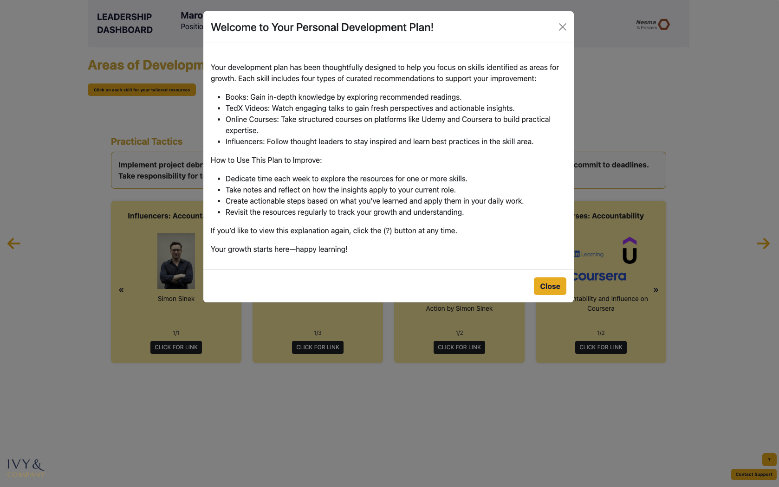

#### ***Fig. 2.1*** *displays the leader’s personalized development plan (PDP) interface, which outlines curated learning resources tied to specific skills identified for growth. Each skill includes actionable content across four formats—books, TED-style videos, online courses, and thought leader recommendations. This structured view guides the leader in self-directed development, reinforcing both insight application and long-term behavioral change.*

#### 

***Fig. 2.2*** *showcases the curated development resources tied to a specific skill—in this case, accountability. Each resource is categorized by format: influencer content, recommended readings, TED-style talks, and structured online courses. The dashboard interface allows users to explore learning materials tailored to their development needs, supporting targeted, self-directed skill improvement. For the full PDP interface, please refer to the PDP Interface.*

#### **7.7 Supporting Consistency Across Dashboards**

While each leader’s PDP was unique, the underlying architecture was standardized across the 13 types of dashboards. This allowed HR to monitor development at both the individual and cluster level, and maintain consistency in content quality and score-to-intervention mapping.

# **Part 3: Findings & Forward Strategy**

## **Phase 8: Analysis**

### **Are leaders in the right roles?**

**Overview**This section addresses the first of three core strategic questions: *Are leaders currently in the right roles based on their behavioral and leadership profiles?* To evaluate this, we analyzed four key dimensions:

* Leadership Index Score (LIS)
* Emotional Intelligence (EQ)
* Leadership Typology
* Skill Gap Performance

**LIS as an Indicator of Role Fit**The LIS represents a composite score that integrates leadership behavior, soft skill proficiency, and emotional intelligence. With a program-wide mean of 77.87, scores were normally distributed across the 100 participants. According to our benchmark:

* **Below Standard**: 8 leaders scored under 67.33 (1.5 SD below mean)
* **Above Standard**: 7 leaders scored above 88.42 (1.5 SD above mean)

Leaders below standard may face challenges with current role demands. While this does not imply automatic misalignment, it flags potential role friction or development gaps. These leaders should be prioritized for immediate intervention, whether through mentoring, training, or potential reassignment.

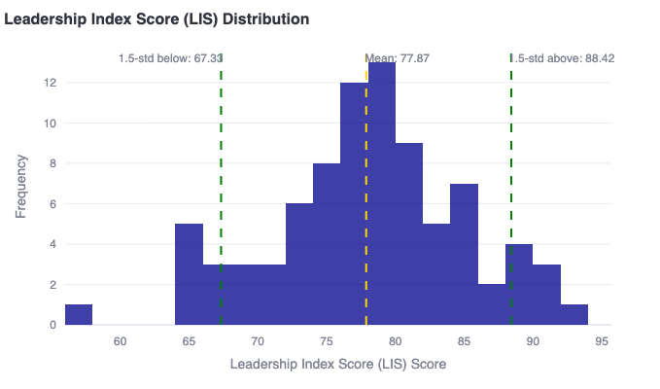

*Fig. 3.1 displays the distribution of Leadership Index Scores across the assessed leadership cohort. The histogram is centered around a mean score of 77.87, with dashed lines indicating 1.5 standard deviations above (88.42) and below (67.33) the mean. This visualization enables clear identification of high- and low-performing leaders relative to the normalized benchmark, supporting cohort segmentation and strategic talent calibration. For the full LIS Distribution Histogram, see Figure A3.1 in Appendix. Further, for the list of below-standard LIS leaders, see Figure A3.2 in Appendix.*

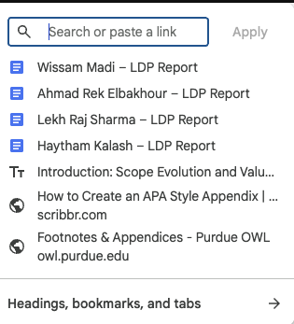

**EQ as a Supporting Competency**Emotional intelligence, treated as a standalone domain, showed wide variability. D2 and D11 clusters led in EQ performance, while D9 trailed significantly (see Figure A2). Since EQ contributes heavily to interpersonal agility, stakeholder management, and conflict resolution, low scores may inhibit leadership effectiveness—particularly in high-collaboration or high-pressure environments.

*Implication:* D9 leaders may be well-positioned in technical roles but need targeted development in emotional agility to succeed in broader leadership contexts.

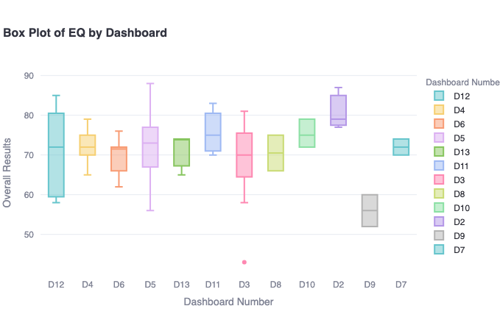

*Fig. 3.3 presents a box plot of overall emotional intelligence (EQ) scores segmented by dashboard cluster. Each box represents the interquartile range, with whiskers indicating score variability and outliers denoted by individual points. This visualization highlights differences in EQ performance across functional groups, allowing for pattern recognition, targeted development planning, and role-specific behavioral insights. To access the full*

**Leadership Style and Role Fit**Leadership typology was examined in tandem with LIS. “Mentoring Leaders” emerged as the highest-performing group, with the highest median LIS and lowest skill gap rates. This supports their suitability for people-focused roles or mentorship responsibilities. Conversely, “Hands-Off” and “Visionary” leaders showed wider LIS ranges and inconsistent skill scores, suggesting either a mismatch between style and responsibilities or unbalanced skill development.

*Implication:* While Visionary styles can excel in strategy roles (e.g., D11, D12), they may underperform in execution-heavy dashboards (e.g., D4, D6). Hands-Off leaders may benefit from stronger goal-setting, accountability, or team coaching.

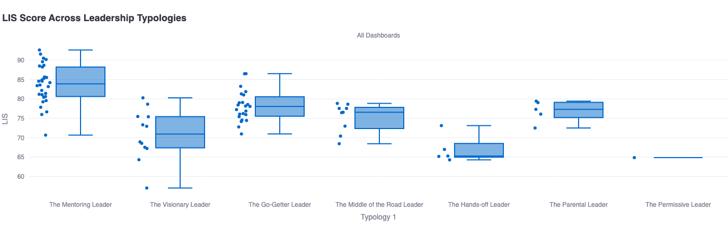

**See Figure A3** for LIS by Typology

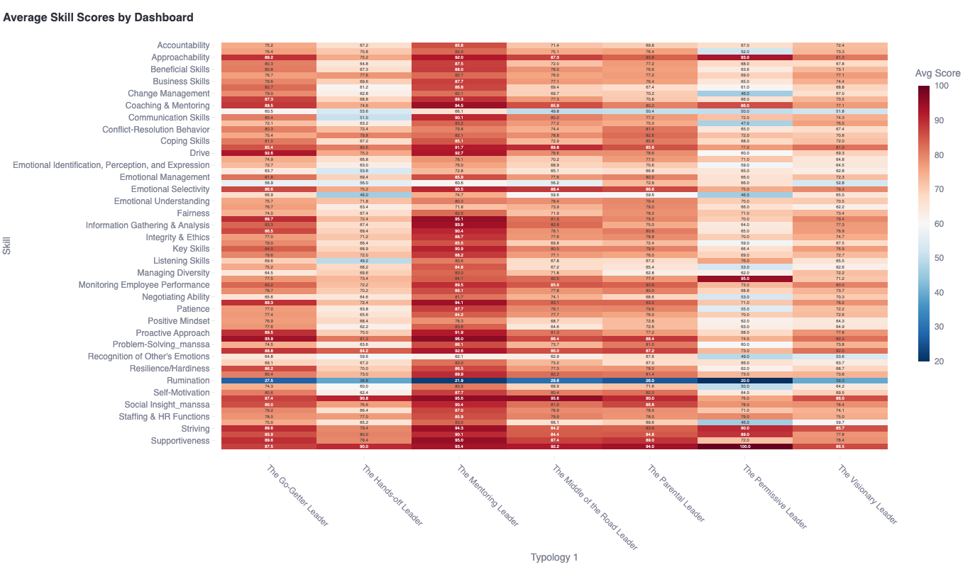**See Figure A4** for Average Skill Scores by Typology

**Skill Gap Patterns & Performance Zones**Analyzing the link between LIS and skill bucket performance (Figure A5) revealed:

* All leaders scoring above LIS 80 had Key Skill performance over 80 (green zone)
* In contrast, ~50% of leaders under LIS 70 fell into “red” skill zones (<70% on Key Skills)

Skill gap patterns further reinforce LIS accuracy in indicating leadership readiness. Notably, the weakest average skill across the cohort was *Emotional Self-Awareness* (52.8), which undermines role fit by limiting adaptability, coaching potential, and relational feedback cycles.

*Implication:* Skill readiness strongly correlates with LIS, and leaders under LIS 70 face both knowledge and behavior-based challenges.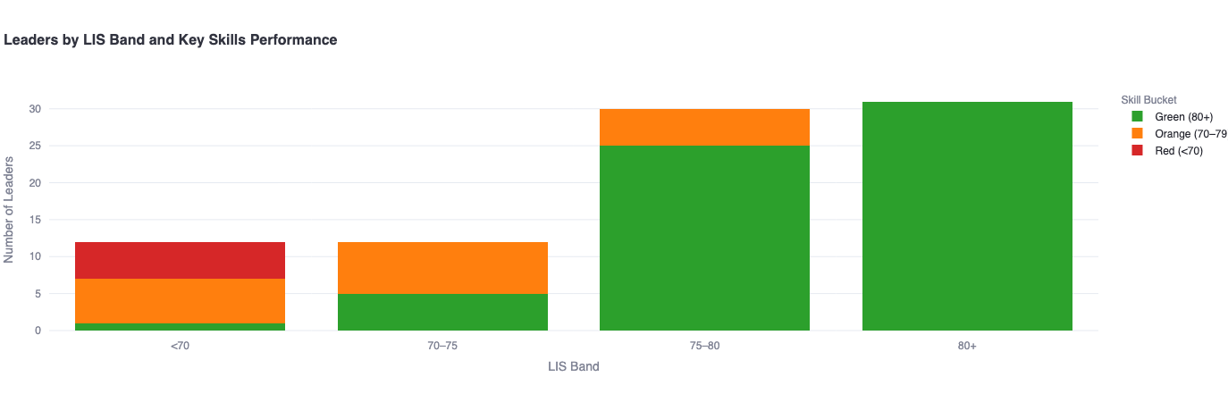

**See Figure A6**: Leaders by LIS Band and Key Skill Performance

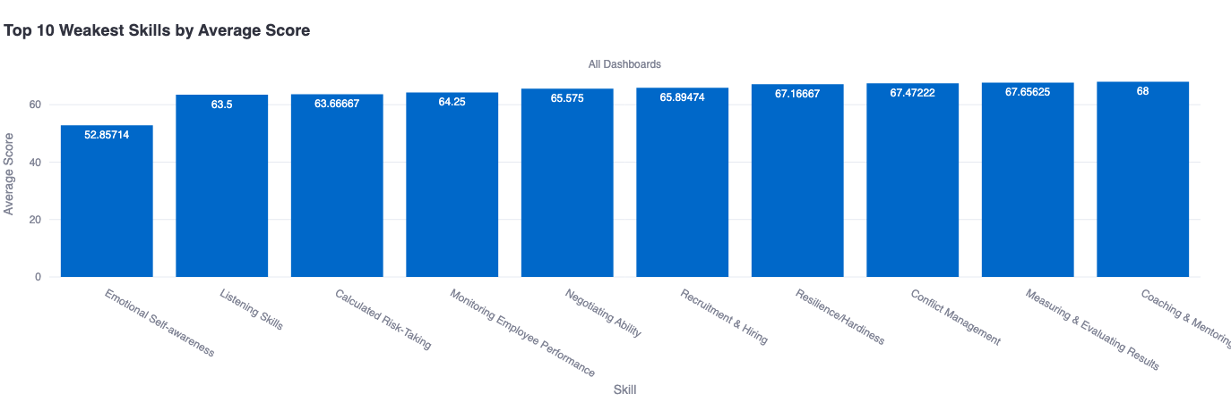

**See Figure A7**: Top 10 Weakest Skills

**Conclusion: Are Leaders in the Right Roles?**The data strongly supports the following conclusions:

* **Yes, the majority of leaders are well-placed.** 85% of participants scored above LIS 70, and skill performance generally matched role expectations.
* **However, there is a small but critical segment (8%) scoring below LIS standards**, with consistently low EQ and skill performance. These leaders require urgent PDP review and targeted support to close readiness gaps.
* **Leadership style should be factored into future talent deployment**—especially when mapping Go-Getters to operations (e.g., D4/D5) and Mentoring leaders to strategic or developmental roles (e.g., D2/D11).
* **Mentoring readiness is a strength.** Over 35% of leaders exhibit Mentoring traits and above-average LIS, reinforcing the case for formal mentorship programs as a development tool.

### **What are the skill gaps**

### **How are we gonna fill that gap**

1. Training roadmap
2. Line Manager report
3. Tools to help leaders work on themselves
   1. Individual = PDP
   2. line manager= line manager report - [Haleema Aboulenein](mailto:haleema@ivy-company.com)
   3. HR = Training plan + clusters
   4. organization level = mentorship program, renewal of LDP, executive training, etc.

## **Phase 9: Implementation Tool kit**

### **What is the tool**

### **How to use**

### **Link**

## **Phase 10: Training Roadmap**

## **Phase 11: Key Learnings Points and Way Forward**

## 

## **Appendix**

Sources:

Goleman, D. (1998). *What makes a leader?* Harvard Business Review, 76(6), 93–102. <https://dme.childrenshospital.org/wp-content/uploads/2019/06/What-makes-a-Leader-HBR.pdf>

Cherniss, C. (2010). *Emotional intelligence: Toward clarification of a concept*. Industrial and Organizational Psychology, 3(2), 110–126.<https://www.researchgate.net/publication/229545635_Emotional_Intelligence_Toward_Clarification_of_a_Concept>

Boyatzis, R. E., Goleman, D., & Rhee, K. (2000). *Clustering competence in emotional intelligence: Insights from the Emotional Competence Inventory (ECI)*. In R. Bar-On & J. D. A. Parker (Eds.), *The Handbook of Emotional Intelligence* (pp. 343–362). Jossey-Bass. <https://www.eiconsortium.org/pdf/eci_acticle.pdf>

Korn Ferry. (n.d.). *Korn Ferry Leadership Architect™*. <https://www.kornferry.com/capabilities/talent-suite-hcm-software/korn-ferry-assess/leadership-architect>

Hay Group. (2016). *Hay job evaluation methodology – An overview*. People Centre. <https://peoplecentre.wordpress.com/2016/07/05/hay-job-evaluation-methodology-an-overview/>

Peoplebox. (2022). Lominger competencies: The ultimate guide. <https://www.peoplebox.ai/blog/lominger-competencies/>

### **1. Structuring the Appendix Scientifically**

**Title**: Use a standalone section titled **Appendix** at the end of your report. If there are multiple components, split them as **Appendix A**, **Appendix B**, etc.

**Contents to Include**:

* All referenced charts, images, tables, and supplementary materials
* Data models, visual frameworks (e.g., LDNA structure)
* Methodological details (e.g., formulae, tiering logic, resource mappings)
* Sample outputs (e.g., dashboard mock-ups, email templates)
* Reference tools (e.g., glossary, acronym list)

**Formatting Tips**:

* Start each appendix on a new page.
* Use consistent numbering (e.g., Figure A1, Table A2).
* Include captions: every image, chart, or table must have a descriptive caption.
* Add source/reference under each item if applicable.

### **2. Referring to Charts, Images, and Figures Throughout the Report**

**Standard Scientific Referencing Format**: When referring to visual elements in the body of the report, follow this format:

“As shown in *Figure A2*, the LIS distribution across leadership clusters reveals clear performance gaps.”

“See *Appendix B* for the full communication rollout email sequence.”

**Refer consistently and early**: Introduce visuals close to when the concept is discussed. Don't bury references after entire paragraphs. Examples:

* “… summarized in *Table 2*.”
* “… visualized in *Figure 3* in *Appendix A*.”
* “… see *Appendix C* for the full dashboard breakdown.”

**Use captions under visuals**: Example:

*Figure A1. LDNA visual framework illustrating the behavioral components mapped to each leadership domain.*

### **3. Labeling Convention for Figures and Tables**

To keep it clean:

|  |  |  |
| --- | --- | --- |
| **Element Type** | **In Main Report** | **In Appendix** |
| Figures | Figure 1, 2… | Figure A1, A2… |
| Tables | Table 1, 2… | Table B1, B2… |
| Charts | Use same as Figures |  |

If you include screenshots or code outputs (e.g., QR scan logs, LIS formula), label them similarly: *Appendix D: PDP Score-to-Content Matching Engine (Figure D1)*.

Training Clusters

Key Metrics

1. Are leaders in the right roles?
2. What skills are missing?
3. What is HR’s clear training roadmap?

Key metrics to analyze for:

Breakdowns: dashboards, jobs, individual leaders

Add button on tool to say ‘compare all group’

* LIS
  + 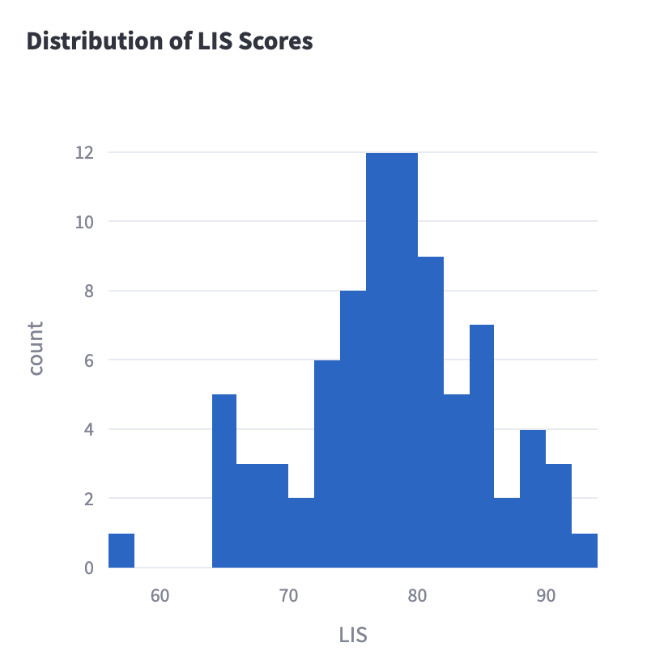
  + Conclusion:
    - It seems the majority of leaders need improvements in their skills relevant to their job category.
* Performance on buckets (key, useful, supplemental skills)
* top 3 skills
  + 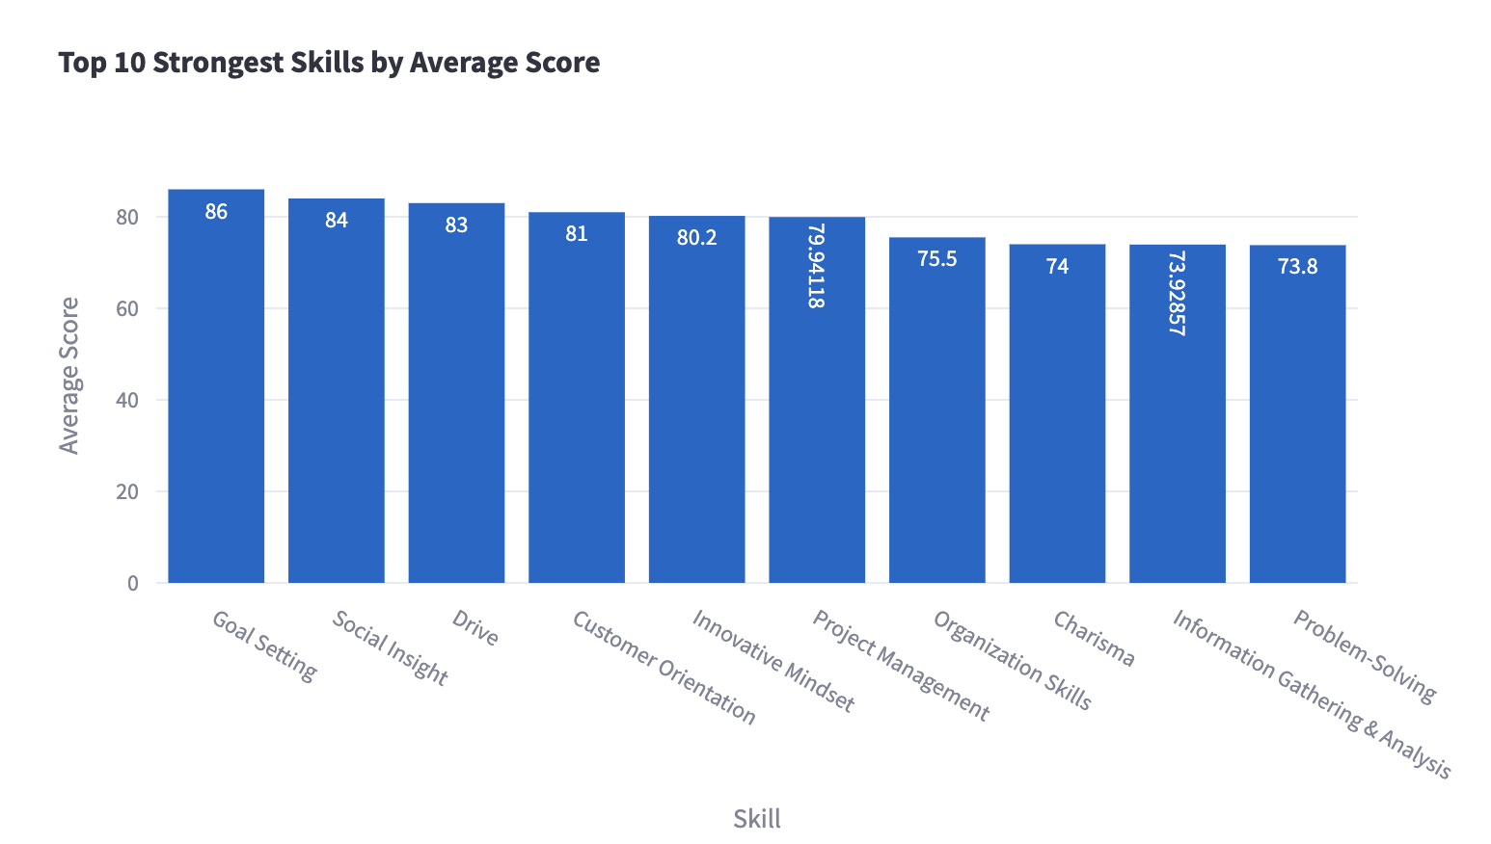
  + Conclusion:
    - These scores suggest strong strategic planning, interpersonal awareness, and motivation.
    - The high average scores for **behavioral and leadership competencies** reflect well on the overall cohort readiness and suggest that Leaders possess a solid foundational capability in areas necessary for role performance and people leadership.
* weakest skills
  + 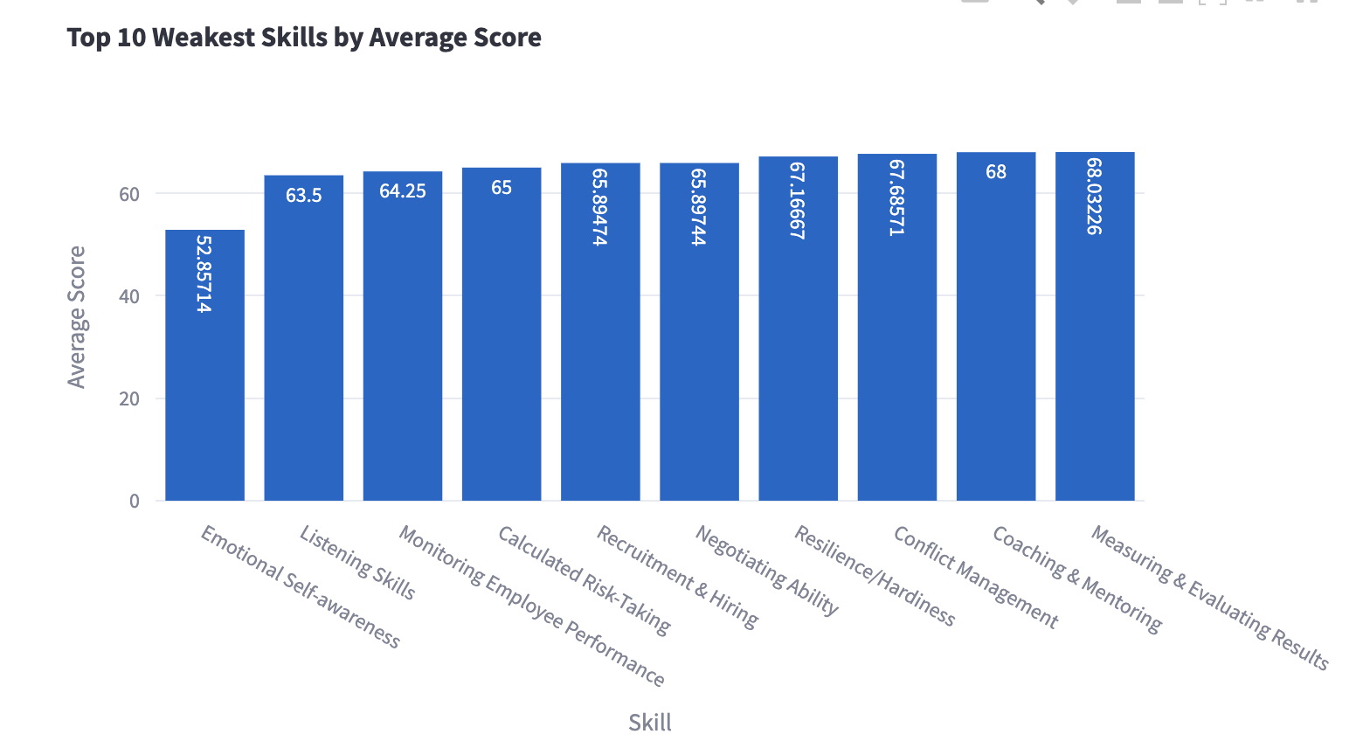
  + Conclusion:
    - **Critical EQ Gap**:
      * **Emotional Self-Awareness (52.9)** is the **lowest scoring skill**.
      * Given that EQ is equally weighted with Key Skills per your updated tiering logic, this is a significant development area.
      * Low emotional self-awareness can impact communication, team morale, and leadership under pressure.
    - **Communication Weaknesses**:
      * **Listening Skills (63.5)** is also among the weakest, suggesting underdeveloped interpersonal sensitivity and two-way communication.
      * Paired with emotional self-awareness, this reflects a **broader empathy and feedback gap**.
    - **People Management Risks**:
      * Skills related to team leadership—**Monitoring Employee Performance (64.3)**, **Recruitment & Hiring (66)**, and **Coaching & Mentoring (68)**—are all under 70.
      * This may **undermine talent development, succession planning, and employee engagement**.
    - **Strategic Soft Spots**:
      * **Calculated Risk-Taking (65)** and **Negotiating Ability (66)** are low.
      * This limits leadership agility and the ability to drive change or advocate persuasively across functions.
    - **Potential Stress/Change Vulnerability**:
      * **Resilience/Hardiness (67.2)** being in the bottom 10 indicates some leaders may **struggle under sustained pressure**, especially in dynamic environments.
    - Interesting Patterns to Highlight in the Report:
* **EQ-Centric Weakness Cluster**:  
   The two lowest scores are **emotional self-awareness** and **listening**, signaling a leadership cohort that may benefit from targeted **EQ coaching and reflection-based workshops**.
* **People Development Weakness Across the Board**:  
   Coaching, mentoring, and performance monitoring are all underperforming. This may hinder the **pipeline of emerging leaders**, and should be prioritized in the **HR training roadmap** and mentorship initiatives.
* **No Skill Above 70 in This List**:  
   Even the highest-ranked "weak" skill, **Measuring & Evaluating Results (68.0)**, falls short of the 70-point threshold used to denote a **Useful Skill**—indicating all these may need intervention.
* general training needs based on Training categorization - Trinity
* Analysis, female to male comparison
* Role to role
* Dashboard to dashboard
* Mentorship
* And any other skill as well
* Industry Benchmark - [Haleema Aboulenein](mailto:haleema@ivy-company.com)
  + Maybe based on how confident we are on the source of the industry benchmark
* Allocation of resources based on skills
* Most frequently recommended resources
* Top 5 of each
* Top 5 influencers
* Any correlation with type of leaders? Any insights that relate to the leadership types (mentoring leader, hands off leader, etc)
  + AND: How does the personality percentage score across the organization: 30% of them where this leadership type, whats the split of personalities
  + 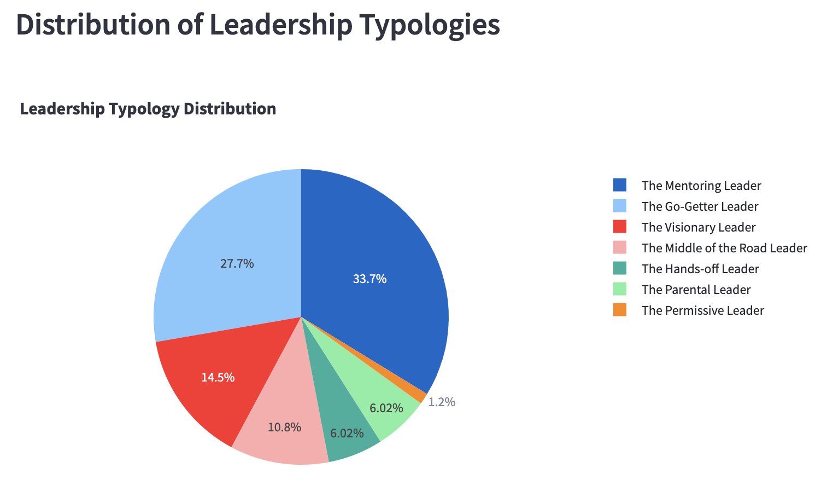
    - Top 3 Leadership Types make up 76.9% of the cohort:
      * The Mentoring Leader (33.7%)
      * The Go-Getter Leader (27.7%)
      * The Visionary Leader (14.5%)
      * These dominant styles suggest an organization that favors:
        + Development-focused leadership (Mentoring)
        + Goal-oriented and change-driven leadership (Go-Getter, Visionary)
        + Relatively strong forward-looking, people-centered management culture
      * HR can interpret this as a sign of strong developmental intent and innovation culture, but may also need to balance with structure, performance monitoring, and accountability mechanisms.
  + 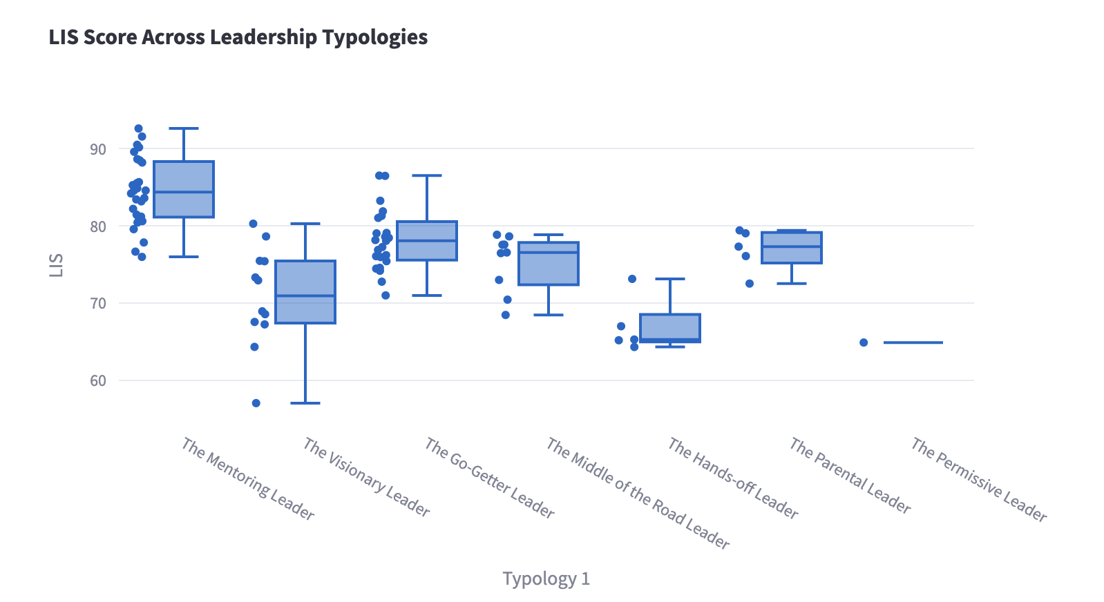
    - Conclusion:
      * Highest LIS Scores:
        + mentoring leader score highest in LIS indicating they are the most well rounded, what else??
        + Mentoring Leaders have the highest and most consistent LIS scores across the cohort.
        + Go-Getter Leaders and Visionary Leaders have moderate LIS scores but with greater variability.
      * Lowest LIS Scores:
        + Middle of the Road, Hands-Off, and Permissive Leaders consistently score lower, suggesting lower readiness or developmental maturity.
      * INSIGHT:
        + “Leadership Typology shows a strong correlation with LIS: Mentoring Leaders consistently outperform other types, confirming the value of coaching-focused, emotionally intelligent leadership. Meanwhile, low-scoring typologies like Hands-Off and Permissive may signal at-risk profiles for key leadership roles, particularly in change-heavy or performance-critical environments.”
    - Handsoff leaders score one of the lowest in LIS indicating maybe they have lower emotional intelligence, and dont score as well in the skill pools relevant to their job
    - Permissive leaders score the actual lowest in LIS at 64.88 indicating what? **There is only one permissive leader so the amount of data is not enough to make accurate conclusions here.**
    - **Development Implications by typology:**
      * 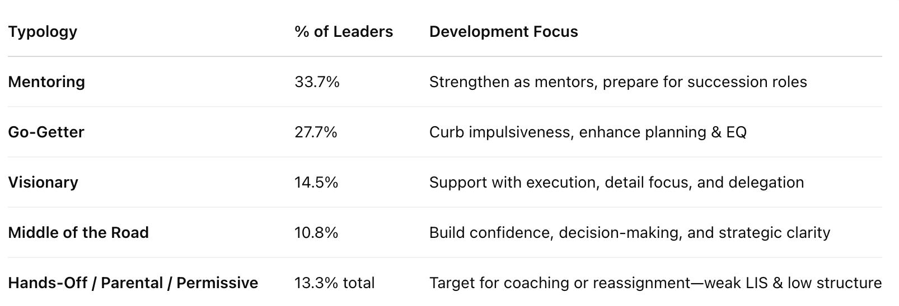
      * HR should leverage Mentoring Leaders as internal mentors in formal mentoring programs, and use LIS + typology data to flag leaders who may require focused coaching or reassignment.
    - **Conclusion Summary:** “Leadership Typology results indicate that over 60% of Nesma’s leaders align with mentoring or go-getter profiles—styles associated with high emotional intelligence, development orientation, and execution energy. Mentoring Leaders not only form the largest group (33.7%) but also achieved the highest LIS scores, indicating a strong internal capacity for mentorship, coaching, and culture-building. Conversely, a small portion of leaders (13.3%) represent less structured or less proactive types (e.g., Hands-Off, Permissive), typically associated with lower LIS scores and weaker team performance. These insights enable HR to tailor mentorship assignments, flag developmental priorities, and further refine leadership pipeline planning.”
* Resource type vs skill category - KEEP AT END
  + **Put as part of overall group training recommendations**
  + Buy these resources bcz they most recommended
  + Then make this link to the training section of the tool and report
* EQ focus on a lot -[oharradi.ieu2024@student.ie.edu](mailto:oharradi.ieu2024@student.ie.edu)

## 

# **Role to Role Comparisons**

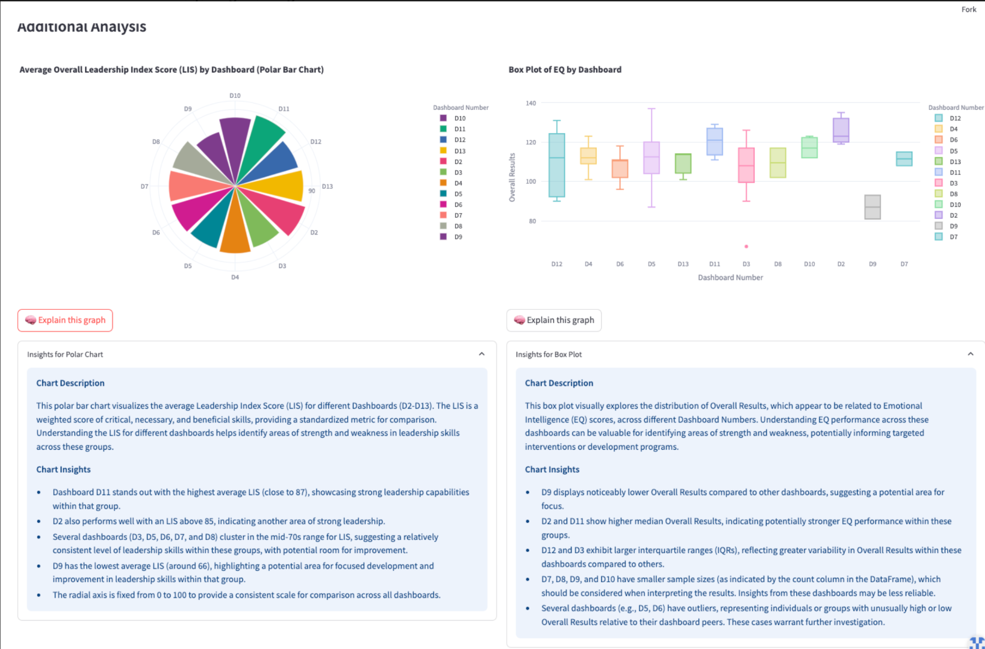

### **Leadership Capability Insights by Dashboard Group**

Analysis of Leadership Index Scores (LIS) and Emotional Intelligence (EQ) across the 12 dashboards (D2–D13) revealed notable trends in leadership readiness and development needs:

#### **LIS (Leadership Index Score) Overview:**

* **Dashboard** **D11** demonstrated the **highest average LIS (≈87)**, signaling a group of leaders with particularly strong behavioral, emotional, and skill-based readiness.
* **D2** also performed strongly with an average LIS above 85, reinforcing its role as a high-performing leadership segment.
* D4 Analysis
* A **cluster of dashboards (****D3****,** **D5****,** **D6****,** **D7****,** **D8****)** centered in the **mid-70s LIS range**—indicating foundational leadership strength but also potential for further development.
* **D9** exhibited the **lowest average LIS (~66)**, marking it as a **priority group for focused training and leadership capability uplift**.

#### **EQ Distribution Insights:**

* **D2 and D11** again showed strong performance, with **higher median EQ scores**, suggesting alignment between emotional intelligence and leadership effectiveness in these groups.
* **D12 and D3** displayed **greater variability in EQ scores**, indicating inconsistency in emotional competencies among leaders within these dashboards.
* **D9’s EQ scores** were **noticeably lower overall**, reinforcing the earlier finding that this group may require **both skill and EQ development support**.
* **Outliers** were observed in several dashboards (e.g., D5, D6), signaling a need for **individual-level follow-up** to explore unusually high or low performance profiles.

### **Summary Recommendation**

"Dashboards D11 and D2 represent leadership strengths, while D9 emerges as a clear candidate for targeted intervention. Groups with mid-range LIS and variable EQ (D3, D5–D8) may benefit from tiered development plans that reinforce core competencies while addressing emotional intelligence gaps. These insights support the case for dashboard-specific training strategies rather than a uniform approach."

## **D2 Analysis**

## **D2: Executive-Level Operations – Leadership Analysis**

### **1. Leadership Index Score (LIS) Distribution**

* **LIS Range**: 78.8 – 90.2
* **Median LIS**: 88.6
* **Quartile Range**: Q1 ≈ 81.3, Q3 ≈ 89.8
* All leaders fall within the **"Strong Fit"** band (85–100), with one slightly below (still above 78)

**Interpretation**: D2 is an **exceptionally high-performing group**, demonstrating elite leadership alignment with their roles. Very tight score distribution indicates **consistency at the executive level**, with minimal outliers.

### **2. Skill Bucket Performance**

|  |  |  |
| --- | --- | --- |
| **Skill Type** | **Median Score (est.)** | **Notes** |
| **Key Skills** | ~95 | Uniformly high, showing strong mastery of mission-critical skills |
| **Necessary Skills** | ~87 | More variability, but still strong |
| **Beneficial Skills** | ~93 | Highly developed interpersonal and adaptive skills |

**Insight**: D2 leaders are not only technically competent but also **emotionally aware and adaptable**—an ideal mix for executive leadership.

### **3. Leadership Typology Distribution**

|  |  |
| --- | --- |
| **Typology** | **% of Leaders** |
| Mentoring Leader | 66.7% |
| Middle of the Road | 33.3% |

* **Mentoring Leaders** show very high LIS (tight range ~88–90)
* **Middle of the Road Leaders** slightly lower (just above 78)

**Interpretation**: The **dominance of Mentoring Leaders** reinforces the group's strong capability in people development, trust-building, and cross-functional influence. The few Middle-of-the-Road leaders may benefit from coaching to better align with the rest of the cohort.

### **4. Strongest Skills**

|  |  |
| --- | --- |
| **Skill** | **Score** |
| Resilience/Hardiness | 92 |
| Measuring & Evaluating Results | 88 |
| Negotiating Ability | 84 |
| Communication Skills | 83 |
| Emotional Intelligence | 81 |
| Emotional Self-awareness | 78 |

**Insight**: D2 excels in **resilience, analytical decision-making, and emotional balance**—traits essential at the executive level for managing pressure and strategic ambiguity.

### **5. Weakest Skills (Still Above Average)**

|  |  |
| --- | --- |
| **Skill** | **Score** |
| Building Effective Teams | 73 |
| Conflict Management | 75 |
| Change Management | 76.5 |
| Emotional Self-awareness | 78 |

**Observation**: While these aren't weak in absolute terms, they represent **relative development opportunities**—especially around **team cohesion, change leadership, and intra-team conflict resolution**.

### **6. Summary & Recommendations**

**Leadership Profile**:

* D2 represents **top-tier leadership**, with high LIS and consistent excellence across key and soft skills.
* Predominantly mentoring-focused, this group likely sets the tone culturally across the organization.

**Strategic Value**:

* Ideal group for **succession planning**, mentorship deployment, and **strategic alignment roles**
* Could serve as **executive sponsors** for upskilling lower-performing dashboards (e.g., D3, D9)

**Recommendations**:

* Minor refinement: Focus development on **team-building, conflict resolution**, and **change leadership**
* Continue reinforcing **mentoring culture**; consider involving them in internal leadership training
* Use this dashboard’s success profile as a **benchmark** for assessing rising leaders across other groups

## **D3 Analysis**

## **D3 Leadership Analysis**

### **1. Leadership Index Score (LIS) Distribution**

* **LIS Median**: ~76
* **Range**: Broad, from ~57 to ~89
* **Notable Outliers**: Two low-performing individuals pulling down the overall range
* **Mode Cluster**: Most leaders hover in the **Solid Fit** (75–84) range
* **Histogram**: Bimodal shape suggests **a divided group**—some high performers, some needing support

**Interpretation**: D3 reflects **a mixed-readiness cohort**. While most leaders show role alignment, a few significantly underperform, indicating possible misfits or developmental delays.

### **2. Skill Bucket Performance**

|  |  |  |
| --- | --- | --- |
| **Skill Bucket** | **Median Score (est.)** | **Notes** |
| **Key Skills** | ~85 | Strong base; outliers drag down range slightly |
| **Necessary Skills** | ~80 | Moderate consistency; wide IQR signals varying execution strength |
| **Beneficial Skills** | ~83 | Surprisingly strong; suggests behavioral range in high performers |

**Insight**: Leaders perform **better than average across all buckets**, especially in **soft leadership skills**—uncommon in technical operations groups. However, **variance suggests coaching and calibration are still needed**.

### **3. Leadership Typologies**

|  |  |
| --- | --- |
| **Typology** | **Observations** |
| **Mentoring Leader** | Highest LIS range (avg ~83–92) |
| **Go-Getter Leader** | Solid LIS range (~76–83), consistent performers |
| **Visionary Leader** | Very broad LIS (down to ~57); a few high performers, but some serious outliers |
| **Hands-Off & Middle** | Present in small numbers; generally lower-performing |

**Interpretation**: The **Mentoring and Go-Getter** types are top performers. **Visionary Leaders** show inconsistent execution—some strong, others underperforming—suggesting **mismatch between ambition and operational fit**.

### **4. Skill Strengths (Top Scores)**

|  |  |
| --- | --- |
| **Skill** | **Score** |
| Innovative Mindset | 80 |
| Project Management | 76 |
| Accountability | 75.2 |
| Problem Solving | 75.2 |
| Emotional Intelligence | 68.0 |

**Observation**: Strong on **executional and forward-thinking capabilities**—well suited to operations leadership. Emotional intelligence, though present, is only moderate, meaning empathy and self-regulation may be unevenly distributed.

### **5. Skill Weaknesses (Lowest Scores)**

|  |  |
| --- | --- |
| **Skill** | **Score** |
| Resilience/Hardiness | 52 |
| Coaching & Mentoring | 57 |
| Communication Skills | 61.2 |
| Measuring & Eval. Results | 63 |
| Negotiating Ability | 65 |

**Key Insight**: **Interpersonal and stress-oriented competencies are underdeveloped**. Many leaders may struggle to motivate teams, coach direct reports, or adapt under pressure.

### **6. Summary & Recommendations**

**Leadership Profile**:

* Operationally strong, with innovation and task ownership
* Variable leadership readiness due to role-person fit gaps
* High potential hampered by inconsistent communication and resilience

**Risks**:

* Leaders under stress may disengage or underperform
* Lack of coaching skills limits team development
* Communication gaps risk operational misalignment

**Strategic Recommendations**

* **Targeted upskilling**: Communication, team coaching, and stress management
* **1-on-1 coaching** for LIS outliers (especially Visionary and Hands-Off types)
* **Peer mentoring**: Leverage top LIS Mentoring Leaders internally
* Introduce **structured feedback loops** to improve evaluation and coaching culture

## **D4 Analysis**

### **1. LIS Score Distribution (Leadership Index Score)**

* **Median LIS**: ~79
* **Range**: Scores span from ~67 to 87, with most leaders falling between 73–85.
* **Distribution Shape**: Fairly symmetrical but with a few outliers (low and high), indicating a moderately diverse performance range.

🟩 **Insight**: Overall leadership capability in D4 is solid, with most leaders in the *“Solid Fit”* band (75–84). However, the presence of lower outliers suggests a need to address specific underperformers.

### **2. Skill Bucket Performance**

* **Key Skills**: Median ~86, strong overall, with most leaders clustering in the high 70s–90s.
* **Necessary Skills**: Slightly lower performance than Key Skills; wider variance, some scores below 75.
* **Beneficial Skills**: Weakest bucket on average; some scores fall close to 60, indicating gaps in soft/emotional competencies.

🟧 **Insight**: D4 leaders are technically competent, but development is needed in **soft skills and emotionally driven behaviors**, especially those categorized as "beneficial."

### **3. Leadership Typology Distribution**

* **Most common type**: *The Mentoring Leader* (44.4%)
* Others include *The Visionary Leader*, *Go-Getter*, *Parental*, and *Middle of the Road*—each between 11–16%.

🟦 **Insight**: There’s strong representation of proactive leadership types (mentoring, visionary), but the diversity of typologies suggests potential **misalignment in leadership style cohesion** across the team.

### **4. LIS Score by Leadership Typology**

* **Mentoring Leaders**: Tend to have higher LIS, with tight distribution above 80.
* **Visionary and Parental Leaders**: Wider spread and more variability.
* **Middle of the Road & Go-Getter**: Moderate performers with narrower ranges.

🟨 **Insight**: D4’s strongest LIS performers are those with *Mentoring* typologies. HR might consider leadership style coaching for other types to raise overall consistency.

### **5. Strongest Skills (Top 10)**

Top scoring skills (all ≥71):

* **Innovative Mindset** (82.5)
* **Project Management** (82.4)
* **Organization Skills** (79)
* **Problem Solving**, **Communication**, **Conflict Management**, **Emotional Intelligence**

🟩 **Insight**: D4 excels in **executional and organizational skills**, particularly those tied to logistics and operations. These are well-aligned with the department’s core functions.

### **6. Weakest Skills (Bottom 10)**

Lowest scoring:

* **Supportiveness** (53)
* **Measuring & Evaluating Results** (55)
* **Negotiating Ability**, **Recruitment & Hiring**, **Building Effective Teams** (under 70)

🟥 **Insight**:

* *Supportiveness* is a significant outlier and needs immediate intervention.
* **Talent-related skills** like hiring and team building are also underdeveloped.
* Leaders may be **over-indexed on execution** and **under-indexed on people-centric leadership.**

### **Overall Summary for D4**

|  |  |
| --- | --- |
| **Category** | **Summary** |
| **Strengths** | Project execution, innovative mindset, problem-solving, organization. |
| **Gaps** | Supportiveness, talent development, emotional and evaluative skills. |
| **Typology Mix** | Diverse, but strongest performers are Mentoring Leaders. |
| **Recommendation** | Soft skills and team development training. Consider mentoring program expansion and coaching for non-mentoring typologies. |

## **D5 Analysis**

### **LIS Score Distribution (D5)**

* **Median LIS**: ~77.2
* **LIS Range**: 64.3 to 91.6
* **Distribution**: Broad and right-skewed, with a majority clustered between 72 and 82, and a few outliers scoring above 90.

**Interpretation**:  
 D5 has a moderately strong LIS profile with a fairly wide distribution, indicating performance variation within the group. Some leaders are highly aligned, while others may require support or reevaluation.

### **Performance by Skill Buckets**

* **Key Skills**: Strong, median above 80, with several scoring above 90
* **Necessary Skills**: Solid, but slightly lower than key skills—some variability
* **Beneficial Skills**: Wider spread, with a few outliers scoring low, though central tendency remains healthy (~78–80)

**Interpretation**:  
 D5 leaders show consistent proficiency in technical/core capabilities but slightly more variability in soft/beneficial areas (e.g., empathy, self-awareness).

### **Leadership Typologies**

* **Top types**:
  + **Go-Getter Leader** (45.5%)
  + **Mentoring Leader** (22.7%)
  + Others: Visionary, Middle of the Road, Permissive

**Interpretation**:  
 This is a goal-driven group, but with diversity in leadership styles. The presence of Go-Getters suggests high execution capacity, while Mentors may provide interpersonal balance.

### **Skill Insights**

#### **Strongest Skills**

* Supportiveness (90)
* Project Management (~78)
* Innovative Mindset (78)
* Communication & EI (~75–76)
* Accountability, Problem-Solving (70+)

#### **Weakest Skills**

* Recruitment & Hiring (52.3)
* Negotiating Ability (61.9)
* Resilience & Analysis (~62–65)
* Building Teams, Conflict Management (~65)

**Interpretation**:  
 D5 excels in delivery-focused areas (project management, innovation, communication), but struggles with people operations (hiring, conflict, coaching). These weaker areas align with typical challenges in technical leadership and should be development priorities.

## **D6 Analysis**

### **1. LIS Score Distribution**

* **Median LIS**: 78.7
* **Range**: From ~71 to ~84.5
* **Distribution**: Relatively tight clustering around the median; the group shows consistency with a few outliers on the lower end.
* **Insight**: Performance is moderate to strong overall, with limited variation across participants.

### **2. Performance by Skill Buckets**

* **Key Skills**:
  + Median ~84.5, with a strong upper range (~93).
  + High and consistent performance.
* **Necessary Skills**:
  + Median ~84, slightly lower but still strong.
  + Wider spread; one value dips close to 70.
* **Beneficial Skills**:
  + Median around ~81.5, showing balance.
  + Wider interquartile range and visible outliers.
* **Insight**: Strongest performance is in **Key Skills**, but **Beneficial Skills** show more variability, suggesting targeted improvement areas.

### **3. Leadership Typology Distribution**

* **Types Present**:
  + **Go-Getter Leader**: 50%
  + **Mentoring Leader**: 33.3%
  + **Visionary Leader**: 16.7%
* **Insight**: The cluster is dominated by action-oriented Go-Getters, with a strong secondary presence of relational Mentoring Leaders. Visionary types are underrepresented.

### **4. LIS by Leadership Typology**

* **Mentoring Leaders**: Highest LIS median (~83–84)
* **Go-Getter Leaders**: Median ~76, wider range
* **Visionary Leader**: Single data point at ~73
* **Insight**: Mentoring Leaders are the strongest performers in this cluster. Visionary and Go-Getter types may need support to close the gap.

### **5. Strongest Skills**

|  |  |
| --- | --- |
| **Skill** | **Avg Score** |
| Change Management | 86 |
| Information Gathering | 84 |
| Innovative Mindset | 78 |
| Supportiveness | 77 |
| Project Management | 76 |

* **Insight**: High marks in adaptability, data collection, and forward thinking — valuable in procurement environments where agility and strategy are key.

### **6. Weakest Skills**

|  |  |
| --- | --- |
| **Skill** | **Avg Score** |
| Communication Skills | 56 |
| Building Effective Teams | 59 |
| Resilience/Hardiness | 64 |
| Accountability | 69 |
| Emotional Intelligence | ~69.7 |

* **Insight**: Interpersonal and self-regulatory skills are the lowest, especially **communication** and **team-building**. These should be prioritized in development plans.

### **Summary of Key Insights**

* This is a high-performing group in core technical and strategic areas (Change Management, Data Gathering).
* Leadership is skewed toward action-oriented types, with mentoring styles yielding the highest LIS.
* Weaknesses in communication, emotional intelligence, and resilience may impact collaboration and team dynamics.
* Tailored training on **soft skills and leadership development** would help balance the technical strengths of this group.

## **D7 Analysis**

## **I. Leadership Index Score (LIS) Overview**

### **Distribution & Central Tendencies**

* **LIS Range**: 72.36 – 84.36
* **Median LIS**: 77.71
* **Q1**: 72.36  **Q3**: 83.57
* **Observation**: The spread is moderately wide, suggesting **some leaders are significantly outperforming others**.
* **Implication**: This may indicate a need for targeted development interventions for those below Q1, while high-performers could serve as mentors.

## **II. Skill Bucket Performance**

### **Key Skills**

* **Median ~82**, with high Q3 reaching ~87+
* **Insight**: Strong foundational competence in critical leadership behaviors like problem-solving and accountability.
* **Note**: Leaders are generally aligned on these priority skills.

### **Necessary Skills**

* **Median ~80**, with less variability.
* **Interpretation**: A steady baseline exists across the team, showing reliable performance on essential operational behaviors.

### **Beneficial Skills**

* **Median ~80**, but wider variability.
* **Insight**: Beneficial skills (like emotional intelligence and supportiveness) are less consistently developed across the team.
* **Recommendation**: Invest in harmonizing soft-skill growth, especially for mid-tier performers.

## **III. Top Skills (Strengths)**

|  |  |
| --- | --- |
| **Skill** | **Avg. Score** |
| Problem-Solving | 90 |
| Resilience/Hardiness | 87 |
| Change Management | 86 |
| Accountability | 84 |
| Supportiveness | 84 |
| Communication Skills | 81 |

### **Observations:**

* The team demonstrates strong capacity in **critical thinking**, **adaptability**, and **execution accountability**.
* High **resilience** is a positive marker for stability under pressure—key in QA/control roles.
* **Supportiveness and communication** also rank high, indicating positive interpersonal dynamics among top performers.

## **IV. Bottom Skills (Weaknesses)**

|  |  |
| --- | --- |
| **Skill** | **Avg. Score** |
| Negotiating Ability | 59 |
| Recruitment & Hiring | 60 |
| Building Effective Teams | 66 |
| Information Gathering | 68 |
| Conflict Management | 70 |

### **Insights:**

* **Team formation, negotiation, and hiring** are core areas of weakness.
* These weaknesses **can impact the function’s capacity to scale, collaborate across teams, and lead high-performance units.**
* **Conflict Management** being low suggests friction is not always resolved effectively, a concern in cross-department QA settings.

## **V. Leadership Typology Distribution**

|  |  |
| --- | --- |
| **Typology** | **% of Leaders** |
| Go-Getter Leader | 60% |
| Visionary Leader | 20% |
| Middle of the Road Leader | 20% |

### **Interpretation:**

* **Go-Getter dominance** suggests an execution-first mindset—ideal for operational excellence but may **lack strategic foresight or people-first emphasis**.
* Underrepresentation of **Visionary and Mentoring Leaders** may limit long-term transformation and team development.
* **Middle-of-the-Road Leaders** may require clarity and motivation to push performance upward.

## **VI. LIS by Typology**

* **Go-Getter** and **Visionary Leaders** show relatively strong LIS scores.
* **Middle of the Road Leaders** are noticeably lower in LIS, suggesting they may **lack clarity in role identity or confidence**.
* These leaders may benefit from coaching, structured feedback loops, or shadowing high-performing peers.

## **VII. Key Recommendations**

1. **Mentorship Pairing**: Assign high LIS Go-Getters to mentor Middle-of-the-Road leaders.
2. **Targeted Soft Skills Workshops**:
   * Negotiation
   * Team-building
   * Conflict navigation
3. **Strengthen Talent Functions**:
   * Incorporate leadership in recruitment decisions and train them on behavioral interviewing.
4. **Vision Development Sessions**:
   * Introduce frameworks to improve long-term thinking and strategic influence (e.g., systems thinking, scenario planning).
5. **Recognition for Emotional Intelligence**:
   * Those showing strength in supportiveness and communication can be highlighted as internal culture builders.

## **D8 Analysis**

### **1. LIS Score Distribution**

* **LIS Range**: From ~67 to ~87
* **Median LIS**: ~77
* The LIS scores are relatively spread out, showing variance in leadership impact within the group.
* Distribution is **evenly split** between two typologies: **Go-Getter Leader** and **Hands-off Leader** (50% each).

### **2. Leadership Typology & LIS**

* **Go-Getter Leaders** significantly outperform **Hands-off Leaders** in LIS:
  + Go-Getter: **86.5**
  + Hands-off: **~67**
* Strong implication: Leadership typology directly influences effectiveness in this cluster.

### **3. Skill Bucket Performance**

* **Go-Getter Leader**:
  + **Key Skills**: 98.25 (very strong)
  + **Necessary Skills**: 90.6
  + **Beneficial Skills**: 89
  + **EQ**: 75
* All scores are high, suggesting comprehensive capability across all categories.

### **4. Top Skills**

* **Measuring & Evaluating Results**: 71
* **Emotional Intelligence**: 70.3
* **Communication Skills**: 70
* These strengths align with roles requiring data-driven decisions and people-focused communication.

### **5. Bottom Skills**

* **Conflict Management**: 57
* **Monitoring Employee Performance**: 57.5
* **Negotiating Ability**: 63
* Indicates underperformance in accountability/enforcement and interpersonal negotiation.

### **6. Summary Insights**

* High-performing **Go-Getter leaders** drive LIS performance for the group.
* Skill strengths are strategic thinking and interpersonal awareness.
* Weaknesses lie in **performance supervision** and **conflict resolution**, which are critical in safety environments.
* Recommendation: **Targeted upskilling** in accountability, monitoring, and conflict handling to balance out the typology-driven performance gap.

## **D9 Analysis**

## **Leader Comparison: Alabdullah Qassem vs Alamoais Shihab (D9)**

### **Overview:**

* **Dashboard D9** as a whole was flagged for lower LIS and EQ scores.
* However, these two leaders show **contrasting individual performance patterns**, revealing nuanced developmental needs.

### **1. Critical Skills**

|  |  |  |
| --- | --- | --- |
| **Skill** | **Alabdullah Qassem** | **Alamoais Shihab** |
| Communication Skills | Below dashboard average | At or slightly above average |
| Conflict Management | Slightly below average | Above average |
| Info Gathering & Analysis | Strong (matches average) | Strong (above average) |

🔍 **Insight**:  
 Alamoais Shihab demonstrates a stronger foundation in **conflict management** and **communication**, both critical in governance settings. Qassem trails slightly in these areas and may benefit from structured communication training.

### **2. Necessary Skills**

|  |  |  |
| --- | --- | --- |
| **Skill** | **Alabdullah Qassem** | **Alamoais Shihab** |
| Project Management | Solid | Very strong |
| Negotiating Ability | Moderate | High |
| Measuring & Eval. Results | Strong | Very strong |
| Change Management | Lower than average | Moderate |
| Listening Skills | Below average | Below average |

🔍 **Insight**:  
 Alamoais significantly **outperforms the dashboard average** across most Necessary Skills, especially in **project management, measurement, and negotiation**—key to operational oversight. Both leaders, however, show **low Listening Skills**, a potential coaching area across D9.

### **3. Beneficial Skills**

|  |  |  |
| --- | --- | --- |
| **Skill** | **Alabdullah Qassem** | **Alamoais Shihab** |
| Social Insight | Excellent | Excellent |
| Fairness | Moderate | High |
| Emotional Self-Awareness | Low | Low |
| Managerial Courage | Moderate | Moderate |
| Organization Skills | At average | Above average |

🔍 **Insight**:  
 Both leaders score well in **social insight**, supporting their interpersonal awareness. However, **low emotional self-awareness** is a shared developmental gap and could hinder people leadership effectiveness. Alamoais also shows stronger fairness and organizational skills.

## **Conclusion & Recommendations**

|  |  |  |
| --- | --- | --- |
| **Area** | **Alabdullah Qassem** | **Alamoais Shihab** |
| **Strengths** | Social insight, project measurement | Strong across project delivery, negotiation, and fairness |
| **Gaps** | Listening, emotional self-awareness | Listening, emotional self-awareness |
| **Training Priority** | Communication + Change Management | Self-awareness + Team Dynamics |
| **Potential Role Fit** | May benefit from support-oriented role | High potential for stretch assignments or mentorship role |

“While Dashboard D9 flagged as underperforming, Alamoais Shihab represents a potential internal mentor or success case within the group. Alabdullah Qassem is broadly aligned but requires growth in communication and adaptability. Both leaders would benefit from targeted support in emotional intelligence.”

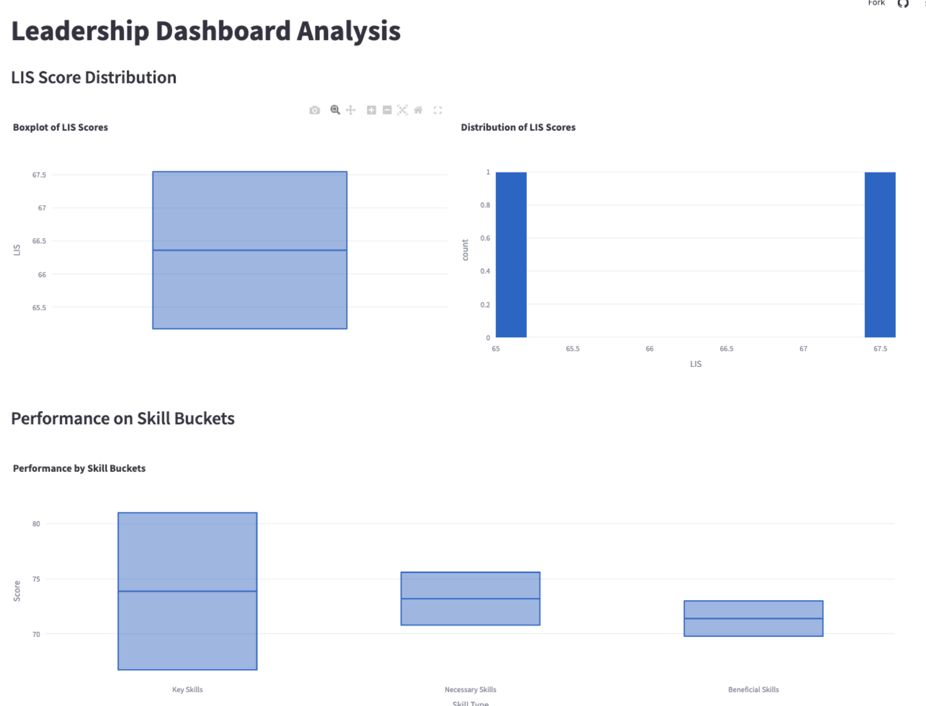

## **D9 Leadership Analysis: Corporate Governance and Compliance**

### **1. Leadership Index Score (LIS) Overview**

* **Median LIS** is **~66.5**, falling within the “Needs Support” range.
* **Distribution** is narrow (single value shown), suggesting either a very small sample or uniform scores across leaders (likely just the two leaders analyzed previously).
* Indicates **broad underperformance against company LIS benchmarks** and confirms the dashboard’s classification as a development priority.

**Interpretation**: D9 leaders are **technically capable but not fully leadership-ready** based on holistic LIS criteria. Core development support is needed to raise performance to the “Solid Fit” band.

### **2. Skill Bucket Performance**

|  |  |  |
| --- | --- | --- |
| **Skill Type** | **Approx. Median Score** | **Notes** |
| **Key Skills** | ~74 | Strongest of the three; near Solid Fit range |
| **Necessary Skills** | ~72 | Acceptable, but slightly below desirable thresholds |
| **Beneficial Skills** | ~70 | Lowest; reflects gaps in EQ and soft behavioral traits |

**Insight**: Leaders are **competent in role-critical skills** (Key/Technical), but less so in **emotional intelligence, self-awareness, and interpersonal attributes**, which are crucial in governance contexts requiring cross-functional influence and diplomacy.

### **3. Top Strengths (by Average Score)**

|  |  |
| --- | --- |
| **Skill** | **Score** |
| Accountability | 78.5 |
| Conflict Management | 71.5 |
| Information Gathering | 70 |
| Negotiating Ability | 69 |
| Communication Skills | 67 |

**Key Takeaway**: D9 leaders show **strong performance in structured, task-oriented areas**—such as accountability, negotiation, and analytical functions. Conflict handling and communication are also relatively stable.

### **4. Top Weaknesses (by Average Score)**

|  |  |
| --- | --- |
| **Skill** | **Score** |
| Emotional Self-Awareness | **45** |
| Change Management | 55 |
| Emotional Intelligence | 56 |
| Listening Skills | 57 |

**Key Takeaway**: The **lowest scores are concentrated in emotional intelligence and adaptability**, suggesting that leaders in D9 may struggle to lead through ambiguity, respond empathetically, or adapt to organizational change—a concern in compliance and governance where discretion, judgment, and influence are key.

### **5. Summary & Recommendations**

**Leadership Profile**:

* Task-focused, reliable, and accountable
* Underdeveloped in empathy, adaptability, and emotional depth
* Ready for training, not for expanded leadership responsibilities yet

**Actionable Recommendations**:

* **Immediate intervention**: Targeted EQ training (esp. self-awareness and emotional regulation)
* **Coaching programs**: Individual development plans focused on interpersonal dynamics and change leadership
* **Mentorship match**: Pair D9 leaders with higher-performing groups like D11 to expose them to broader leadership styles
* **Measurement**: Reassess in 6 months using LIS to track progress post-intervention

## **D10 Analysis**

### **1. High Scores in “Drive” & “Communication” – But Low Conflict Management**

**Implication:**

* These leaders are **motivated and action-oriented**, capable of pushing initiatives forward.
* But their **limited ability to resolve disputes** could result in unresolved tensions—especially risky in high-stakes environments like finance and risk control, where decisions are often contested.
* **Interpretation:** This group may default to pushing through rather than navigating interpersonal challenges—suggesting a **potentially high-pressure culture** with suppressed conflict.

### **2. Strong in “Information Gathering & Analysis”**

**Implication:**

* The team shows **analytical discipline**—critical for risk control and financial oversight.
* This suggests they’re data-driven and thorough in pre-decision analysis, likely contributing to **reduced operational risk**.

### **3. Low “Calculated Risk-Taking” in a Risk Team**

**Implication:**

* Ironically, the risk control group demonstrates **caution in taking risks**, even calculated ones.
* This may **reflect cultural over-conservatism** or an aversion to innovation and experimentation—even when supported by data.
* In practice, it might slow down adaptive strategies or limit strategic risk-taking necessary for financial growth or transformation initiatives.

### **4. Leadership Typology Spread Suggests Cultural Fragmentation**

* **Mentoring Leaders (40%)**: Collaborative, development-focused—likely strong team builders.
* **Parental Leaders (40%)**: Protective and possibly micromanaging—less empowering.
* **Middle of the Road (20%)**: Balanced but noncommittal—may avoid difficult decisions.

**Interpretation:**

* The lack of a dominant leadership typology may indicate **cultural inconsistency**.
* With varying leadership philosophies, team members might **receive mixed signals**, leading to **uncertainty or inconsistent expectations**—particularly problematic in high-regulation sectors.

### **5. Emotional Intelligence Scores (around 75) Are Moderate**

**Implication:**

* Leaders are **not emotionally disengaged**, but also **not particularly emotionally tuned in**.
* This may **limit empathetic decision-making**, especially in situations involving team stress, ethical dilemmas, or cross-functional coordination.

### **6. Wide Variability in “Necessary” and “Beneficial” Skills**

**Implication:**

* Key skills are consistently strong, but the wide spread in supporting skillsets suggests that while **leaders are technically strong**, their **soft skill development varies significantly**.
* This might point to **inconsistent training**, or a culture that **doesn’t equally prioritize interpersonal and strategic development** across the board.

### **7. High LIS for Mentoring Leaders – Strategic Opportunity**

* Their consistently high performance indicates a **clear leadership model that works well** in this context.
* **Recommendation:** Consider mentoring leaders as **role models or internal trainers** to help uplift performance in other typologies.

### **8. Final Strategic Insight**

This group seems to **value clarity, control, and performance**, but may be **limited by low adaptability, conflict navigation, and emotional nuance**. Their effectiveness likely lies in **technical execution and analysis**, but **transformation, innovation, and people strategy may be weaker areas** without further development.

## **D11 Analysis**

## **Dashboard D11: High-Performing Leadership Cluster**

### **1. Leadership Index Score (LIS) Distribution**

* **LIS Range**: 82 to 92
* **Median LIS**: ~86
* **Distribution**: Tight and elevated — all leaders fall within the **“Strong Fit”** category (85–100)
* This makes D11 one of the **highest-performing groups across the entire cohort**

**Interpretation**: This is a strategically strong dashboard with consistent leadership capability. D11 likely represents a **mature, experienced leadership group** well-aligned with their roles.

### **2. Skill Bucket Performance**

|  |  |  |
| --- | --- | --- |
| **Skill Type** | **Score Range (Approx.)** | **Notes** |
| **Key Skills** | 90–98+ | Strong and consistent |
| **Necessary Skills** | 85–98 | Some variability, but still strong |
| **Beneficial Skills** | ~95–99 | Exceptionally high — signals depth and behavioral range |

**Insight**: Leaders in D11 are not only capable in critical areas but also display **strong behavioral and emotional intelligence**—especially rare in technical or governance-heavy roles.

### **3. Leadership Typology Distribution**

|  |  |
| --- | --- |
| **Typology** | **% of Leaders** |
| Mentoring Leader | 66.7% |
| Go-Getter Leader | 33.3% |

**Interpretation**: D11 is dominated by **Mentoring Leaders**, who also have the **highest LIS scores** across all typologies. This supports a **culture of coaching, empowerment, and long-term development**. The minority Go-Getters may help balance strategic execution and drive.

### **4. Skill Performance (Top and Bottom Scores)**

#### **Top Strengths**

|  |  |
| --- | --- |
| **Skill** | **Score** |
| Goal Setting | 100 |
| Project Management | 98 |
| Information Gathering & Analysis | 93.5 |
| Social Insight | 84 |
| Change Management | 81 |

**Observation**: D11 excels in both **strategic execution (goal setting, project management)** and **emotional awareness (social insight, change adaptability)**—a rare and powerful combination.

#### **Relative Weaknesses (Still Strong)**

|  |  |
| --- | --- |
| **Skill** | **Score** |
| Measuring & Evaluating Results | 75 |
| Emotional Intelligence | 77.5 |
| Negotiating Ability | 80.3 |

**Note**: These are not weak in absolute terms — all above 75 — but represent **relative areas for fine-tuning**. Stronger measurement systems and influence strategies (e.g., negotiation) could further elevate this group.

### **5. Summary & Recommendations**

**Leadership Profile**:

* Highly capable, experienced, and developmentally mature
* Strong balance between execution and people leadership
* Dominated by mentoring-focused styles that support knowledge transfer and succession

**Strategic Value**:

* **Ideal mentor pool** for developing lower-LIS dashboards (e.g., D9, D3)
* Well-positioned for expanded responsibilities or special projects
* Set a **benchmark** for LIS and behavioral balance across the company

**Recommendations**:

* Involve D11 leaders in cross-dashboard mentoring and coaching
* Leverage this group in leadership strategy design, internal facilitation, or culture building
* Provide **advanced development** (e.g., innovation leadership, systems thinking, external stakeholder influence)

## **D12 Analysis**

### **1. Leadership Index Score (LIS) Distribution**

* **Range:** Approx. 64 to 91.
* **Median:** Around 78–79.
* **Variance:** High – the group includes both top-performing and lower-scoring leaders.
* **Implication:** This group is diverse in leadership effeciveness. There's a clear need to reduce gaps and elevate the lower-performing cohort.

### **2. Leadership Typology Distribution**

* 40% Mentoring Leaders
* 20% Middle of the Road
* 20% Hands-off
* 20% Go-Getter
* **Insight:**
  + Strong presence of **Mentoring Leaders**, which aligns with training and communication-focused functions.
  + However, the presence of **Hands-off** and **Middle of the Road** leaders my undermine the group’s influence, engagement, and communication clarity.
  + Balanced distribution indicates both high potential and development needs.

### **3. Skill Bucket Performance**

* **Key Skills**: Strong overall, median around 87.
* **Necessary Skills**: Lower median (~76), some leaders are well below.
* **Beneficial Skills**: Also shows wide range, from mid-60s to 95+.
* **Interpretation:**
  + Group excels at foundational leadership (Key Skills), suggesting strong capability.
  + Weaker Necessary and Beneficial Skills indicate specific development needs—especially in practical or context-specific competencies.

### **4. Leadership Typology Insights**

**Mentoring Leader (40%)**

* High LIS: 86.96
* Strong Key (91.75), Necessary (88.2), Beneficial (90.2)
* EQ: 82
* Strongest performers—ideal mentors or anchors in this cluster.

**Middle of the Road Leader**

* LIS: 68.45
* Significantly lower EQ: 60
* Consistently below group median—likely in need of urgent upskilling.

**Hands-off Leader**

* LIS: 64.3
* Lowest EQ: 58
* Weakest across all metrics—leadership engagement or clarity likely impaired.

**Go-Getter Leader**

* LIS: 78.58
* Strong Key Skills (87) and Beneficial Skills (85.8)
* Moderate EQ (72)—good base but needs emotional development.

### **5. Skill-Level Insights**

#### **Top Strengths**

* Building Effective Teams (88)
* Goal Setting (79)
* Charisma (74)
* Coaching & Mentoring (73.5)
* Emotional Intelligence and Change Management also present (~70–72)

#### **Key Weaknesses**

* **Emotional Self-Awareness** (50.5)
* Listening & Org. Skills (~61.5)
* Communication Skills (63.3)
* Conflict Management (64)

**Interpretation:**

* High performance in outward leadership (team-building, goal orientation)
* Significant deficits in **internal regulation and interpersonal communication**, especially **self-awareness, active listening, and conflict handling**.

### **Key Takeaways for the HR Report**

* **Dual nature cluster**: Strong top-tier performers and clear underperformers coexist.
* **Leadership training should prioritize**:
  + Emotional self-awareness
  + Listening & communication
  + Conflict and change management
* **Mentoring Leaders can be leveraged** to support and uplift others.
* **Consider targeted coaching** for Hands-off and Middle-of-the-Road types.
* **Emphasize EQ development** across the board to balance technical and relational leadership traits.

## **D13 Analysis**

### **1. Leadership Typology Distribution**

* **66.7% Mentoring Leaders**
* **33.3% Go-Getter Leaders**

This dashboard shows a dominant representation of Mentoring Leaders, suggesting a culture focused on guidance, people development, and support. Go-Getter Leaders are fewer but may drive task and performance focus.

### **2. LIS Score Distribution**

* **LIS Median (Overall)**: ~81.5
* **Range**: ~74.5 to 84.5

The department shows a **high baseline of leadership effectiveness**, with no extremely low performers. The distribution reflects **moderate variability** with an upper-middle concentration.

### **3. LIS by Leadership Typology**

* **Mentoring Leaders (LIS ~82.89)** significantly outperform **Go-Getter Leaders (LIS ~74.46)**.

This indicates that the mentoring approach aligns better with the department’s needs or operational context. It may suggest that leaders focused on team cohesion and development are more effective in this environment.

### **4. Skill Bucket Performance**

|  |  |  |
| --- | --- | --- |
| **Skill Bucket** | **Avg. Score** | **Observations** |
| **Key Skills** | ~91 | Strength in foundational leadership traits such as team building, communication, and goal setting. |
| **Beneficial Skills** | ~89 | High competency in value-adding areas like coaching, negotiation, and evaluation. |
| **Necessary Skills** | ~85.6 | Solid performance in core operational skills. |

The department is strongest in **Key and Beneficial Skills**, suggesting leaders are excelling in critical thinking, team management, and support-centric capabilities.

### **5. EQ Insights**

* **Mentoring Leaders EQ**: 74
* **Go-Getter Leader EQ**: 65

Mentoring Leaders show higher emotional intelligence, which may explain their stronger LIS scores. The lower EQ for the Go-Getter profile could indicate challenges in interpersonal or empathic engagement.

### **6. Top Skills**

|  |  |
| --- | --- |
| **Skill** | **Avg. Score** |
| Building Effective Teams | 80 |
| Problem-Solving | 80 |
| Recruitment & Hiring | 75.3 |
| Negotiating Ability | 73 |
| Accountability | 72.3 |
| Emotional Intelligence | 71 |

The top skills reflect a **balanced mix of strategic, relational, and operational strengths**, especially around team-building and hiring—key functions in admin/support roles.

### **7. Weakest Skills**

|  |  |
| --- | --- |
| **Skill** | **Avg. Score** |
| Conflict Management | 63.5 |
| Measuring & Evaluating Results | 69 |
| Emotional Intelligence | 71 |

**Conflict Management** stands out as a **key weakness**. This may hinder effective team collaboration or resolution practices. Additionally, lower performance in **measurement and evaluation** suggests a need to improve how leaders track and reflect on outcomes.

### **8. Key Insights for HR Reporting**

* **Mentoring Leaders are outperforming across all metrics**, both in LIS and skill buckets—highlighting a strong leadership archetype fit.
* The department is **high-functioning**, with no major leadership underperformance, and strong scores in core and value-adding skills.
* However, **Conflict Management and Measurement & Evaluation** are the most significant development gaps, potentially affecting team dynamics and accountability structures.
* Leaders could benefit from **targeted training in interpersonal conflict resolution and data-driven performance assessment**.
* EQ levels, while decent, show room for development—especially among Go-Getter Leaders.

# **Are leaders in the right roles?**

### **1. Boxplot – LIS Distribution by Dashboard**

**Interpretation Approach:**

* **LIS = 75** (orange dashed line) is your benchmark for *minimum role alignment*.
* Dashboards **above** the benchmark suggest leaders are generally well-matched.
* Dashboards **below** suggest misalignment, development needs, or potential role mismatch.

**Key Insights:**

* **D11, D13, D2, D10** have **medians > 80**, suggesting strong alignment and capability fit.
* **D3, D5, D6, D4** hover around the 75–80 range—mixed but still within reasonable range.
* **D12, D9, D7** have a significant portion of leaders below the 75 mark, suggesting deeper issues:  
  + **D9**: Lowest median and narrow range (65–67), indicating consistently weak alignment.
  + **D7**: Wide spread, low median, and potential outliers pulling it down.
  + **D12**: Wide variability – some strong performers, but many below alignment threshold. Could signal role misfits or inconsistent leadership quality.

**Questions:**

* Are D9 and D12 composed of more junior or legacy leaders who may not have been recently evaluated for fit?
* Have there been recent restructurings in D12 that explain variability?

### **2. Stacked Bar Chart – Leaders by LIS Band & Key Skill Performance**

**Interpretation Approach:**

* Categorizes leaders into LIS bands: <70, 70–75, 75–80, 80+.
* Color-coded by **Key Skills**:  
  + **Red (<70)**: High risk for role misalignment.
  + **Orange (70–79)**: Some concerns.
  + **Green (80+)**: Strong competency fit.

**Key Insights:**

* Nearly **60% of leaders** fall into the **75+ LIS band**, mostly with Green Key Skills. That’s a healthy base.
* However, the **<70 group is concerning**:  
  + Many of these leaders have Red or Orange Key Skills – this is a **clear cluster for development or reassessment**.
  + Some leaders with mid LIS scores (~70–75) still have poor Key Skills – this suggests **role inflation** or poor support.
* A few leaders have good LIS scores but poor Key Skills (green LIS band with orange/red skill buckets) – possibly indicating **high EQ or tenure masking skill gaps**.

**Strategic Callouts:**

* Focus upskilling efforts on leaders in the 70–75 LIS band with **non-green buckets**.
* Use Red buckets as **alerts for HR review** – these leaders may not be able to succeed without realignment or support.

**Questions:**

* Is job-role complexity distributed evenly, or are some of the “Green” leaders in simpler roles (masking fit)?
* Are any high-LIS, low-skill leaders considered “top performers” by management?

### **3. Bubble Plot – LIS vs. Key Skills vs. EQ**

**Interpretation Approach:**

* X = LIS, Y = Key Skills, Bubble Size = EQ (or role complexity)
* Top-right = ideal fit (high LIS, high Key Skills, potentially high EQ)
* Bottom-left = risk zone (low LIS, low Key Skills)

**Key Insights:**

* Strong positive correlation: **higher LIS aligns with higher Key Skill scores**.
* Leaders in **bottom-left quadrant** have **low LIS + low Key Skills**—they’re likely **misaligned or underperforming**.
* **Top-left quadrant** is interesting: a few leaders with high Key Skills but moderate LIS – these may be **under-challenged or under-placed**.

**Notable Observations:**

* Bubbles (EQ/complexity) tend to be larger in the upper right quadrant – suggests top performers often have **high emotional intelligence**, reinforcing alignment.
* Some smaller bubbles in upper left – **strong skills but low EQ or simpler roles**—are these high-potential leaders underutilized?

**Questions:**

* Is EQ measured through self/peer feedback or assessment?
* Would you like to tag job role complexity explicitly in this view?

### **4. Heatmap – Skill Scores by Dashboard**

**Interpretation Approach:**

* Use this to **triangulate skill fit** across dashboards with LIS performance.

**D13: Administrative & Support Services (Focus)**

* **High performers** in: Problem-Solving, Striving, Self-Motivation, Emotional Understanding.
* **Low performers** in: Emotional Reflection, Rumination, Conflict-Resolution Knowledge.
* D13 is **balanced but not elite** – slight weaknesses in soft behavioral/emotional domains might cap effectiveness under pressure.

**General Observations:**

* **D9** (weak LIS group) has broadly low scores, especially in Resilience, Emotional Insight – this aligns with LIS misalignment.
* **D11, D10, D2** – high LIS and strong Key Skills, EQ, and problem-solving: these are model clusters.

**Questions:**

* Would you want to highlight behavioral competencies in the training roadmap?
* Do you plan to normalize across departments or compare by role type?

### **Next Steps (Optional Deeper Layers):**

1. **Flag specific leaders in orange/red bands for HR review**
2. **Overlay job-role expectations (if available) to confirm LIS threshold is valid**
3. **Map LIS and Key Skills by tenure or age cohort** – see if underperformance is tied to seniority, newness, etc.
4. **Segment by leadership typology** – are misalignments concentrated in one type?